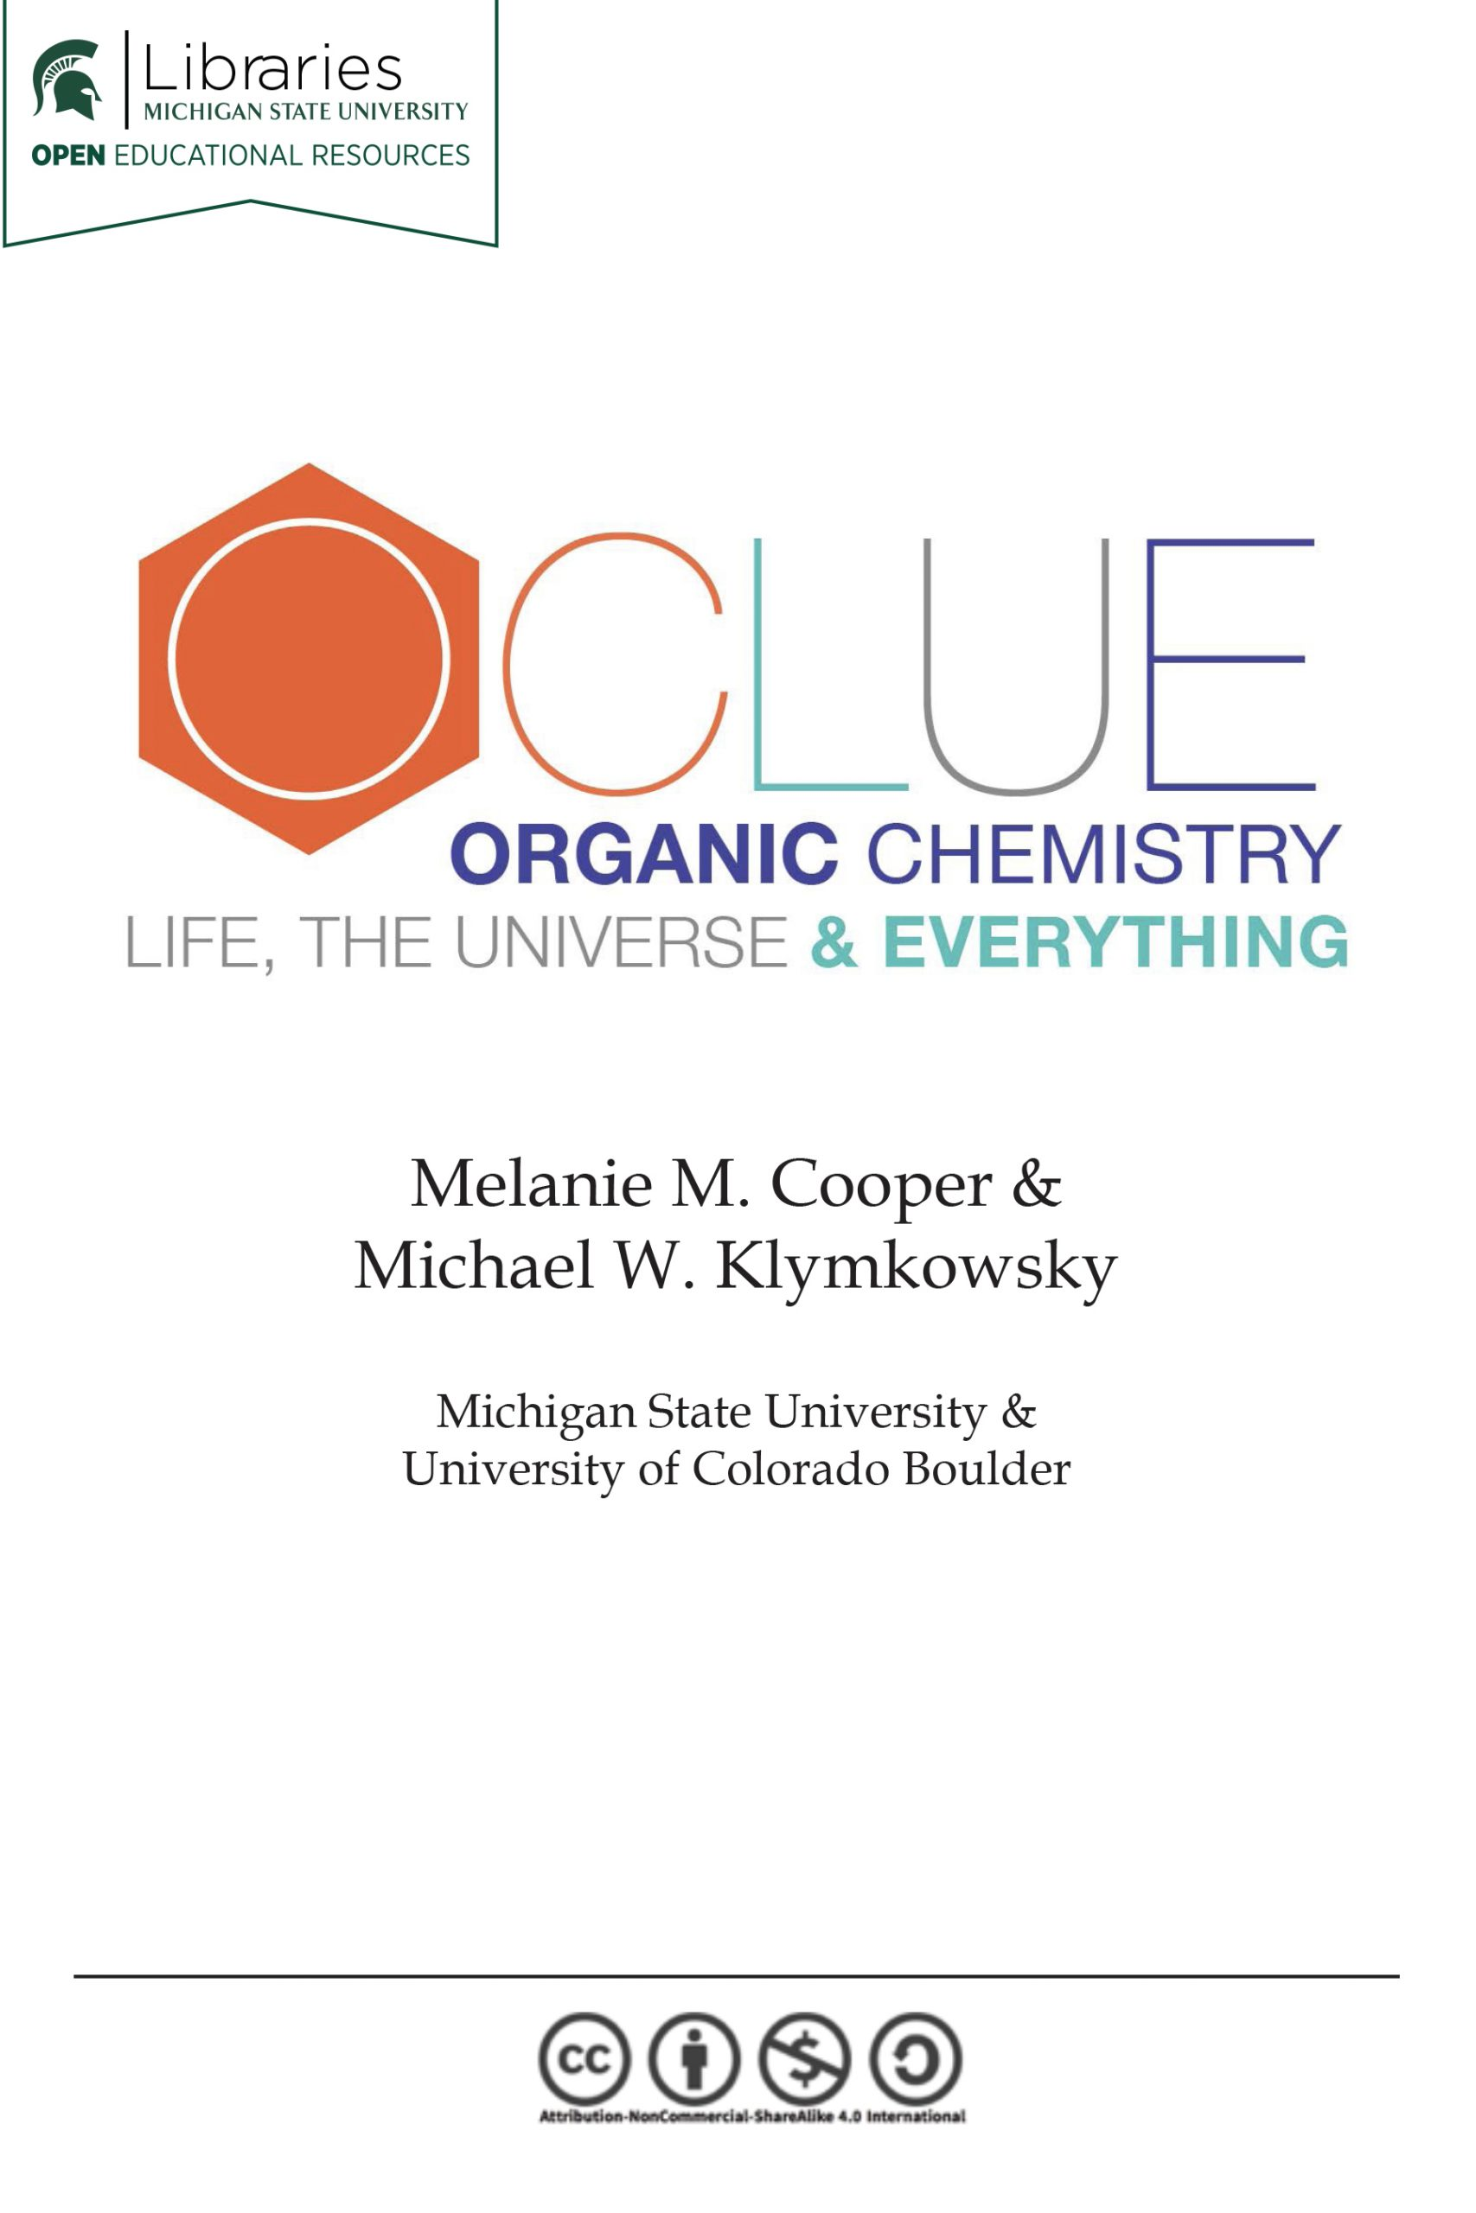

OCLUE: Organic Chemistry, Life, the Universe & Everything

OCLUE: Organic Chemistry, Life, the Universe & Everything

Melanie M. Cooper and Michael W. Klymkowsky

Michigan State University Libraries

East Lansing

OCLUE: Organic Chemistry, Life, the Universe & Everything by Melanie Cooper and Michael Klymkowsky is licensed under a Creative Commons Attribution-NonCommercial-ShareAlike 4.0 International License, except where otherwise noted.

Contents
- Preface
- Chapter 1: Acid–Base Reactions
- Chapter 2: Spectroscopy: how we know what we know about the structure of matter
- Chapter 3: Conformations and Configurations: the consequences of the three- dimensional nature of carbon compounds.
- Chapter 4: Nucleophilic Substitution Part II
- Chapter 5: Alkenes and Alkynes
- Chapter 6: Alcohols and an introduction to thiols, amines, ethers & sulfides
- Chapter 7: Nucleophilic attack at the carbonyl carbon:
- Chapter 8: Conjugated compounds and aromaticity
- Chapter 9: A return to the carbonyl


Organic chemistry is chemistry of carbon and
carbon-containing compounds. Since the core
structural, catalytic, information storage and retrieval
systems of organisms are carbon-based
macromolecules, organic chemistry is of direct relevance to the life sciences. Just as importantly, the properties of carbon make possible an amazing range of molecules with unique properties, from small molecules to complex plastics and even more complex biomolecules. An understanding of organic chemistry enables us to understand the properties of these substances, how they come to be synthesized and how they breakdown. Given its importance, the question then is: can we improve the design the course to make as effective and engaging as possible?
The essence of organic chemistry is how carbon atoms interact with other atoms and groups of atoms to produce an astounding array of complex and interesting molecules. The basics of bonding and intermolecular interactions are introduced in the general chemistry version of CLUE (Chemistry, Life, the Universe & Everything), along with how the structure of a molecule affects its properties, how the energy changes associated with chemical and physical changes can be predicted and explained, and how chemical systems can be stabilized or perturbed by changing conditions. These four core ideas (structure-property relationships, bonding and interactions, energy, and stability and change) are continued on into OCLUE and are deepened and expanded as we discover and explain ever more complex chemical systems. Our goal is to help you to make plausible (and correct) predictions as to what types of reactions are likely and which are unlikely to occur, and to be able to predict products for unfamiliar reactions by understanding how molecules interact. To confirm these predictions we will need to employ methods to characterize molecular structures based largely on how molecules interact with light (the field generally known as spectroscopy). Once you have a resource of reaction types and reaction systems at your disposal, we can begin to design syntheses of molecules for particular purposes, and understand how and why some biosynthetic pathways occur.
A few reminders:
Each atom is composed of a positively charged nucleus and negatively charged electrons, arranged in accord with the predictions of quantum mechanics. The properties of atoms and molecules are dependent on the way that the electrons are organized in the molecule, but in general we only need consider the behavior of the valence electrons: the electrons that are not part of the core. The core electrons are tightly attracted to the positively charged nucleus and are very difficult to dislodge, whereas the valence electrons are further away (on average) from the nucleus and therefore are more easily dislodged or moved (require less energy), because the strength of the attraction between the nucleus and the valance electrons is weaker. The strength of these nuclear/electron interactions is different for each type of atom—a fact captured in the idea of electronegativity. The stronger the nuclear attraction for the valence electrons, the more electronegative an atom is. As atoms bond together to form molecules, the electron density arrangement within a molecule (whether two or two hundred thousand or more atoms) is determined by the three-dimensional arrangement of the atoms, and the relative electronegativities of the bonded atoms. Therefore, it is possible to predict whether molecules are polar (even though they are neutral), and from the direction of the polarities we can predict how molecules will interact—that is how strong the intermolecular forces are between molecules, and also which ends of a polar molecule will interact—and then perhaps react to form a new substance.
While a bond is inherently stable, how stable it is depends on its environment. It takes energy to break any bond. You might think that all bonds are stable, but no, the kinetic energy of surrounding molecules (a function of temperature) can (through collisions) supply enough energy to break a bond. Under these conditions molecules will rearrange (through bond breaking and formation) to produce new molecules. Organic chemistry’s goal is to understand (predict) this end state, given a particular starting molecule or molecules, a particular solvent (environment), and various environmental variables (e.g. temperature) based on the behaviors of atoms and their constituents).

Chapter

Chapter 1: Acid–Base Reactions
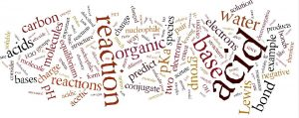
As we will see, organic reactions can be classified using a small set of reaction types—the largest and most all-encompassing of which are those involving acid–base reactions. Understanding acid–base reactions, therefore, provides a broadly useful conceptual framework within which to consider a wide range of organic reactions. Although it is likely that you have already been introduced to acid–base reactions (especially if you used the CLUE general chemistry curriculum), we are going to review this class of reactions in order to emphasize their general features. Our goal is that you learn how to recognize their role in a range of reaction mechanisms; understanding how and why acid–base reactions occur will give you to a set of tools to understand phenomena as diverse as why most drugs are usually administered as in their salt form (a conjugate acid or base), why biological systems are buffered to specific pH levels (and why different pH levels are found in different cellular and organismic compartments), and why molecular oxygen (O2) transport systems require a metal ion complex (within the proteins involved, e.g. myoglobin, hemoglobin, cytochromes). As we will see, acid–base reactions are by far the most common types of reactions in biological systems.

A quick review of the models of acid–base reactions.
There are a number of ways to discuss acid–base reactions, depending on what aspects of the reaction we want to highlight. They range from the extremely simplified (and not useful) Arrhenius model, to the Brønsted–Lowry model that we use only for reactions in which protons are transferred, and finally to the Lewis model, which can encompass any type of acid–base reaction.
Arrhenius: The Arrhenius acid–base model is probably the first acid–base model that you were introduced to in the course of your education. In this model, when an acid dissolves in water it dissociates to release a hydrogen ion (H+); when a base dissolves it releases a hydroxide ion (–OH).
Acid: HCl(g) + H2O H+ (aq) + Cl– (aq) (sometimes written as or HCl(aq))
Base: NaOH(s) + H2O Na+(aq) + –OH(aq)
Acid–Base Reaction: HCl (aq) + NaOH(aq) NaCl(aq) + H2O (l)
Although simple, the Arrhenius model is not particularly useful when it comes to understanding the reactions considered in organic chemistry. This of course raises the obvious question: so why are we mentioning it? The answer is two fold: i) because you might well vaguely remember it as a description of acid–base behaviors and ii) so that we can consider why it is not useful and why you should not use it. The Arrhenius acid–base model applies only when water is the solvent—as we will see many organic reactions do not occur in water. The Arrhenius model also, falsely implies that there are free protons (H+) roaming around in water and it restricts bases to those substances that release a hydroxide ion. Finally, it implies that an acid can exist independent of a base—and vice versa, which doesn’t make a great deal of sense.
Brønsted–Lowry: The Brønsted–Lowry model is a much more useful and flexible model for considering acid base reactions. In this model an acid is a proton (H+) donor and a base is a proton acceptor. In the Brønsted–Lowry model you cannot have an acid without a base, and vice versa; the acid has to donate its H+ to something (the base), and similarly the base has to accept it. The H+ doesn’t just “drop off”—it is transferred. In the case of reactions that occur within aqueous solution, the H+ is transferred to a water molecule to form H3O+. Consider, as an example, HCl; in aqueous solution HCl transfer a H+ group to a water molecule. The products are H3O+ (the conjugate acid of water) and Cl–, the conjugate base of HCl.
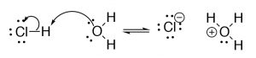
The flexibility of the Brønsted–Lowry model lies in the fact that the base does not necessarily have to be water. For example, if we look at the reaction of hydrogen chloride and ammonia (NH
), we see that the proton transfer from acid to base is analogous to the reaction in water.
In the Brønsted–Lowry model, as for all chemical reactions considered at the molecular level, there is the possibility for the reaction to reverse, which is denoted by the use of equilibrium arrows (⇄).
; the result is that the electron density in the bond will lie mainly with the more electronegative atom (e.g. O, N, or Cl). The outcome is that, for example, an H–O bond will be weakened (require less energy to break); the H will have a large partial positive charge on it, and will be strongly attracted to basic centers (as described in the next section). Similarly, simple
can be identified by the presence of an atom (within the molecule) that has a partial negative charge; this partial negative charge arises because the atom (the basic center) is bonded to less electronegative atoms. Now we add one further consideration, this base center atom also needs to be able to accept the incoming H
. In practice, this means that a

.
The Lewis model allows us to describe exactly the same set of reactions as does the Brønsted–Lowry model, but from a different perspective, and it also allows us to expand on the model. In the Lewis model

with the

, often but not always with the concomitant breaking of a bond within the acid molecule. We use same rationale for why the reaction occurs between two oppositely charged centers, but from the perspective of the electrons, rather than the H
. A base must therefore have a lone pair of electrons that can take part in a bond while an acid must have an atom that can accept that lone pair of electrons. Using the reaction of HCl and water as an example, we use the curved arrow notation to denote how the electrons move between base and acid. Recall
that we use this curved arrow notation to indicate the movement of electron pair
from a source of electrons to a sink. Here the source is the lone pair on the oxygen, and the sink is the hydrogen (which has a δ+ due to its bonding to a Cl) The second arrow moves from the source (the bond between H and Cl, to the sink—the electronegative Cl which ends up with the negative charge, while the O that donated the original electron pair ends up with a positive charge).
The Lewis model encompasses the Brønsted–Lowry model, that is, all Brønsted–Lowry acid–base reactions that can be described using the Lewis model. However, the Lewis model extends the range of reaction types that can be considered as acid–base reactions. Take for example the reaction of ammonia (NH3) and boron trifluoride (BF3). This reaction is classified as a Lewis acid–base reaction, but it is not a Brønsted acid–base reaction.
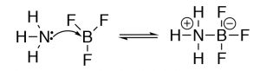
Why use different models of acid–base chemistry? While at first the idea of using different models to explain acid–base chemistry may be a little confusing. Why not use the all-encompassing Lewis model for everything? It turns out that both the Brønsted–Lowry and Lewis models are particularly useful depending on the system under consideration. The trick is to recognize which is the most useful when describing, predicting, and explaining a particular type of chemical reaction.
In our explorations in organic chemistry we will be using both Brønsted–Lowry (proton transfer) and Lewis (electron pair donation) models to describe acid–base chemistry, depending on the type of reaction. In practice, the Brønsted–Lowry model is simple and useful; it tells you what is happening (proton transferred from acid to base) but nothing about the mechanism by which the H+ moves. For that we must turn to the Lewis model, which tells us how the electrons rearrange during the reaction. It is also important to keep in mind why these reactions happen—they are caused by an electrostatic interaction between two oppositely charged parts of molecules: δ– is attracted to δ+.
One further note, all reactions are initiated by random collisions of molecules, but only collisions that allow the electrostatic interaction of the acid and base to occur are productive (that is, collisions that involve two similarly charged parts of molecules will not give rise to a reaction. Again we will have more to say about this later.

Acid–Base Reaction Direction and Position of Equilibrium
Acid base reactions begin because of electrostatic interactions, but the extent to which the reaction proceeds depends on the relative Gibbs free energy of the reactants and products, that is, the overall Gibbs free energy change (ΔG) for the reaction. This is a subtle but important point: the reaction does not occur because the products are more stable, it occurs because there is an attractive force between two reactants that have polar structures, As we will see, we can predict the relative amounts of reactants and products in a mixture (at equilibrium), based both on an understanding of molecular structures and by comparing their pKa.
AcidStrength(usingtheBrønsted–Lowrymodel): The strength of an acid, that is the degree to which it donates H+ to (or accepts electron pairs from) other molecules, depends on a number of factors including, obviously, the strength of the base (that is the degree to which the base donates electron pairs to other molecules) it reacts with. Acid and base strengths are usually reported using water as the solvent (i.e. as the base or acid respectively), so that acid strengths can be compared directly. Since biological reactions take place in aqueous solution we will be able to extend our understanding of simple acid base reactions to much more complex ones as we move forward.
The reaction for any acid HA is:
HA + H2O ⇄ H3O+ + A–
We can estimate the extent of the reaction (i.e., how far the reaction goes, that is the concentrations of reactants and products when the reaction reaches equilibrium) by determining the equilibrium constant Ka.
Ka = [H3O+][ A–]/[ HA]
In contrast to strong inorganic acids (such as HCl, or HNO3), the equilibrium constants for many organic acids are small (ranging from 10–1 to 10-55) and it is more common to report pKa – which, as you will remember, is = –log Ka. A strong acid such as HCl has a large Ka (in fact it is so large as to be meaningless) and therefore a very small (negative) pKa.
Some representative Ka and pKa values.
4+4 | –10 | 9.25
CH4 (methane) | –55 | 55
It helps to be able to interpret these numbers in terms of the extent of the associated reaction. For example, water (which acts as both an acid and a base) dissociates to a very small extent. In a liter of pure water, which contains ~54 moles of water molecules (or ~54 x 6.02 x 1023 molecules or ~3.25 x 1025 molecules), ~10-7 moles (or ~10-7 x 54 x 6.02 x 1023 molecules or ~3.25 x 1016 H3O+ ions). The weaker the acid the higher the pKa (can you explain why that is the case and what it means in terms of the relative concentrations of species at equilibrium?).
It will help you greatly if you
for common acids, for example alcohols tend to have a pK
of ~15, while amines have a pK
~33. As we will see the pK
of various carbon species is very dependent on the environment of the C-H bond, but remembering that sp
carbon-hydrogen bonds (pK
~55) are not likely to ionize under any circumstances is helpful. However, it is even more important to understand the factors that affect acid strength, and be able to use them to predict and explain the outcomes of reactions.
Another important idea to remember is that the extent of a reaction (as measured by its equilibrium constant K) is related to the change in Gibbs free energy (ΔG° = ΔH° – TΔS°) associated with that reaction. That is when we think about the extent of a reaction (the concentration of reactants and products when the reaction reaches equilibrium) in terms of the relative stabilities of the reactants and products we need to take into account both the enthalpy change (ΔH°), which reflects the changes in bonding and intermolecular interactions involving both reactants and products, and the entropy change (ΔS°) associated with the reaction system. Recall that ΔS° reflects change in the number of possible energy states and positions in the reaction system. For most organic (weak) acids, it turns out that the ΔH° of the dissociation reaction in water is approximately zero, because the types of bonding and interactions that are broken and formed during the reaction are similar. Differences in ΔG for the reaction (and therefor Ka and pK
) are typically due to differences in ΔS.

Questions to answer:
- Explain why acids and bases are always (as pairs) found together in a system.
- What is meant by the terms conjugate acid or conjugate base?
- In the Lewis model for the HCl + water reaction, explain why you draw the arrow pointing from O to H.
- Complete these acid base reactions and predict the relative amounts of reactants and products when the reaction reaches equilibrium for each reaction. Explain your predictions using your knowledge of atomic and molecular structures and electronegativity.
CH3NH2 + HCL ⇄
CH3NH2 + H20 ⇄
CH3NH– + H20 ⇄
CH3NH3+ + H20 ⇄

Organic Acids and Bases
Having reviewed acids and bases using rather simple molecules (HCl and NH3), let us move on to the more complex world of organic acids and bases, how to identify them, how to determine relative strengths, and how to predict what will happen in any given mixture. We begin by comparing the pKa‘s of some organic acids. Let us begin with ethanol (pKa ~16), a molecule that we typically do not consider to be an acid, and acetic acid (pKa 4.8). There is clearly a huge difference between the pKa’s of these two molecules, the question is can we understand why this is the case?
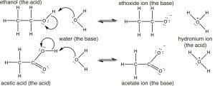
If we draw out their structures we see that both have (as expected) the acidic hydrogen bonded to the electronegative oxygen. (Make sure you remember why the hydrogens bonded to carbons are not as acidic as those bonded to oxygen). So why the huge difference in pKa‘s? To answer this question we have to remember that the extent of the reaction depends on the relative thermodynamic stability of the products—that is, the system containing the conjugate base of the acid and the hydronium ion. The reactions and conjugate bases of the two are shown here (↓). Based on their pKa values, we would predict that the ethanol dissociation reaction is rare (few ethoxide ions form) while the acetic acid dissociation reaction is more frequent. However note that even in the case of the acetic acid only about 3% of the acid molecules are dissociated in a 1M solution.
The first step in both reactions appears to be more or less the same, an electron pair from the oxygen in water forms a bond to the electron deficient hydrogen while the O–H bond of the acid breaks and the electrons originally associated with it the move back to the oxygen. The difference between the two reactions lies mainly in the way that the negatively charged conjugate bases (ethoxide and acetate) behave, and the way that they are solvated by the solvent (water). For ethoxide (ethanol’s conjugate base), the extra negative charge is localized onto the oxygen, which leads to a concentration of charge. Water molecules are strongly attracted to the ethoxide anion, an interaction that limits the mobility of the Resonance Structures Resonance Hybrid water molecules and results in a decrease in entropy (ΔS is negative). In contrast, in acetate (acetic acid’s conjugate base), the negative charge is delocalized onto both oxygens (even though it is often drawn as if it was associated with one but not the other). We can illustrate this in two ways (or more!) by drawing arrows to indicate how the extra electron pair can move from one oxygen to the other; it looks like this (→).
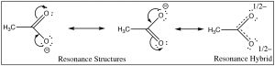
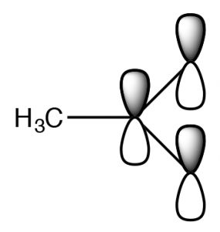
The actual structure has a partial negative charge on both oxygens. This pair of structures is often referred to as a resonance structure and the process is termed resonance but the name is misleading. In fact the actual structure, the resonance hybrid, does NOT involve the electrons (and the double bond) moving back and forth between the two oxygen atoms. By a biological (and not completely sensical) analogy we might say it is a mule or a hinny—the offspring of a cross between a horse and a donkey. Just as a mule (or a hinny) is not bouncing back and forth between being a horse and being a donkey, so the resonance hybrid actually exists as a new species, with an actual structure that is partway between the two (drawn) resonance structures. In this case, we are using two bonding models (a valence bond and a delocalized molecular orbital model) to describe the structure of acetate anion. The localized valence bond model involves a sigma single bond framework that connects the atoms and provides the molecular shape. The delocalized molecular orbital model describes a pi bond that connects both Os to the C. We can visualize the anion as a planar sp2 hybridized carbon connected to a methyl group and two oxygens by sigma bonds together with a 3 atom two electron pi bond that extends over the O–C–O framework (→). The result is that in the acetate ion the negative charge is delocalized over two oxygens, rather than being concentrated on only one atom as it is in the ethoxide ion. The result is that the interactions of the acetate with solvent water molecules is not as strong, so that the water molecules are not as ordered, meaning that the water is not as ordered around the molecule and the entropy change is not as negative. The effects of delocalizing charge over more than one atom play a major role in predicting the outcomes of a wide range of reactions. We note that ΔS is still negative since the creation of a charged species still leads to increased ordering of solvent molecules.
One way to predict whether charge can be delocalized is to determine whether resonance structures can be drawn for the charged species. For example: try convincing yourself that you cannot draw resonance structures for ethanol.
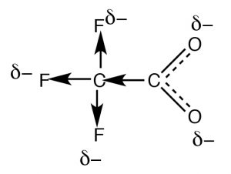
Resonance is not the only way to stabilize charge. Typically, resonance occurs through aconjugated pi bond system, such as occurs within the –CO2– part of an organic acid, but how do we account for the difference in the acidities of acetic acid (pKa 4.8) and trifluoroacetic acid (→) (pKa 0.5), even though they both have the carboxylate functional group? The difference between the two lies in the fact that the charge on the trifluoroacetate anion is delocalized by two distinct mechanisms. As in acetate, the negative charge is delocalized by resonance through the pi bonding system; in addition it is also delocalized onto the fluorines by the fact that the highly electronegative fluorine atoms (more electronegative than O) withdraw electrons from the methyl carbon through the sigma bonds, which in turn withdraws electrons from the next carbon, and in turn from the two oxygens (a process known as “induction”). The result is that the negative charge is “smeared out” over even more atoms, making the anion even less likely to cause a solvent molecule ordering (reducing the effect on ΔS). As you might expect, the inductive effect is distance dependent (perhaps you can predict the effect of adding more CH2 groups between the CF3 and CO2 groups).

Questions to answer:
- Using resonance structures predict which is more acidic: C6H5OH or CH3CH2OH?
- Draw structures to show how sodium ethoxide and sodium acetate are solvated in water, and use them to show why the negative entropy change for the formation of sodium acetate is smaller than that of sodium ethoxide.
- Consider the pKa‘s of the three chlorobutanoic acids: CH3CH2CHClCOOH (pKa 2.86), CH3CHClCH2COOH (pKa 4.05), and CH2ClCH2CH2COOH (pKa 4.53). Draw structures and use them to explain why these carboxylic acids have different pKa‘s.

Organic Bases
As noted previously, there are no acids without bases, and vice versa. Even if we are only discussing H+ (proton) transfer, it is (arguably) easier to think about the base using a Lewis model. That is, a base has an electron pair available for donation into a bond with the acid. Recall that almost everything that has a pair of non-bonding electrons (sometimes called a lone pair) can act as a base. The most common types of organic bases often have a nitrogen atom somewhere in their structure. If we compare the basicity of N, O and F, each of which have lone pairs that are could potentially be donated, nitrogen is the least electronegative and therefore the best able to donate its electrons into a bond, since its lone pair is least attracted by the nucleus. Fluorine, the most electronegative element, holds its electrons very close to the nucleus, and under normal circumstances would not be considered as a base.
Oxygen, since it is more electronegative than nitrogen is not as strong a base, therefore when ammonia and water are mixed, the only reaction that occurs (and that to a relatively small extent) is a proton transfer from water to ammonia.
NH3 + H2O ⇆ NH4+ + –OH
The equilibrium constant for this reaction is 1.8 x 10–5 (most of the species in the mixture at equilibrium are reactants)
*insert image here*
Here are some organic bases (→). Note that they are components of a wide range of biologically active molecules, including DNA, hormones and pharmaceuticals. As we will see the basic nitrogen provides an important way to understand the reactivity of a particular species.
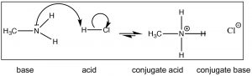
For now, however, let us start with a simpler base such as methylamine (CH3NH2) the simplest nitrogenous organic base. Methylamine reacts with acids (↓) in much the same way that ammonia does; it will react with a strong acid like HCl(aq) to produce methylammonium chloride.
Recall that the position of equilibrium can be predicted by comparing the strength (pKa’s) of the two acids. HCl (pKa –7) is a much stronger acid than CH3NH3+ (pKa ~10) and therefore we predict that the equilibrium of the methylamine + HCl reaction will lie well to the right. Now consider the reaction in which methylamine reacts with acetic acid (↓).
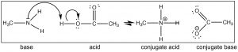
Again we can predict the position of equilibrium by comparing pKa’s of the conjugate acids (acetic acid 4.8 and CH3NH3+ ~ 10). Notice that you can predict the structure of the products simply by following the flow of electrons. We could change the CH3 (methyl) groups on either methylamine and acetic acid to a wide range of different groups and still be able to predict the product easily, as long as you recognize that the reaction that takes place is a (simple) proton transfer (acid–base). For example, look at the structure of cocaine (above): can you predict what will happen if it were reacted with acetic acid? What would be the structure of the product?

Molecules that contain both an acid and a base:
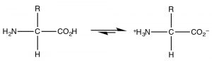
The most common example of a molecule that act as both an acid and a base is of course water because it has both a potentially acidic hydroged, and a lone pair that can accept the proton. However, since this is organic chemistry, where water is not as common a solvent, let us consider the class of molecules that have both acidic and basic domains simultaneously. The most biologically important such molecules are the amino acids, which have both an amino group and a carboxylic acid. A subset of the possible amino acids are those used in biological systems to assemble polypeptides. Amino acids (or rather the α-amino acids) contain both a carboxylic acid and an amino group attached to a central carbon (the α-carbon). The generic structure is given here (→) where R stands for a wide range of side chains. At pH 7 the amino acid exists in what is know as a zwitterionic form, in which the carboxylic acid group is negatively charged while the amino group is positively charged. At no time would an amino acid (dissolved in water) exist in an un-ionized form. We can predict what form would be present at different pH’s by considering the pKa‘s of the species involved.

Effect of pH on acid base reactions
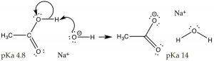
So far, we have discussed situations when the acid or base is added to solution of pure water. Pure water has a pH of 7, and [H3O+] = [–OH]. Now let us consider what happens when we change the pH of the solution. For example consider a situation in which we dissolve a simple organic acid (CH3CO2H, acetic acid) in a solution that has a pH > 7, that is where the [–OH] > [H3O+]; under these conditions the extent of the acetic acid’s ionization is increased. Recall that in 1M acetic acid only ~3% of the acid is ionized at pH 7. If we change the solution to make it basic by adding NaOH, the excess of strong base (–OH) will completely deprotonate the acid. At equilibrium, the reaction will now favor products over reactants (i.e. it will move to the right). What we have done here is drive the acetic acid ⇆ acetate reaction to the right, increasing the concentration of acetate, which is an application of Le Châtelier’s principle). Note that Na+, derived from the addition of the NaOH used to adjust the pH, is present but does not take part in the reaction – for this reason it referred to as a “spectator ion”. Another, perhaps simpler, way to predict the outcome of this reaction is to use the pKa values of the two acids (CH3CO2H, 4.8 and H2O, 14), clearly acetic acid is a much stronger acid than water, and therefore the equilibrium position for this reaction will lie over to the right in favor of the weakest acid and the weakest base. What we have done here is change the acetic acid, which is a polar organic molecule, into acetate, an ionic species.
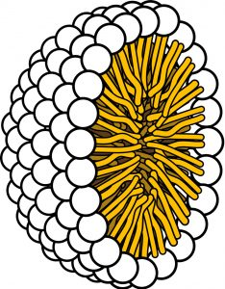
Acetic acid is a small organic molecule; since it is polar it can interact with water (though intermolecular forces), therefore acetic acid is very soluble in water (indeed it is miscible with water (it has unlimited solubility.) But now, let us consider the effect of increasing the length of the hydrocarbon group of the organic acid on its molecular properties. Acetic acid has a methyl (CH3–) group, the smallest possible hydrocarbon. In contrast dodecanoic (lauric) acid has a 12-carbon hydrocarbon chain (CH3[CH2]11–) and has a solubility in water of 0.063 g/L (~30 mM) at 25 °C, which is much less that of acetic acid. As the hydrocarbon (non-polar) part of the molecule increases in length, solubility in water decreases: the ΔG of the process of dissolving the organic acid in water becomes more positive. This decrease in solubility is primarily due to a negative entropy change (ΔS) caused by the self-organization of water molecules around the hydrocarbon “tail” of the molecule. Now let us consider the behavior of ionized sodium dodecanoate (the sodium salt of dodecanoic acid); it, like many ionic species, it is soluble in water. Although as you may remember, this is a different form solubility – the soluble species is not isolated molecules but rather molecular complexes known as micelles (→). The upshot of this is we can “solubilize” organic acids in water by deprotonating them, but if we then lower the pH, the organic acid will separate from solution again.
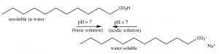
Organic bases can be solubilized in a similar way, except that now the solution must be made acidic. For example, a nitrogenous base with a large non-polar group such as dodecylamine (C12H27N) has a solubility of about 3.5 g/L (~20mM), but at acidic pHs it is completely soluble. Contrast the solubility of dodecyl amine with cadaverine (NH2CH2CH2CH2CH2CH2NH2), the compound that smells like its name, which is completely miscible with water because it has two polar amino groups. It turns out that we can predict the pH at which a particular acid or base protonates or deprotonates. You may recall from general chemistry that the pH of weak acids and their conjugate bases (like most organic species) can be described using the Henderson Hasselbalch equation (→).
One way to work with this equation is to note that [acid] = [conjugate pH = pKa + log base] when the pH of the system is equal to pKa of the acid. At pH’s below pKa, [acid] > [conjugate base], there is more acid than base, and vice versa for pH > pKa. Therefore, by adjusting the pH we can change the concentrations of conjugate acid and base to suit our purposes, or we can predict the relative concentrations at any pH. For example, acetic acid with a pKa of 4.8 would have 50% CH3CO2H, and 50% CH3CO2–Na+, at a pH of 4.8. If the pH falls below 4.8 the concentration of protonated acid will increase, and if it rises the concentration of acetate ion will increase.
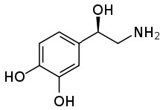
This ability to transform an organic substance from an insoluble (in water) molecule to a soluble ionic species can be very useful. One common example stems from the fact that many pharmaceutical drugs are organic substances that are insoluble in aqueous solutions (like cytoplasm or blood). If these substances were introduced into the body in their non-ionized form they would not dissolve, and therefore be inactive. If you check the labels on many prescription bottles you will see that the drug is administered as a salt. Consider norepinephrine (→), a hormone that is often administered intravenously to counteract the effects of allergic reactions. It is administered as a salt of tartaric acid to ensure that it is soluble in the blood stream.
You may come across another example of this phenomenon (that acids are soluble in basic solution, and bases are soluble in acid solution) if you take the organic chemistry laboratory course. If your product has an acidic or basic moiety in its structure, you can extract the substance into aqueous (acid or basic) solution, washing away all the organic by-products with an organic solvent, and then regenerating the acidic or basic substance. This is an important purification method for many substances, because it allows the compound of interest to be separated into aqueous solution and then regenerated simply by adding or subtracting a proton.
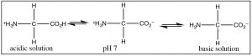
When we consider biomolecules (that is, organic molecules found in organisms) the situation is not so clear cut; most biomolecules have a variety of acidic and basic groups as part of their structure. Even the simplest amino acid, glycine (→) exist in a variety of protonated and deprotonated forms depending on the pH.
One thing that becomes clear is that individual amino acids are always charged regardless of the pH, so they are water-soluble. But the extent of the protonation/deprotonation reactions is pH dependent. As we will see this has a number of ramifications for a wide range of biological molecules, because they will behave very differently in different pH solutions. This is one important reason why most biological systems are buffered so that they remain at a fairly constant pH.

Questions to Answer:
- If you have a mixture of benzoic acid C6H5CO2H (pKa 4.2), toluene, C6H5CH3 and aniline hydrochloride (pKa of C6H5NH3+ 4.6). Which substance will be soluble in aqueous acidic solution, which will be soluble in aqueous basic solution, which will not be soluble in water?
- Outline a scheme for separating these three substances by using their differing solubilities in organic and aqueous solutions of different pHs.

Lewis Acids and Bases, Electrophiles and Nucleophiles
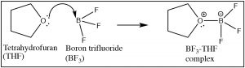
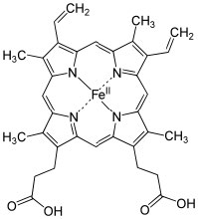
As we have seen, any reaction in which a proton (H+) is transferred from one molecule to another can be considered as a Lewis acid–base reaction, but now it is time to broaden the scope of Lewis acid–base reactions. The structural requirement for a Lewis base is essentially the same as those we discussed for a Brønsted base. That is, a Lewis base must have an accessible lone pair of electrons that can be donated into a bond with a Lewis acid. For example, many (but not all) nitrogen and oxygen containing molecules have such available lone electron pairs and so can be considered as Lewis bases. It is the Lewis acid that can take a number of different forms (and so, can be harder to recognize). A Lewis acid must be able to accept a pair of electrons. In practice this means a variety of substances (besides H+) can act as Lewis acids: for example, any species with empty orbitals that are energetically accessible can be a Lewis acid. Common examples of this situation are compounds of Group III elements (specifically B and Al); these have only three valence electrons. Examples include BF3 (↑) and AlCl3, both of which have a partial positive charge on the central atom and an empty orbital that can accept electrons. Other examples of Lewis acids are metal ions such as Fe2+, Fe3+, Cu2+, and Mg2+; these, by definition, have empty orbitals. The same situation holds true for many transition metal salts, for example TiCl4 and NiCl2. In biological systems, examples of Lewis acid–base complexes include the active site of the oxygen transport complex in hemoglobin (and myoglobin), which consists of an iron ion complexed with 4 nitrogens, which are part of a porphyrin ring. A similar iron-porphyrin complex is found associated with the cytochrome proteins that participate in the ATP synthesis reaction associated with in the electron transport chain of the mitochondria (→). Chlorophyll, the green pigment that is part of the light capture system in algae and plants has a similar structure, except that the Lewis acid at the center of the complex is Mg2+ rather than Fe2+. This has the interesting effect of making chlorophyll species appear to be green, rather than the red observed in blood. This is caused by the difference energy gaps between the molecular orbitals in an Fe complex as compared to a Mg complex with a porphyrin ring. We will discuss this effect in more detail later. As we will also see later, Lewis acids are important class of reagents in organic chemistry because they can interact with a wide range of bases.

Electrophiles and Nucleophiles
The next logical step in expanding our ideas about Lewis acids and bases is to consider reactions that involve carbon. We will first consider reactions in which carbon acts like the Lewis acid, that is, it accepts a pair of electrons to form a new bond with a Lewis base. So, what situations would we make a carbon act in this way? We can rule out (for now) carbon compounds with an empty orbital (akin to boron). Why? Because all stable carbon compounds form 4 bonds and there are no low-lying empty orbitals that can be used to accept electrons.
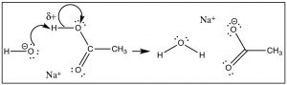
But let us first look at the proton (H+) transfer reaction as a model (→). In this case the bond with the Lewis base (OH-) is formed at the same time as the bond to the conjugate base (of the acid) is broken. We see that the δ+ on the H means that the bond to the H is partially ionized. The H is “on the way” to becoming H+—a species that does have an empty and accessible orbital. The δ+ on the H attracts the negative (or δ–) charge on the base, and the reaction is initiated, forming a new bond between the O and the H, and at the same time breaking the old O–H bond.
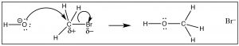
We can imagine that a carbon compound with a δ+ on the C might behave in a very similar way. In this molecule (H3CBr) the C-Br bond is polarized so that there is a small positive charge on the C, which attracts the negatively charged hydroxide (→). Formation of the O–C bond occurs with the simultaneous breaking of the C-Br bond.
Consider the analogies between these two reactions – the mechanisms of how and why the electrons move are similar. The only real difference between the two reactions is that in the first an H+ is transferred from an O (on the carboxylic acid) to the OH–, while in the second, a methyl group is transferred to the OH–. Now for a change in nomenclature: when such a reaction involves a C atom (a carbon center) rather than call the electron deficient carbon a Lewis acid, we call it an electrophile (electron or negative charge loving). Similarly, the hydroxide ion (which acts as a Lewis base) is now called a nucleophile (positive charge loving). This change in terminology is not just to confuse students! In fact, there are subtle differences between Lewis acids and bases and electrophiles and nucleophiles that make the distinction between the two useful. In particular, while all Lewis bases are nucleophiles, as we will see, not all nucleophiles are bases.
So now we have to ask ourselves, what factors make a particular C within a molecule an electrophile? How can we recognize a nucleophile? What criteria do we use to estimate the strength of a particular electrophile or an nucleophile? Can we ever get carbon to act as a nucleophile? If we can answer these questions, we can predict the outcome of a wide array of reactions.
What makes a particular carbon an electrophile?
The simplest of organic compounds are hydrocarbons, and the simplest of hydrocarbons are known as alkanes. Alkanes typically have the formula CnH2n+2 (or if CnH2n if there is one ring of carbons, subtract 2H for every extra ring). All of the bonds within an alkane are sigma (single) bonds; they do not contain pi (double) bonds. In an alkane, each carbon is fully saturated, it makes four single bonds and (as noted above) there are no double or triple bonds. C-C bonds are of course, completely non-polar since the electrons are equally distributed between two identical atoms, however C-H bonds are also relatively non-polar since the electronegativities of C and H are quite similar. In practice this means that alkanes are limited in their reactivity. The most common reactions that an alkane can take part in are reactions with oxygen to produce CO2 and H2O. This reaction is highly exothermic, although there is a significant activation energy, so it requires an initial input of energy (typically a spark, a burning match) to start the reaction, but then the energy from the formation of the strong C=O and O-H bonds (which is why the reaction is exothermic) can be used to initiate more reaction. The actual reaction mechanism is complex; it proceeds via a series of highly reactive (unstable) free radicals (species with unpaired electrons). While this reaction is obviously highly important—this is still how we generate much of the energy to run our cars and electrical power stations, from an organic chemistry perspective it is not very interesting in large part because it is more or less uncontrollable. That is, if you have enough oxygen once started the reaction generates CO2 and H2O, regardless of which hydrocarbon you begin with.
All this is to say that alkanes are not good candidates for the kinds of reactions we are considering, they have neither nucleophile nor electrophilic carbons. So, let us turn our attention to carbon compounds with elements other than C and H and both sigma and pi bonds (this is, of course, the rest of organic chemistry). Here we find a very different situation: the range of reactions and the types of products can seem almost unlimited. While it is impossible (and certainly undesirable) to memorize every reaction and every potential product, it is possible to organize your understanding of chemical systems so that you can make plausible predictions as to which reactions may occur. By knowing reaction mechanisms, and when they are relevant, you can also predict which reactions will occur and therefore what products will form. As you might recognize, this is the same strategy we have used to consider acid–base reactions, which can be understood much more broadly than simple proton (H+) transfer reactions. Thinking in an electrophile-nucleophile context provides an entrée into much of organic chemistry.
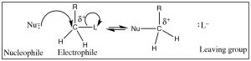
For reactions (other than reactions involving free radicals, like combustion) to occur, there is generally a “handle” within the substrate: a place where the electron density is not evenly distributed, a site at which reactants of opposite charge interact (and react). In the example we used previously, the electrophilic carbon has a δ+ on it; this partial charge arose because the C was bonded to a more electronegative element. Such a partially positively charged C is attractive to any species with a negative (or partial negative) charge. Note that, for now, we are going to restrict the type of carbon atom that we are considering to either a primary (that is a carbon with only one alkyl group (denoted by R) and 2 hydrogens, CH2R–) or a methyl carbon (CH3–). As we will see things become more complicated when we start to add more alkyl groups around the site of attack—so we will come back to that later.
To identify such a partially positively charged C one would look for C’s bonded to groups (atoms) that are more electronegative, that is, that will act to withdraw electrons from the carbon (denoted by L below). But since carbon cannot form more than four bonds as the nucleophile comes in and forms a bond, another bond must break. The electronegative atom (L) (or group of atoms), is known as the “leaving group” (oh, how dull) needs to be stable when it leaves with the extra pair of electrons. We can, in fact, predict the characteristics of a good leaving group. For example, the bond to the leaving group should be polarized, and since the leaving group takes the electron pair with it, the group should be stable with this extra pair of electrons on it (L–). Another way of saying this is that the leaving group should be electronegative and breaking the C-L bond should produce a weak base. Halide ions are examples of good leaving groups, and their order of reactivity is I– > Br– > Cl– > F–. This ranking mirrors their acid strength rankings—that is, HI is the strongest acid and HF is the weakest—which means F– is the strongest base (and therefore least likely to leave)
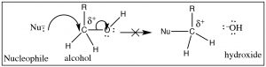
So, what about oxygen, in the form of an alcohol O–H group, as a leaving group? (→) It certainly fulfills the requirement that the C–O bond be polarized, but if you follow the reaction through it would mean that the leaving group would be a hydroxide ion (– OH), a very strong base. Therefore, alcohols (ROH) are not likely to be attacked by a nucleophile.
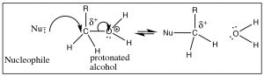
There are ways, however, ways to make an alcohol reactive. For example, if we can carry out the reaction in an acidic solution, the alcohol will be protonated (at least some of the time), and therefore the leaving group will be a water molecule, a stable entity (→).
What makes a good nucleophile?
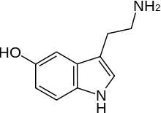
As we have noted, a Lewis base is also a nucleophile, so the trends you have learned about the strengths of Lewis bases also hold for nucleophiles. So, for example, nucleophilicity decreases across a row in the periodic table so NH3 > H2O > HF in the same way as base strength does (recall this is because the lone pair is more available on the N than on F). But since this is organic chemistry, we should have some organic groups dangling off the nucleophiles. So for example, instead of a hydroxide nucleophile, we could use an alkoxide nucleophile (for example, CH3CH2O– Na+ sodium ethoxide), or we could use amine nucleophiles like serotonin (the nitrogen in the NH2 group here is more nucleophilic than the OH group, and the N in the ring). In addition, if we compare nucleophiles with the same nucleophilic atom, a negatively charged species is more nucleophilic than the uncharged form, so OH– > H2O, and NH2– > NH3 (and by analogy any organic derivatives behave the same way).
Besides the nucleophiles that are easily recognizable because they are bases, there is another class of nucleophiles that are somewhat different; they have a lone pair of electrons, but they are not particularly basic. The most common examples are the halide ions, which are weak bases and good leaving groups. So, the question arises: why are halide ions such good nucleophiles? The reason for this has to do with their polarizability (that is, the extent to which an electron cloud can get distorted) of the nucleophile. A very large anion-like iodide has a very polarizable electron cloud because the electrons extend much further out from the nucleus than, for example, the electron cloud in fluoride. This means that the electron cloud for iodide can begin partial bond formation to the carbon much earlier than the one for fluoride, and therefore iodide reacts much faster than fluoride. This logic allows us to explain why the nucleophilicity of halide ions increases as you go down a group: I– > Br– > Cl– > F–.
Although we will return to this reaction in greater detail later, let us take a look at the range of possible reactions that this generic scheme enables us to predict – with the caveat that we are considering simple carbon substrates. Reactions like this are called nucleophilic substitutions, because the species that attacks the carbon is a nucleophile, and the overall effect of the reaction is that we have substituted the nucleophile for the leaving group. This particular example is called an SN2 reaction which stands for Substitution, Nucleophilic, 2nd Order, and we will come back to discuss the reaction in much more detail later.
Another type of carbon nucleophile
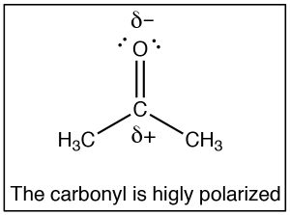
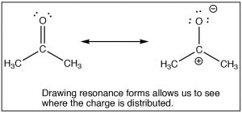
The SN2 reaction is a mainstay of organic chemistry, by varying the substrate (carbon electrophile) the leaving group, and the nucleophile we can construct a huge array of different compounds. Another very important type of compound that has an electrophilic carbon (i.e. a carbon that is subject to nucleophilic attack) is one which contains a carbonyl group (C=O). The carbonyl group is highly polarized, with a large δ+ on the carbon. This can be rationalized by the idea that there are two bonds to the electronegative oxygen and therefore the oxygen has even more tendency to pull electrons away from the carbon than a single bonded oxygen would. One way to visualize this is to draw resonance structures for the carbonyl group as shown, where the electrons from the double bond are now located on the O. We will come back to how to draw resonance forms in much more detail later.
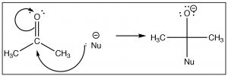
Once we understand how compounds with carbonyl groups are polarized, we can predict (at least for the first step) how these compounds will react. For example, if we have a reasonably good nucleophile (here shown as Nu–)we might predict that it would attack at the carbonyl carbon. The difference in this reaction and an SN2 reaction is that there is no leaving group. Instead the electrons from one of the C-O bonds move onto the oxygen as shown.
There are a number of ways that this reaction can continue, the most obvious of which is that if the reaction is in contact with a solvent that has acidic protons (e.g. water or an alcohol), the O– can simply protonate in an acid base reaction. As we will see later, the course of the reaction also depends on what the nucleophile is. Here we will give the simplest example which is the reaction of a ketone (acetone) with a carbon nucleophile (CH3CH2Li, ethyl lithium). For now, we will not worry about how to make ethyl lithium, but rest assured it is possible! When the negatively charged carbon electrophile adds to the carbonyl we make a new carbon-carbon bond. This is followed by addition of water to protonate the oxygen, to produce an alcohol. The overall reaction is a nucleophilic addition.
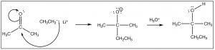

Questions to Answer
Try your hand at predicting the outcomes for these reactions by drawing arrow pushing mechanisms.
- CH3CH2I + NaOH →
- CH3Br + NaN3 →
- CH3CH2Cl + NH2CH3 →
- CH3OH + H+ →
What nucleophile and electrophile would you react together to form these products?
- CH3OH + Br–
- CH3CH3NH3+ + Cl–
- Construct a generalizable model for the SN2 reaction and explain the role of the substrate (the carbon electrophile), the leaving group, and the nucleophile. Construct a generalizable model for the nucleophilic addition reaction and explain the role of the substrate (the carbon electrophile), and the nucleophile. What functional groups would undergo a nucleophilic addition?
- What would make a carbon in a compound a nucleophile? How could you go about making a particular carbon nucleophilic?

In fact, later on we will use abbreviated notation to indicate the transfer of H
from one molecule to another simply because there are so many reactions in which multiple proton transfers take place. However, you should always be aware that protons are always transferred (not simply ionized or dropped off).

In fact AlCl
(l) exists as a dimers Al
Cl
, but this structure decomposes and then reacts as AlCl
in the presence of a Lewis base. Diborane B
H
is also a dimer of BH
, that will break apart to react as BH
.

Chapter

Chapter 2: Spectroscopy: how we know what we know about the structure of matter
Spectroscopy is the study of how energy (particularly electromagnetic radiation) and matter interact. By analyzing these interactions, we can infer a great deal of evidence about the structure of matter. In organic chemistry, spectroscopy allows us to determine the structure of products and reactants (and in some cases we can also get information about intermediates of reactions). By using spectroscopy of different kinds, we can gather evidence about reaction rates and from this information we can infer mechanisms of reactions. In this chapter, we will briefly review the background that you (probably) learned in general chemistry, and then we will move on to the various type of spectroscopy and discuss what each type can and cannot tell us about the structure of organic compounds.
From your earlier studies, you will recall that at the atomic/molecular level, the energies of atoms and molecules are quantized: that is, there are discrete, separate energy states with nothing in between. This applies not only to the energies of electrons, but also to the energies of vibration of bonds and rotation around bonds. Nuclear energies are also quantized. It is possible to switch from one energy state to another by absorbing or emitting an amount of electromagnetic energy (a photon) that corresponds to the energy difference between the two states. Photons with the energy that does not correspond to differences between two energy states are not absorbed or emitted, which means that we can use the energies of the photons absorbed or emitted to tell us about the energy differences between quantum states in atoms and molecules. The differences between these quantized energy levels is highly dependent on the identity and environment of the atoms and molecules, and therefore we can the photons emitted to identify particular species. For example, in isolated atoms the energy differences between levels often correspond to electromagnetic energy in the ultraviolet or visible. This results in the atomic absorption or emission spectra that allow us to determine what elements are present in (for example) stars, and interstellar space.

Interactions of electromagnetic radiation and electrons in molecules
Now we will extend this idea from atoms to molecules. Just as electrons occupy atomic orbitals in atoms, the electrons in molecules occupy molecular orbitals.
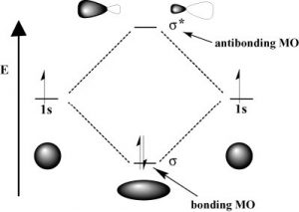
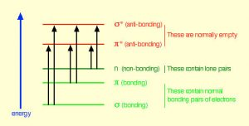
As with atomic orbitals, electrons in molecular orbitals can absorb or release photons of a specific energy as they move from one molecular orbital to another. However, there is a significant difference between the absorption/emission process in isolated atoms (or ions) versus that of molecules. When an electron is promoted to a higher energy level in an atom, the product is an atom in an excited state—generally the excited atom (or ion) will decay back to the ground state by emitting a photon (↓). However, when an electron within a molecule is excited it moves (or is “promoted”) from its original molecular orbital to another. Now there are a number of different consequences that can occur. For example, if the electron absorbs a photon and is promoted from a bonding molecular orbital to an antibonding orbital, the result will be that the bond will break, since there is now no overall stabilizing interaction. Consider H–H, which is the simplest possible molecule. The set of molecular orbitals for hydrogen includes a (sigma) bonding and a * antibonding orbital. In the ground (or lowest-energy) state, molecular hydrogen has a bonding orbital containing both of the molecule’s electrons. If one of the bonding electrons absorbs a photon that has just the right amount of energy (the energy difference between the bonding and antibonding orbital) it will be promoted and move into the destabilized antibonding orbital—causing the bond between the atoms to break because there is now no overall bonding interaction. As you might imagine, if chemical bonds were susceptible to breaking merely by being exposed to low-energy electromagnetic radiation (such as that of visible light) the world would be a different (and rather boring) place. For example, life would not be possible since it depends upon the stability of molecules. In fact, the energy of the photons required to bring about bond-breaking is quite large. For example, the energy required to break an H-H bond (the bond energy) is 436 kJ/mol. If you calculate the wavelength of a photon that could deliver this amount of energy, the amount of energy required to break one H-H bond would be in the far UV section of the electromagnetic spectrum (~280nm). The typically strong covalent (or single) bond requires quite high-energy photons to break them.
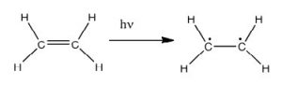
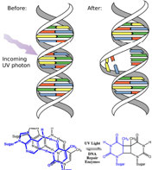
In fact, the Earth’s atmosphere blocks out most (>98%) high-energy (ultraviolet) photons and most biologically important molecules cannot absorb visible light, so that leaves us with the question of why is there a need for sunscreen, which filters out the UV A (400- 315 nm) and UV B (315-280 nm) photons. The answer is that a number of biological molecules contain more than simple sigma bonds. For example, most complex biological molecules also contain (pi) bonds and non-bonding electrons in addition to bonds; transitions between these orbitals may be observed. The energy gaps between these different orbitals are quite are smaller than the * energy gap. Photons with enough energy to cause these electron transitions are present in sunlight. For example, a double bond typically involves both a and a bond. Absorption of a photon that would promote an electron from a bonding orbital to a * anti-bonding orbital would have the effect of breaking the original pi bond. One way to represent this is shown here (→). In this case, one of electrons that was in the pi bond is now in the high-energy pi* antibonding orbital and is far more reactive. Another way to think about it is that the electrons are now unpaired, and are much more likely to react to form a more stable entity. An obvious way to regain stability is for the electron in the antibonding orbital to drop back down to the bonding energy level and emit a photon of the same energy, and in most cases this is what happens—ultimately causing no damage. (As we will see later, since double-bonds are rotationally constrained, another possible occurrence is that there can be rotation around the single [ ] bond) and then reformation of the bond, leading to an isomer of the original alkene). However, in some instances, if there is another potentially reactive species in proximity, reactions between molecules (or in the case of biological macromolecules, between distinct regions of these molecules) can occur and cause problems. For example: most of us are aware that exposure to the sun causes skin damage that can lead to skin cancer. A major mechanism occurs in DNA where two thymidine bases are adjacent to one another. A UV photon can be absorbed by a pi bond in one thymine base. This broken pi bond (and resulting unpaired electron) is very reactive. It can react with a pi bond in an adjacent thymine leading to a new bond, a reaction that produces a four-membered carbon ring, known as a thymine dimer. The DNA replication machinery cannot accurately replicate a sequence containing a thymine dimer, resulting in a change in DNA sequence—a mutation. Mutations of this type are a common early step in the generation of cancerous skin cells (carcinomas) and pigment cells (melanomas).
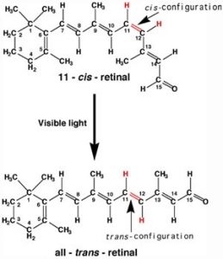
A more benign example of photon absorption in biological systems underlies the mechanism by which we (and other organisms) detect light—that is how we can see things! While it was originally thought (at least by some) that vision involved rays emitted from eyes, we now understand that to see we need to detect photons that are reflected or emitted by the objects around us. The process begins when the photons of light fall on cells known as photoreceptors. In our eyes, these cells are located within the retina: a sheet of cells that line the interior surface of the eye. Within a subset of retinal cells are a number of different types of molecules that contain pi bonds. These molecules are proteins known generically as opsins. An opsin is composed of a polypeptide (or apoprotein) that is covalently bound to another molecule, 11-cis-retinal.
This molecule is derived from vitamin A (all-trans-retinal). The complex of apoprotein and retinal is the functional opsin protein. There are a number of different opsin components that influence the wavelength of the photons absorbed by the functional opsin protein. When a photon is absorbed, it promotes an electron from one of the retinal’s pi bonds to an antibonding orbital. Instead of reacting with another molecule, like thymine, there is a rotation around the remaining single (sigma) bond, and then the formation of a new pi bond, this leads to the isomerization of the original 11-cis form into the trans-isomer. This change in retinal shape influences the shape of the opsin protein which initiates a cascade of electrochemical events that carry signals to the rest of the brain (the retina is considered an extension of the brain) that are eventually recognized as visual input.

UV-Vis spectroscopy and chromophores – or why are carrots orange?
One common recommendation from doctors is that we eat plenty of highly colored fruits and vegetables. The compounds that give these foods their strong color have a number of commonalities. For example, the compound that gives carrots and sweet potatoes their distinctive orange color is beta-carotene. You might well notice its similarity to retinal. The compound that contributes to the red color of tomatoes is lycopene. Molecules of this type are known generically as pigments.
The wavelengths at which a compound absorbs light depends on the energy gap between the orbitals that are involved in the transition. This energy gap is determined by the structure of the molecule. A molecule with only single bonds absorbs light at shorter wavelengths (in the high-energy UV), while more complex bonding patterns are associated with the absorption of visible light. For example, the presence of multiple pi bonds and their interactions within the molecule can affect the energy gap between the molecular orbitals. Recall our discussion of graphite. Rather than thinking of graphite as sheets of fused six-membered rings with alternating single and double bonds, we can think of each bond as a localized sigma bond and a delocalized pi bond. There are huge numbers of pi molecular orbitals spread over the whole sheet of carbon atoms. The more pi MO’s there are, the more the energy gap between these orbital decreases; that is, the less energy (longer wavelength light) is needed to move an electron from a pi to pi* orbital . In the case of network substances like graphite and metals, the energy gap between the orbitals becomes negligible, and we think of the bonding model as a band of molecular orbitals. In these cases, many wavelengths of light can be absorbed and then re-emitted which gives graphite and metals their characteristic shininess. In substances like lycopene or β-carotene we also find this pattern of alternating single and double bonds. We say that compounds with this pattern of alternating single and double bonds (e.g. –C=C–C=C–) are conjugated, and we can model the bonding in the same way as graphite. There are pi MO’s that can extend over the region of the molecule, and the more orbitals there are, the closer together in energy they get.
For an isolated C=C double bond, the energy required to promote an electron from the pi to the pi* orbital corresponds to the light in the UV region (around 170 nm), but as the number of double-bonds that are conjugated (separated by single bonds) increases, the energy gap between the highest occupied molecular orbital (HOMO) and the lowest unoccupied molecular orbital (LUMO) decreases. Eventually, the wavelength of light needed to promote an electron from the HOMO to the LUMO moves into the visible region, and the substance becomes colored. (Note that it does not become the color of the light that is absorbed, but rather the remaining light that is transmitted or reflected). These conjugated regions of molecules are called chromophores. The longer the conjugated section of the molecule, the longer the wavelength of light that it absorbs. You will notice that both lycopene and B-carotene contain large chromophore regions.
Samples of UV-VIS absorption spectra are shown here. Note that in contrast to the atomic absorption spectra we saw earlier (which consisted of sharp lines corresponding to the wavelength of light absorbed by atoms) these spectra are broad and ill-defined. In addition, you can see that the longer (larger) the chromophore, the longer the wavelength that is absorbed—and each of these compounds appears to be a different color. The fact that the peaks in these spectra are not sharp means that UV-VIS spectroscopy is typically not used for identification of compounds (see below for IR and NMR spectroscopy which can be used for this purpose). However, the amount of light absorbed is proportional to the concentration of the substance and therefore UV-VIS spectroscopy can be used to determine the concentration of samples.

Questions to Answer:
- Construct a representation that can help you explain why compounds with longer chromophores absorb lower energy photons than those with shorter chromophores
- Which compound do you think absorbs photons of the lowest energy light? Explain your reasoning, using a molecular orbital diagram to illustrate.
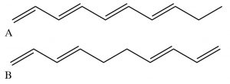

Infrared (IR) spectroscopy—looking at molecular vibrations
Up to now we have concentrated on the absorption (and emission) of energy associated with transitions of electrons between quantized energy levels. However, as we discussed earlier, electron energies are not the only quantized energies at the atomic/molecular level. In molecules, both vibrations and rotations are quantized, but the energies involved are much lower than those needed to break bonds. Let us begin with the simplest of molecular systems, consisting of two atoms bonded together. In such a system, the atoms can move back and forth relative to each other along the bond axis (vibrations). As they vibrate and change rotational speeds (and directions), the potential energy of the system changes (Why is that? What factors influence these changes?). There are also motions associated with rotations around bonds. But (weirdly, and quantum-mechanically) rather than being able to assume any value, the energies of these vibrations (and rotations) are also quantized. The energy gaps between the vibrational energy states tend to be in the range of infrared radiation. If three or more atoms are bonded together the molecule can also bend, changing the bond angle or the shape of the molecule.
Infrared radiation is of lower energy than visible light (longer wavelength, lower frequency). You are probably familiar with IR heat lamps that are used for warming and night vision goggles that allow the wearer to “see” at night. Recall that objects tend to emit radiation (the phenomenon is called black-body radiation) as the kinetic energy of the atoms and molecules in the object is converted to electromagnetic radiation. Around 300K (room temperature or body temperature) the radiation emitted is in the IR region of the spectrum. Conversely, when IR radiation falls on our skin, we feel that as a warming sensation, mainly because it is causing the molecules in our skin to vibrate and rotate—increasing the kinetic energy and thus the temperature.
When we investigate the light absorbed or emitted as molecules undergo vibrational energy changes it is known as infrared spectroscopy. Why, you might ask, are we interested in the vibrations of molecules? The vibrations, rotations, and bending movements of molecules are influenced by the structure of the molecule as a whole (as well as its environment). The result is that that many molecules and fragments of molecules have very distinctive IR absorption patterns that can be used to identify them. Infrared spectroscopy allows us to identify substances based on patterns in the lab and, for example, in interstellar dust clouds. The presence of quite complex molecules in space (hundreds of millions of light years away from earth) has been detected by the use of IR spectroscopy.
The types of changes that can be detected using IR spectroscopy are associated both with stretching (vibrations of) one particular bond, and with movements associated with three or more atoms such as bending or twisting. Consider methane for example: Each C–H bond can vibrate separately, but we can also imagine that they could vibrate “in phase” (at the same time) so that the C–H bonds lengthen and shorten at the same time. This movement is called the symmetric stretch. Conversely, we can imagine that one might lengthen as the other shortens: this is called the asymmetric stretch. Furthermore, the molecule can bend and twist in a number of ways so that there are quite a number of possible “vibrational modes.”
Vibrational Modes of CH2
Here we see the the vibrational modes for part of an organic molecule with a CH2group. Not all these modes can be observed through infrared absorption and emission: vibrations that do not change the dipole movement (or charge distribution) for the molecules (for example, the symmetrical stretch) do not result in absorption of IR radiation, but since there are plenty of other vibrational modes we can always detect the presence of symmetrical molecules like methane (and most other molecules) by IR spectroscopy. In addition, the more the charge distribution changes as the bond stretches, the greater the intensity of the peak. Therefore, as we will see, polar molecules tend to have stronger absorptions than non-polar molecules.
For historical reasons, IR spectra are typically plotted as transmittance (that is the amount of light that is allowed through the sample) versus wavenumber (cm–1). That is, the peaks are inverted, so that at the top of the spectrum 100% of the light is transmitted and at the bottom it is all absorbed.
The position of the absorption in an IR spectrum depends three main factors:
- Bondstrength: it makes sense that the energy needed to stretch a bond (i.e. make it vibrate) depends on the strength of the bond. Therefore, multiple bonds appear at higher frequency (wavenumber) than single bonds.
- Whether the vibrations involved involve bond stretching or bending: it is easier to bend a molecule than to stretch a bond.
- The masses of the atoms in a particular bond or group of atoms: bonds to very light atoms (particularly appear at higher frequency).
The figure below shows each of the general areas of the IR spectrum and the types of bonds that give rise to absorptions in each area of the spectrum. In general C–H, O–H, and N–H bond stretches appear above 3000 cm–1. Between 2500 and 2000 is typically where triple-bond stretches appear. Between 2000 and 1500 cm–1 is the region where double-bond stretches appear, and the region below 1600 is called the fingerprint region. Typically, there are many peaks in this fingerprint region which may correspond to C–C, C–O and C–N stretches and many of the bending modes. In fact, this region is usually so complex that it is not possible to assign all the peaks, but rather the pattern of peaks may be compared to a database of compounds for identification purposes.
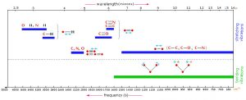
Vibrational Frequencies for Common Bond Types or Functional Groups
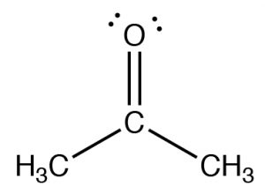
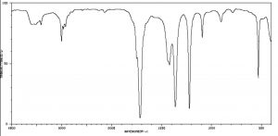
The figure below (↓) shows a spectrum of acetone (→) in which you can see a number of absorptions, the strongest of which appears around 1710 cm–1. Note also that there is a discontinuity in scale above and below 2000 cm–1. The strong peak around 1710 cm–1 can be ascribed to one particular part of the acetone molecule: the C=O (or carbonyl) group. It turns out that carbonyl groups can be identified by the presence of a strong peak in this region although the wavenumber of absorption may change a little depending on the chemical environment of the carbonyl. The presence of a strong peak between around 1700 cm–1 almost always signifies the presence of a C=O group within the molecule, while its shift from 1700 cm–1 is influenced by the structure of the rest of the molecule.

Functional groups:
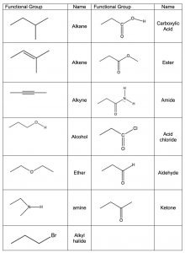
The idea that a carbonyl group can be recognized, regardless of the structure of the rest of the molecule, is evidence for a major organizing idea of organic chemistry—that of functional groups. Functional groups are recognizable clusters of atoms within a larger molecule that have predictable properties allowing us to organize and make sense of organic chemistry. Rather than having to look at very large molecules as whole entities, (for example biomolecules that have many thousands to millions of carbon atoms) we can identify functional groups, and if we know how they behave we can predict how the molecule will behave. A list of common functional groups is shown in the table (→) and it is important that over time you learn to recognize each of them. Later, we will consider each of these groups in more detail and discuss their chemistry. For the moment, it is enough to be able to recognize these groups and understand how to use the evidence for the existence of functional groups that can be obtained from IR spectroscopy. Molecules with functional groups always give rise to particular patterns of peaks that correspond to the vibrations associated with that group.
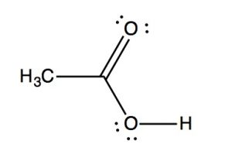
IR spectra can provide evidence for the presence of many of these functional groups, although in practice the most easily detected groups are double bonds—especially the carbonyl (1600–1800 cm–1), and OH and N–H groups (above 3000 cm–1). For example, the spectrum of acetic acid (below) shows two very strong absorptions (above the fingerprint region): a very broad absorption around 3000 cm–1, and a stronger, narrower one around 1720 cm–1.
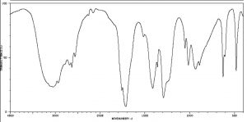
IR spectrum of Acetic Acid
The broad peak corresponds to the O–H group in the carboxylic acid. It is so broad because this group participates in hydrogen bonding of various types and strengths, meaning that the energy required to promote this bond stretch varies with the degree of hydrogen bonding. The peak at 1720 corresponds to the carbonyl group. It should be noted that there are also C—H stretches around 3000 that are hidden by the strong OH stretches. The take-home message here is that IR spectroscopy is good for identifying clusters of atoms (functional groups) within a larger molecule, but it does not provide us with information about how the atoms in the molecule are actually arranged and connected. For that we need to turn to another kind of spectroscopy: nuclear magnetic resonance.

Questions to Answer
- What factors predict the strength of the IR absorption?
- What factors predict the position of the IR absorption?
- Draw a structure for a carboxylic acid in solution in methanol and use it to explain why the O–H bond absorption is so broad.
Nuclear Magnetic Resonance (NMR) Spectroscopy is a form of spectroscopy based on the fact that atomic nuclei behave like tiny spinning charges that generate a magnetic field. Just as with electrons, nuclei have a characteristic that we call “spin” that is quantized. Nuclei can have spins that are integers (1, 2, 3…) or non-integral spins (1/2, 3/2, 5/2…), and some have no spin. Those nuclei with a non-integral-spin quantum number are said to be NMR active, and of these the two most relevant to NMR analyses of organic molecules are H-1 and C-13, which have spin quantum numbers of ½. When materials that contain carbon or hydrogen are placed in a magnetic field their nuclei can assume either of two possible orientations with respect to the field: a low energy orientation in which the spin- associated nuclear magnet is aligned parallel to the field and a high energy orientation in which the nuclear magnet is aligned anti-parallel to (against) the field. A parallel nucleus can be flipped to the anti-parallel orientation by absorbing the appropriate amount of electromagnetic energy—which happens to be in the radio-wave range. From the pattern of energy absorbed, we can deduce the structure of the molecule being analyzed (see below)
The energies of electromagnetic radiation that cause the nuclei to spin flip are referred to as resonance frequencies, (which is why the method is called nuclear magnetic resonance (NMR) spectroscopy). The same phenomena is involved in magnetic resonance imaging (MRI)—although the “nuclear” part of the name was removed because of concerns that patients might be worried (needlessly) about exposure to damaging radiation. Both NMR and MRI involve placing the specimen, either a chemical sample or a human body, into a very strong magnetic field, but the energy used to “flip” the spin of the nuclei within the sample is relatively low, that is in the radiofrequency range. We are constantly bombarded by low energy radio-waves but their energy is not enough to be absorbed by most molecules, and so they have little effect. It is only when very high magnetic fields are applied to a sample (or body) that the spin states of the nuclei are split (into orientations that are parallel and anti-parallel to the field) and we observe the absorption (or emission) of these low energy radio-waves.
An NMR spectrum (or an MRI image for that matter) requires a sample to be placed into a strong magnetic field. In older NMR spectrometers, the field strength is changed, and the resonance frequencies are recorded. Newer (now almost all) NMR machines operate with a fixed magnetic field strength; the sample is irradiated with radio frequency (RF) radiation at all relevant frequencies which excites all NMR active nuclei into the more energetic spin state. As the nuclei relax, the machine records the energies of the emissions, which are then resolved into distinct wavelength using a Fourier-transform-based deconvolution.
The separation of the spin states (and therefore the amount of energy required to flip them) depends upon the strength of the external magnetic field. For example, for a relatively small magnet of 1.4 Tesla the RF used is 60 MHz; at 7 Tesla the frequency is around 300 MHz. The most modern instruments use very strong magnets, operating in the 1000 MHz range. In practice stronger magnets provide better, more detailed spectra. Since different NMR instruments use different magnetic field strengths, they will also produce different RF absorption/emission peaks for same molecule. In order to make measurements from different NMR instruments comparable, the scale is set to show signals in terms of parts per million (ppm) from a reference signal (see following section on chemical shift.

Carbon-13 NMR Spectroscopy
We begin by considering the use of C-13 NMR spectroscopy because it can provide the simplest type of NMR spectrum. C-13 is a minor isotope of carbon, usually ~1% of carbon nuclei present in sample are C-13 (the majority are C-12 and a very small percentage (less than 1 in a million are C-14). In a C- 13 spectrum, each chemically different carbon atom will give rise to a signal or peak in the spectrum. By chemically different, we mean that the carbons are in different environments; these environments impact the local magnetic field that a particular nucleus will experience. So, for example, while ethane CH3CH3 (obviously) has two carbons, because of the symmetry of molecule, both carbon nuclei experience the same chemical (and local magnetic) environment; we would expect ethane to show a single C-13 NMR peak.
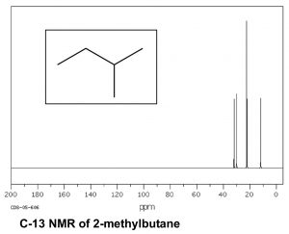
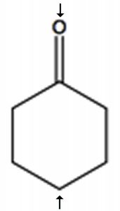
Now consider a more complex hydrocarbon such as 2-methylbutane (ß), which has a total of five carbons; of these the C1 and C2 methyl carbons are in identical chemical environments. The molecule as a whole has four distinct environments and therefore there are 4 peaks in its C-13 NMR spectrum.
To determine the number of chemically distinct carbons that are present within a molecule, you need to look at the patterns of bonds within the molecule, that is, what each carbon bonded to. One quick way to check for identical chemical environments is to look for planes (or axes) of symmetry in the molecule (ignoring rotations around C–C single bonds). For example, cyclohexanone (→) has a single symmetry axis (marked by arrows); the result is that molecule has only 4 chemically distinct carbons as shown in the spectrum below. Now we need to answer the question of why these signals appear at different places in the spectrum
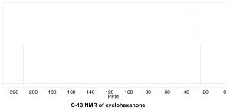
The chemical shift
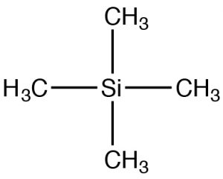
Since NMR instruments may have different field strengths, NMR spectra are often reported with reference to a standard material: tetramethyl silane (TMS). TMS has tetrahedral symmetry, so all of the carbons in the molecule have an identical chemical (local magnetic) environment. We can therefore confidently predict that the C-13 NMR spectra for TMS has a single peak. The chemical shift (in ppm) = shift from TMS/total spectrometer frequency. By using this approach, the chemical shift is not dependent on the type of instrument used. For C-13 NMR the chemical shifts usually range from about 220 to 0. The designation of 0 is where TMS would actually appear, although this signal is often removed from the spectrum for clarity (as in the two preceding spectra). However, if you see spectra with a peak at 0 ppm it is almost certainly due to the TMS standard and should not be used in your determination of the structure.
Shielding and Deshielding
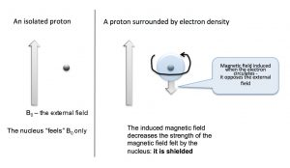
We can answer the question of why NMR signals appear at different places by first remembering that we are dealing not with isolated nuclei, but with molecules that consist of nuclear cores surrounded by electrons that can be described as occupying various molecular orbitals. The electron density around the nucleus has a marked effect on the local magnetic field—that is, the magnetic field that is “felt” by each nucleus. The electrons also “feel” the effect of the magnetic field and begin to circulate around the nuclei to induce a new magnetic field that opposes the original one. This overall impact of this is to reduce the effective nuclear field as shown in the figure below. It now takes a stronger external field to bring the nucleus to resonance at the same frequency (the flip the nuclear spin).
Nuclei that are surrounded by a larger amount of electron density are said to be shielded; they require a larger magnetic field to bring to spin flip than nuclei that are de-shielded (that is, surrounded by lower electron density). Absorption by shielded nuclei tend to be higher (“upfield”) in the spectrum and de-shielded nuclei appear downfield. Consider for example, the C-13 NMR spectrum of 1-chloropropane.
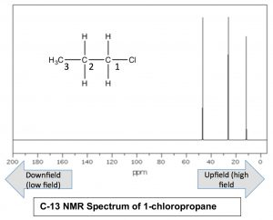
As we might expect, there are 3 peaks in the spectrum, but now we can figure out which is which, because we can predict the relative charge densities on each carbon. The carbon attached to the chlorine (C-1) is most de-shielded by the inductive effect, and therefore should appear at lowest field. Indeed the signal at around 47ppm belongs to the C-1. We can also see how the inductive effect dissipates with distance from the electron withdrawing group to the C-3 signal at around 11 ppm. This is direct evidence for the inductive electron-withdrawing effect.
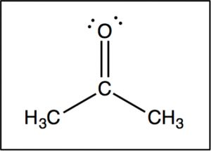
Now let us compare this spectrum to that of acetone. As we might predict, this spectrum has only two peaks in it because acetone only has two types of carbon, but what is even more interesting is that the C=O carbon appears at such low field, around 205 ppm. This means that the C=O carbon must be very electron deficient—much more so than a carbon single-bonded to an oxygen (C–O) in an alcohol, which appears around 64 ppm (as shown in the spectrum of 1-propanol) . This is direct evidence for a phenomenon that we will see time and again, which is that the C=O carbon is highly electron deficient and is very susceptible to nucleophilic attack. Note that the spectrum of acetone also shows this highly downfield shifted peak corresponding to the C=O carbon.
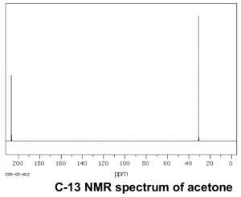
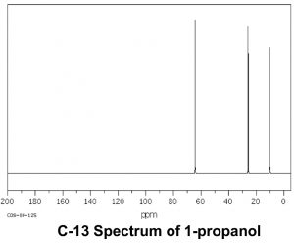

H-1 (proton) NMR:
While C-13 NMR provides information about how many chemically distinct carbons there are in a compound, and something about their electronic environments, it does not tell us anything about how the molecules are organized or which carbons are connected together. For that information, we often turn to NMR spectroscopy using the H-1 isotope. There are a number of advantages to H-1 NMR: H-1 is the naturally-occurring, most-abundant isotope of hydrogen, and is much more abundant than C-13. The result is that the concentration of H-1 in a sample is much greater than the concentration of C-13. It is therefore easier to obtain a spectrum and instruments with a lower field can be used. As we will see, H-1 NMR can provide information about which atoms are connected to each other. On the other hand, the resulting H-1 NMR spectra are more complex.
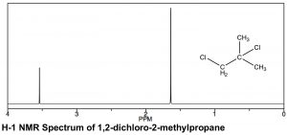
The basic theory of both H-1 and C-13 NMR are the same and, in fact, both spectra can be recorded on the same instrument. The sample is placed in a magnetic field that splits the spin states of the H-1 nuclei; the energy required to flip the nuclei from one spin state to another is detected and is transformed into a spectrum such as the one below.
There are similarities and differences in the appearance of H-1 and C-13 NMR spectra. As can be seen in the spectrum of 1,2-dichloro-2-methylpropane (←), the scales over which the spectra are recorded are different. Both involve a chemical shift from a reference peak at 0, (TMS [tetramethylsilane] is used in both), but the shift range (often referred to as δ, as well as ppm, in proton NMR) is smaller for H-1 compared to C-13 NMR. Typically an H-1 NMR spectrum is recorded between 0-10 ppm (as opposed to 0-200 for C-13), although in this case it is truncated because there are no peaks between 4–10 ppm. That said, the same trends in chemical shifts are observed: the more de-shielded the atoms (in this case protons) are, the further downfield they appear. In the 1,2-dichloro-2-methylpropane spectrum above there are two peaks corresponding to the two types of chemically distinct hydrogens (that is, the two identical –CH3 and the –CH2 group). The peak’s lowest field, around 3.6 ppm can be assigned to the CH2 (methylene) group, which is directly attached to the electron withdrawing chlorine atom, while the second peak, corresponding to the six equivalent hydrogens of the two methyl groups, is further upfield, around 1.6 ppm.
In a proton NMR spectrum, the area under the peak is proportional to the number of protons that give rise to the signal. By integrating the area under the peak, we generate an estimate of the relative numbers of hydrogens giving rise to each signal. In the spectrum of 1,2-dichloro-2-methylpropane the ratio of the two peak areas is 1:3, thus supporting our assignment of the downfield peak to the CH2 and the upfield peak to the two equivalent –CH3 (six) methyl hydrogens. As a technical note, C-13 NMR signals are not reliably proportional to the number of equivalent carbons involved: they are dependent on the number of H’s attached to them and so integration cannot provide a reliable estimate of the proportions of the types of carbon in a compound.
Spin-Spin Splitting
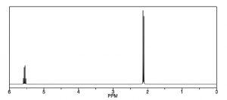
Another way that H-1 NMR differs from a C-13 NMR is shown in the spectrum of 1,1-dichloroethane , which has two types of equivalent hydrogens. Each type gives rise to a distinct signal but each of those signals is split into multiple peaks. The upfield signal around 2 ppm, from the 3 equivalent H’s of the methyl group, appears as a doublet (two separate peaks) because each of the hydrogens in the methyl group is affected by the magnetic field generated by the neighboring hydrogen’s possible spin state, thereby altering (adding to or subtracting from) the atoms’ local field. The downfield signal around 5.5 ppm is due to the single proton on C-1, de-shielded because of the proximity of the electronegative chlorine, but now it appears as a quartet.
For example, consider a molecule that has two non-equivalent protons (Ha and Hb) on adjacent carbons (→). Ha will experience the magnetic fields generated by Hb which has two spin states, which will produce two possible electronic environments for Ha, resulting in two signals for Ha.
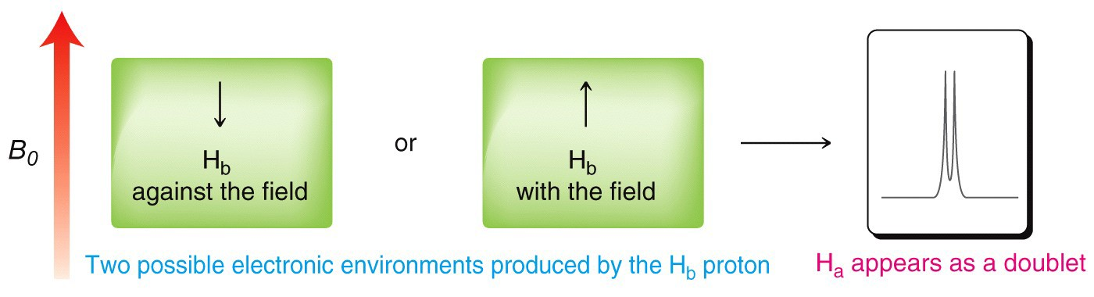
A single proton produces a doublet in the adjacent signal
The splitting effect is small and does not extend (in a significant way) beyond the protons on adjacent carbons. The local magnetic field also depends on the number of protons that do the splitting, for example if there are two protons on the adjacent carbon, the signal is split into a triplet, and for three adjacent protons the signal is a quartet. The general rule is that for n adjacent protons, the signal is split into n+1 peaks.
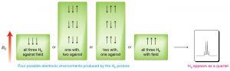
Three adjacent protons produce a quartet in the adjacent signal
The width, in Hz, of the splitting (that is, the distance between the split peaks) is called the coupling constant j. The value of j between the protons on adjacent carbons is the same. The number of split peaks therefore allows us to determine how many hydrogens there are on adjacent carbons, which in turn allows us to determine the how the atoms are connected together in the structure. Signals that are split by more than one kind of hydrogen can get quite messy as shown in the spectrum of D-glucopyranose (→).
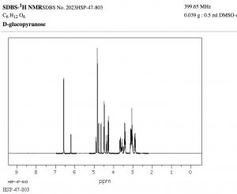
Fortunately, there are ways to simplify such spectrum by selectively irradiating particular frequencies but that is beyond the scope of this course (but something you can look forward to in the future!).
That said, this raises another question: why do C-13 NMR spectra appear as single lines for each carbon? Shouldn’t the carbon signals also be split both by adjacent carbons, and by the hydrogens attached to them? There are two reasons that this does not happen. First, the abundance of C-13 is so low that the probability of finding more than one C-13 in a molecule is very low; in the absence of a second (or third) C-13, no splitting by adjacent carbon nuclei will occur, (recall C-12 does not generate a spin-based magnetic field). Second, when we originally introduced C-13 NMR spectroscopy we presented a simplified model. In fact, the carbon signals are split by the adjacent protons, but this leads to a complex spectrum that is often hard to interpret. Therefore, for most purposes, the sample is irradiated with a radiofrequency that promotes all the hydrogens to the higher-energy spin state. The carbon nuclei do not experience two (or more) magnetic field environments, and therefore only one signal is produced. This technique is called broadband decoupling, and these types of spectra are the most common examples of C-13 NMR.
Solvents and Acidic hydrogens in the NMR
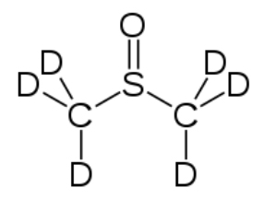
Most NMR spectra, whether C-13 or H-1, are recorded in solution (although it is possible to obtain spectra on solids—as evidenced by the fact that we can obtain MRI data on people, that say, people [biological systems] are mostly [> 70%] water). However, since the solvent is usually present in much greater concentration than the actual sample, as long as we use a solvent that does not generate a strong signal the effects of the solvent can be minimized; typically this involves solvents in which the hydrogens present are replaced with deuterium (D), an isotope of hydrogen that is not NMR active. Common solvents are CDCl3, (deuterated chloroform) and dimethylsulfoxide d-6 (DMSO) (→).
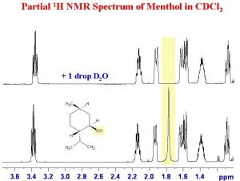
Another instance in which deuterated solvents are used is to detect the presence of potentially acidic hydrogens. Proton transfer is a rapid and reversible process, and any hydrogen attached to an electronegative element is potentially available for exchange by reacting with even very weak base such as water. In fact, by adding a drop of D2O (“heavy” water) to the NMR sample, the signal from any O–H or N–H disappears as the H is replaced by D.
As shown here (→), the signal from the OH (shaded in yellow) disappears when the sample is shaken with D2O.

Questions to Answer:
Type your exercises here.
- Draw a diagram of an atom and use it to explain why the electron density surrounding the nucleus affects the strength of the external field required to bring the nucleus to resonance (to flip the spin state).
- Using the table below, use your diagram from above and explain a) why the signals for C-1 in the three compounds are different, and b) why the signals for C-1 and C-2 are different (for any single compound).

Chapter

Chapter 3: Conformations and Configurations: the consequences of the three- dimensional nature of carbon compounds.
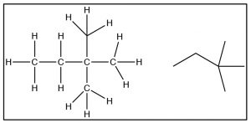
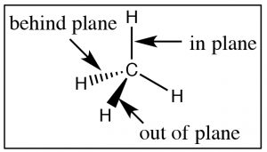
Now it is time to turn our attention to the ways in which the three-dimensional structure of organic molecules affects their stability, reactivity, and the ways in which they interact with one another and with solvent molecules. To begin with, we will consider compounds that are composed of sp3 hybridized (i.e. tetrahedral) carbons which are inherently three-dimensional since each of the four bonds points toward the vertex of a tetrahedron (a three-dimensional as opposed to a planar or two-dimensional organization). It is important to remember and understand this aspect of organic chemistry, since we tend to represent organic compounds in ever more simplified (and abstract) two-dimensional diagrams. The Lewis structure of a molecule is a 2-D (that is, flat) cartoon that contains a great deal of information (if you know how to look for it). As we move to even more abstracted representations of molecular structures it is easy to forget about the wealth of information encoded within a structural diagram. This includes both how many carbons and hydrogens are present and the three-dimensional relationships between the parts of the molecule. While there are ways to show the three-dimensional nature of sp3 hybridized carbon (such as through the use of wedge-dash structures à), they can be quite cumbersome when it comes time represent complex molecules and we don’t often use them unless we want to specifically address the three-dimensional arrangement of atoms within the molecule. The other idea that gets lost in a static two-dimensional representation is that the bonds between sp3 hybridized carbon atoms are sigma (σ) bonds; the two parts of the molecule linked by a σ bond can rotate relative to each other, without disrupting the overlap between the bonding orbitals. At room temperatures the carbons in most σ bonds are rotating freely and rapidly with respect to each other, although we have to portray them in a fixed orientation when we draw them.

Conformations of Organic Molecules
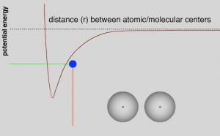
While most C-C single bonds do allow for free rotation, there are energy costs that are associated with such rotations which arise from the fact that as the carbons rotate around the bond axis, the distance between groups attached to each carbon (even if they are hydrogens) changes. To understand the implications of this changing distance between these groups, recall our previous discussions of London dispersion forces and van der Waals interactions. As two uncharged atoms, molecules, or groups within a molecule approach each other there is initially an attraction between them due to the instantaneous and induced dipoles in their electron clouds (London dispersion forces). If the molecules (or parts of a molecule) also have a permanent dipole (i.e. the molecule is polar), then there is an additional attractive (or repulsive) interaction in the form of dipole-dipole interactions and hydrogen bonding. Attractive interactions lead to a decrease in the potential energy of the system and repulsive interactions lead to an increase. Even when the interaction is attractive, as the interacting molecules (or regions of molecules) get closer, the repulsive interactions between their electron clouds increase and the potential energy of the system increases. This gives rise to the familiar (or at least it should be familiar) potential energy v distance curve that we have encountered many times in CLUE.
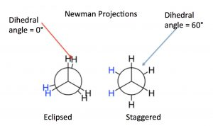
While we have previously discussed this change in potential energy for separate molecules (and atoms), the same principles apply as parts of molecules approach each other, for example, because of rotations around C-C sigma bonds. The different rotational structures of a molecule are called conformations, and one of the best ways to represent different possible conformations is called the Newman projection. In a Newman representation, we look down the C-C bond of interest; this has the effect of making the groups (atoms, etc.) attached to each carbon (known as substituents) appear to be at angles of 120° to each other (this is due to the perspective from which we are viewing the molecule; the bond angles are still 109°). If we imagine the carbons rotating with respect to one another, we can see how the relative distances between the groups on each carbon change with the “dihedral angle” between the substituents on the front and back carbons. The two conformations shown for ethane are the fully eclipsed conformation, where the dihedral angle is equal to 0°, and the staggered conformation, where the dihedral angle is 60°. As the rotation around the C-C bond continues, these two conformations repeat.
Based on NMR studies at low temperature, these two conformations are not equally stable, the staggered conformation is about 13.8 kJ/mol more stable than the eclipsed conformation. At room temperature, this energy difference is negligible, that is, a typical molecular collision supplies much more energy, and the two conformations rapidly interconvert between one another. As the sample is cooled down, however, the energy available from collisions is reduced (because the molecules are moving more slowly) and we can actually find, based on NMR studies, that we can see different conformations present in different proportions—in part because in the eclipsed conformation the hydrogens on the two carbons come closer to their van der Waals radii and so begin to repel one another, raising the potential energy of the molecule.
Potential Energy v Dihedral Angle for Butane
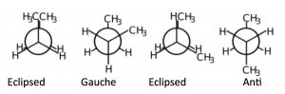
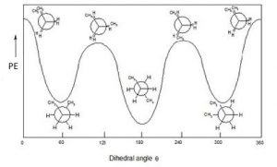
If we look at butane (→) down the C2-C3 bond axis we can see a more exaggerated version of this repulsion due to the presence of the bulkier methyl groups. There are two types of eclipsed conformations, and two types of staggered conformations—the anti conformation where the methyl groups are 180° from each other, and the gauche conformation where they are 60° apart. If we plot their relative energies vs dihedral angle we can see how the potential energy changes as the larger centers of electron density (the methyl groups) get closer to one another. The anti conformation is the most stable and the eclipsed methyl group conformation is the least stable. Again, these energy differences are not all that large. The difference between the highest-energy eclipsed conformation and the lowest-energy anti conformation is about 21 kJ/mole, which is not a big enough barrier to prevent rotation at room temperature.
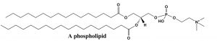
By applying these ideas, we can predict conformations of long-chain alkanes as well. We usually draw long-chained alkanes in the most stable (all-“anti”) conformation, but there are occasions when the gauche conformation is also present—the result of this conformation is a bend or kink in the chain. This has implications how long-chained alkyl groups interact with one another, and influences the molecules’ physical properties, such as melting point. Many biologically-significant lipid molecules contain long-chain alkane groups. For example phospholipids form the structural basis of biological membranes. These lipids are a major component of the cell membrane that is the permeable barrier that surrounds the cell. The long-chain fatty acids that make up the membrane are typically found in the all-anti conformation, which is not only the lowest-energy conformation, but it also makes for the largest surface area. If the long-chains were in the gauche conformation, they would be more clumped up and have a lower surface area. Having a large surface area means that the chains are more likely to attract each other by London dispersion forces, which also stabilizes the structure of the membrane.

Questions to Answer
- Construct an explanation for why the potential energy of ethane changes as you rotate around the C-C bond. What is the interaction that is raising the potential energy? Where does the energy come from—so that the rotation around the C-C bond can occur?
- Construct a potential energy v dihedral angle diagram for propane, as you look down the C1-C2 bond. Label the maxima and minima with the corresponding Newman projections.
- Draw a schematic picture of a lipid bilayer made up of phospholipids (no need to draw every bond and atom). What would be the effect if the C-C bonds in phospholipids took up the less stable gauche conformation?
Conformations of Cyclic Compounds
As we will see, cyclic compounds show some of the same kinds of energy changes with rotations around C-C bonds; conformations change from eclipsed to staggered. However, when the molecule is cyclic two other factors come into play and they complicate things a little. The first is that, by their very nature, ring compounds are more constrained; it is not possible to do a full 360º rotation around the C-C bonds without breaking a covalent bond (which requires more energy than is available through thermal collisions). There is, however, a range of rotations that most ring compounds can move through. The other factor involves rings that would have bond angles that are inconsistent with the ~109° bond angle that is usually found for sp3 hybridized carbons.
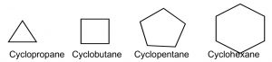
For example, consider the C-3 to C-6 cycloalkanes (→). We can calculate the bond angles for these regular polyhedrons if they were flat, that is, two-dimensional: they would range from 60° for cyclopropane to 120° for cyclohexane, both far outside the range of sp3 bond angles. Not surprisingly, cycloalkanes behave in a range of different ways to minimize the strain imposed by both bond angles and the constraints on bond rotation. This ring strain can be experimentally determined by measuring the heats of combustion for cycloalkanes: the energy released by this reaction is a proxy for the stability of the particular cycloalkane. To compare among cycloalkanes, we need to calculate the heat of combustion per CH2 group, and as we will see shortly, six-membered rings do not, in fact, have any ring strain so we can determine the stabilities of differently sized rings compared to cyclohexane.
Heats of Combustion for the Cycloalkanes
Cyclopropane is actually the worst-case scenario: it has the highest strain because it is forced to exist as a flat, 2-D ring (since three points define a plane). If we look at a Newman projection of cyclohexane we can see that all the C–H and C–C bonds are eclipsed, which raises the potential energy of the molecule.
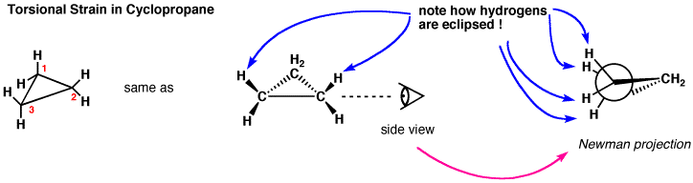
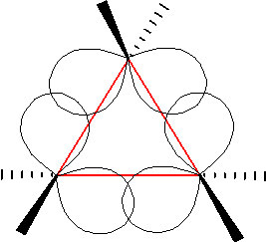
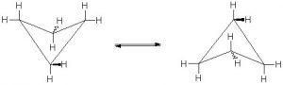
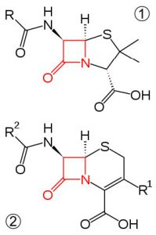
In an attempt to relieve some of the strain imposed by having a 60° bond angle, cyclopropane has bent bonds (sometimes called banana bonds). The electron density bulges out rather than being located between the two carbons, thus making the bond angle a little larger—however, there is still considerable strain. The combination of angle and eclipsing strain (also called torsional strain) explains why cyclopropane is a much more reactive species than its straight-chain analog, propane. There are a few naturally occurring three-membered ring compounds, but in general they are quite chemically reactive since the ring structure is quite unstable. Four-membered rings are more stable—they have less angle strain because the ring is bigger and because the larger ring can bend a little, which has the effect of relieving some of the torsional strain. At room temperature, the cyclobutane ring is constantly bending so that each carbon can be relieved of a little of the strain. There are a number of important four-membered ring compounds that you may have run across: the antibiotics penicillin (1) and cephalosporin (2) have a four-membered amide ring as part of their structure (à). Normally (as we will see), amide groups are relatively stable (chemically nonreactive), but because this amide in the ring structure is constrained in a high-energy, four-membered ring, it is much more reactive than normal. Antibiotics act by targeting some part of the biochemistry of bacteria that will not affect the host organism (us). These antibiotics interfere with the synthesis and replication of the microbial cell wall, which is a type structure that most animals do not have (we have cell membranes).
Ring stability improves with cyclopentane. If the molecule were flat, it would have almost exactly the sp3 bond angles between the ring carbons; this would mean, however, that all the bonds would be in the eclipsed conformation and the resulting torsional energy would be high. To relieve torsional strain the molecule bends into a sequence of “envelope” type shapes—again in dynamic and rapid motion so that the energy associated with the eclipsed conformation is reduced.
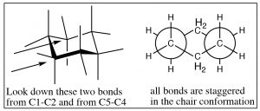
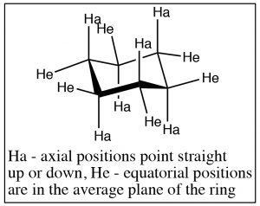
This brings us to cyclohexane, the “goldilocks” of cycloalkanes. The bending of the cyclohexane molecule can completely relieve all angle strain and torsional strain. In fact, cyclohexane is as stable as hexane—there is no ring strain associated with a six-membered ring. The most stable conformation of cyclohexane is known as the chair conformation, because one might imagine it as a chair with a footrest, seat, and back. In the chair conformation all the bonds are staggered, and all bond angles are 109º.
The groups attached to the cyclohexane ring can assume two types of positions: the positions that seem to point straight up or down are called axial, and the ones that are more in the plane of the ring are called equatorial. On each carbon, there is one axial and one equatorial position as shown (↑).
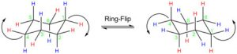
Chair conformations can “ring-flip” as shown below. Here the structure on the left has all the axial positions in blue and the equatorial in red. Just as with the other rings, the ring is in constant motion and the bonds are rotating (as far as they can within the confines of the ring) so that the ring will “flip” back and forth between chair conformations, by bringing the chair back down and the footrest up. When this happens, axial substituents are converted to equatorial and vice versa. It’s worth noting that axial components can be “above” or “below” the ring plane; and the equatorial positions are also above or below the plane—but on average they lie in the plane of the ring. The other thing to notice is that while groups can flip between axial and equatorial, they do not flip from above to below. That is an axial substituent above the plane becomes and equatorial substituent above the plane.
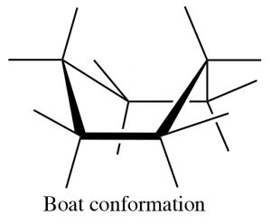
There are a number of conformations between one chair conformation and another, for example the boat conformation (→). This is a much more high-energy species since many of the bonds are eclipsed and there is a strong repulsion of the H’s at the 1 and 4 position.
Mono-substituted cyclohexanes:
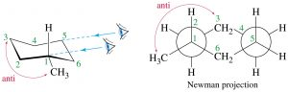
Now consider methylcyclohexane, the methyl group can be either axial or equatorial. When we look at Newman projections we see that the equatorial methyl group is in a more stable position, it is anti to the C-C bond in the ring, whereas an axial group is gauche to the ring C-C bond.
Equatorial methylcyclohexane
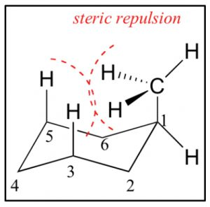
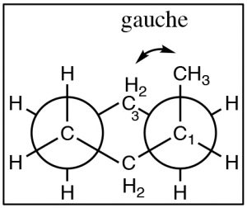
In addition, an axial methyl group is also close to the axial hydrogens on carbons 3 and 5 in what is called a 1.3 diaxial interaction—which introduces another source of strain. Therefore, the more stable conformation is always equatorial.
Axial methylcyclohexane
For a methyl group the difference in energy is still quite small, and both axial and equatorial are present at room temperature, but as bulkier groups are introduced onto the ring, the preference for equatorial becomes even stronger. For example, cyclohexane rings with isopropyl (–CH(CH3)2) or t-butyl (-C(CH3)3) groups are locked into conformations where these groups are equatorial.
Disubstitutedcyclohexanes: When we get to cyclohexane rings that have two (or more) substituents, we need to consider whether the substituents are on the same (cis) or opposite (trans) sides of the ring. This is easiest to see if we first draw the ring flat and use a wedge dash representation to show relative positions of the groups. In these representations we don’t know whether the methyl groups oriented in axial or equatorial configurations (but we can figure it out), but what we do know is that these are different compounds, they cannot be interconverted by ring-flips like axial and equatorial—which are conformations of the same compound. To interconvert we would have to break the C-C bonds in the ring. These two compounds are called geometric isomers—they have the same molecular formula and connectivity but their atoms have a different (permanent) relationship in space (a different geometry).
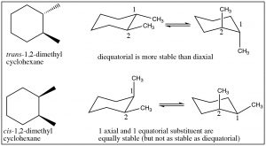
We can determine the actual conformations that each isomer can take up by drawing the chair representation, and we can ring-flip to find the most stable conformation. Remember that equatorial is always favored, so when we do this we can see that the trans isomer has a conformation in which both methyl groups are equatorial; whereas the cis conformation has both conformations where one is axial and one is equatorial. Therefore, we can conclude that the trans isomer is more stable than the cis. Note that the groups do not change their cis or trans relationship when the ring-flips.
It is possible to do this kind of analysis for 1,3- and 1,4-disubstituted cyclohexanes, and even for more complex substances. For example, most sugars actually exist as ring structures in which the many alcohol groups (which are bigger than hydrogen) take up the equatorial position. For example, glucose exists as cyclic six-membered rings (one of the atoms is an oxygen but the principle is the same).
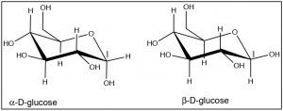
Note how almost all of the OH groups take up the equatorial position, except for the OH group on C-1 in α-D-glucose. These two forms of glucose are actually separate compounds. It is not possible to convert α-D-glucose to β-D-Glucose simply by a ring-flip (convince yourself that this is true by making model). We will see much more of these cyclic sugar molecules later in the course.

Questions to Answer
- Use excel to plot total ring strain vs ring size (number of CH2 units) as shown in Table 1. In addition use these total ring strain values for C7H14 (6.3 kJ/mol), and C8H16 (9.6 kJ/mol), C9H18 (12.6 kJ/mol). What trends do you see? How do you account for them?
- Draw two chair forms of cyclohexanol, which one is most stable? Is this a geometric isomer or a conformational isomer.
- Draw chair forms of cis and trans-1,3-dimethylcyclohexane and predict which geometric isomer is the most stable. Do the same for cis and trans-1,4-dimethylcyclohexane.
- Does 1,5-dimethylcyclohexane exist?

Optical Isomerism
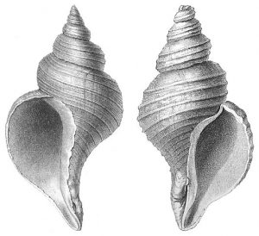
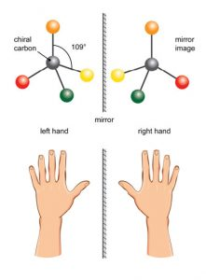
In the previous section we looked at conformational and geometric stereoisomerism, by which we mean that molecules that have the same molecular formula and connectivity of the atoms, but that have different arrangements in space. Conformational isomers can be interconverted by rotations around C-C bonds while geometric (cis/trans) isomers have permanently distinct geometries. Now we introduce another type of stereoisomer, known as optical isomers. Optical isomers have a property called chirality—they are mirror images of one another. While they have exactly the same overall shape, they are not superimposable on one another. One obvious example of macroscopic objects that are chiral are your hands. Your hands are mirror images of each other, but they are not superimposable on one another placing one hand on top of the other shows you that they are different as does the fact that a left hand glove does not fit your right hand. There are many objects in the world that are chiral. At the molecular level, many molecules are chiral—and it is often said that they exist in left- and right-handed forms.
The simplest examples of chiral molecules are those that have a single carbon atom with four different substituents attached. While these compounds have exactly the same structure, connectivity and relationship between the atoms in space, they are different in the same way that a right and left hand are different: they are known as enantiomers—non-superimposable mirror images of each other. An equal mixture of enantiomers is called a racemate (racemic). Under normal laboratory conditions it is difficult to differentiate between a pair of enantiomers. If you were able to separate the left- from the right-handed forms, you would find that they have the same structure, the same physical and chemical properties, that is, the same melting point, boiling point, solubility, and chemical reactivity. Nevertheless, they are not identical—they can be distinguished by the way they interact with certain types of light.
Electromagnetic radiation can be considered as being composed of electrical and magnetic (e-m) waves that oscillate perpendicular to each other and to the direction of wave transmission. But a beam of light is not a single e-m wave; it consists of many such waves. The orientation of the various e-m waves within the beam are independent on one another and oriented randomly with respect to the direction of the beam. We can simplify an e-m wave by passing the light beam through what is known as a polarizer. A polarizer is a transparent material (it allows light to pass through it) composed of oriented crystalline that block all e-m oscillations that do not align with the crystal structure. The result is that the light that passes through the polarizer oscillates in only one plane; known as plane-polarized light. You can now make a prediction; if you place a second polarizing filter in the same orientation as the first, in the path of a plane-polarized light beam, the beam will pass through, but if you rotate the second filter by 90º to the first, the beam will be absorbed (blocked). This is an experiment you can do if you have polarizing sunglasses, which reduce glare by allowing light vibrating in only one direction to pass through. If the plane-polarized light interacts with an asymmetric electric field (such as the one generated by a chiral molecule), the plane of vibration will be rotated. We can measure the angle of rotation using another polarizing lens and in this way, we can detect the presence of chiral molecules. On the other hand, passing plane-polarized light through a racemic mixture (with 50% of each enantiomers present), or through a solution containing a non-chiral solute, will not affect the direction of the polarization plane.
In a sample that rotates the plane of a plane-polarized light beam to the right, the enantiomer is designated as the (+ or dextrorotatory) isomer; if it rotates the plane-polarized light beam to the left it is referred to as the (– or levorotatory) isomer. This phenomenon is direct evidence of the existence of chiral molecules. The amount of rotation is dependent on the concentration of the substance in the solution, the path length of the sample tube, the wavelength of the incident light, and also the nature of the substance itself. We often report these rotations as a specific rotation, where all of these variables are defined, so that compounds can be identified by this property. Because of this phenomenon, substances that are chiral are said to be optically active.

Configurations of Chiral Molecules: the Cahn-Ingold-Prelog Convention
Since we cannot distinguish between enantiomers using the naming conventions that we have considered so far, we have to invoke a new convention to unambiguously specify the arrangement of bonds around a chiral center which is known as the configuration (not to be confused with conformation). The most common naming strategy used is referred to as the Cahn-Ingold-Prelog Convention: a set of rules that assigns a configuration (known as R or S) to a specific chiral (or stereogenic) center. An important fact to remember is that the configuration assigned to a molecule in this way has nothing to do with the molecule’s observed optical rotation.
Cahn-Ingold-Prelog Convention
- Look at each atom directly connected to a chiral carbon and rank by atomic number (Z); highest first (e.g. O>N>C). For isotopes the higher atomic mass receives a higher priority (e.g. D>H).
- If you can’t make a decision here, go out to the next atom in each chain—and so on until you get to the first point of difference. So for example, –CH2CH2OH takes priority over –CH2CH2CH2OH .
- Multiple bonds are equivalent to the same number of single-bonded atoms. For example, CH2=CH2 takes priority over –CH2CH3 because it is counted as if it were CH2(CH3)2 .
- Now place your eye so that you are looking down the bond from carbon to the lowest ranking group.
  - If the sequence, highlow, is clockwise: R (Rectus).
  - If the sequence, highlow, is counterclockwise: S (Sinister).

The skill of assigning configurations is one that takes practice and it is necessary to understand what the rules mean. Some common errors that people make are:
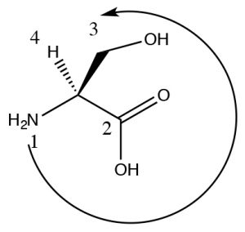
(a) Looking at the substituent as a whole rather than looking only at the atom (or the first atom that is different). -CO2H. " width="138" height="131" srcset="https://openbooks.lib.msu.edu/app/uploads/sites/37/2020/09/OCLUE_Ch03_027-300x284.jpg 300w, https://openbooks.lib.msu.edu/app/uploads/sites/37/2020/09/OCLUE_Ch03_027-65x61.jpg 65w, https://openbooks.lib.msu.edu/app/uploads/sites/37/2020/09/OCLUE_Ch03_027-225x213.jpg 225w, https://openbooks.lib.msu.edu/app/uploads/sites/37/2020/09/OCLUE_Ch03_027-350x331.jpg 350w, https://openbooks.lib.msu.edu/app/uploads/sites/37/2020/09/OCLUE_Ch03_027.jpg 408w" sizes="(max-width: 138px) 100vw, 138px">So for example, O > N > C, but also –OH > –CO2H even though CO2H is overall larger, it is attached by a C which is a lower priority than an O. Consider the example of this stereoisomer of the amino acid serine (It’s the L isomer but we will get to that in a while). The highest ranking group is the N (since its atomic number is higher than C), next is the CO2H because there are an equivalent of three C-O bonds on that carbon and only one C–O bond on the CH2OH group. Since the H is pointing back, we can now directly see that 123 is counterclockwise and the configuration is S.
(b) Forgetting to look down the bond from the C to the lowest ranking group (often, but not always, an H). If you look down any other bond (or from the low ranking atom to the carbon) then you will almost certainly get the wrong assignment.
If the molecule is not drawn with the lowest ranking group pointing away, there are a number of options:
(1) Particularly when you are first getting started, you should MAKE A MODEL. There is research evidence that shows using an actual, physical model is the best way to learn this particular skill. Be careful to construct the model so that it looks exactly like the drawing. Then you can physically rotate it and identify the configuration.
or
(2) You can switch two groups—either redrawing or in your imagination (we strongly suggest you redraw it), so that the lowest group is now pointing back out of the plane. Then the configuration you get will be the opposite of the actual configuration.
or
(3) You could imagine yourself moving in space to look down the bond from C to the lowest ranking group. This is quite difficult for some people.
or
(4) You could rotate the molecule in your head so that you are looking down the bond from C to the lowest ranking group. This is also quite difficult for some people.
You should always use at least two methods – and make sure you get the same answer both
times!
After a while, this skill will come more easily to you.
R and S and D and L isomers:
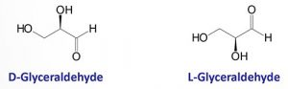
As you probably already know, most biological molecules are chiral. For example, all of the naturally-occurring amino acids (aside from glycine) have a chiral carbon (see above), sugars have several chiral centers, and so the large molecules made up from these smaller monomers (such as nucleic acids, carbohydrates, lipids, polypeptides, and a range of smaller molecules) contain one or more (sometimes many) chiral carbons. For historical reasons, however, most simple biological molecules (that is the monomers from which polymers are constructed) are referred to as either D or L isomers, rather than R or S. The convention for naming substances as D or L dates back to the early 1900s and has to do with a compound’s similarity to glyceraldehyde which exists as a pair of enantiomers. The enantiomer that rotated light to the right (+) was identified as D, and the other one (–) as L. For example, the naturally-occurring amino acids are the L-isomer, and many of the simple sugars are the D isomer. It should be noted that a compound such as glucose can be identified as D-glucose, even though it contains 5 chiral centers. The D/L nomenclature is applied to the molecule as a whole, whereas the R/S nomenclature applies to a specific chiral carbon. The D/L nomenclature does not, in fact, predict the direction of rotation of polarized light in most larger molecules—but it is a much simpler way of naming compounds with more than one chiral center.
Speaking of which…
Molecules with two or more chiral (stereogenic) centers
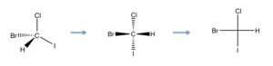
Molecules that have more than one chiral center bring in another level of complexity. It can be quite difficult to draw molecules accurately that have more than one chiral center, and therefore we often turn to a representation that is more stylized than the wedge-dash; this is known as the Fischer projection, named after Emil Fischer (1852-1919) who elucidated the structures of sugars (and who also introduced the D/L nomenclature). Fischer projections are written as vertical and horizontal lines. The carbon backbone is the vertical line, and the other substituents are horizontal. We assume that the horizontal bonds are coming out towards you (↓). This convention makes it easier to draw and to assign configuration to the chiral centers (this structure is S). Now if we look at Fischer projections for a four carbon sugar that has two chiral centers, we see that there can be several possibilities.
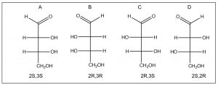
Numbering from the aldehyde carbon as carbon 1, both C2 and C3 are chiral. We also see that there are two pairs of enantiomers: A and B are mirror images of each other and so are C and D. In general, for a molecule with n chiral centers, there are a possibility of 2n stereoisomers. When we look at the relationship between isomer A and isomer C (or D) we note that they are not mirror images of each other (the chiral centers are the same at one carbon and different at the other). These compounds are known as diastereomers, that is, stereoisomers that are not mirror images of one another; they do not have identical distances between all of their atoms. Because they have different arrangements in space, diastereomers have different properties, both physical and chemical, and can be separated. In fact, the two compounds have different names: A and B are called erythrose while C and D are called threose. Diastereomers actually belong to the same class of stereoisomers as cis/trans ring compounds (and alkenes), they have the same molecular formula and connectivity, but have different arrangements in space and cannot be interconverted by bond rotations. In contrast, enantiomers have the same atomic arrangements in space, but cannot be superimposed on one another.
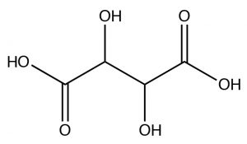
So now you might well ask yourself, given that stereoisomers have the same physical properties: how could you possibility separate enantiomers? The existence of enantiomers was first observed by Louis Pasteur (1882-1895), who was actually able to identify different crystalline forms of tartaric acid (actually, the potassium salt), which turned out to be the two enantiomers (but not the meso isomer), which appeared as tiny crystals that were mirror images of each other. In fact, this selective recrystallization is highly unusual, and it is normally not possible to selectively recrystallize isomers.
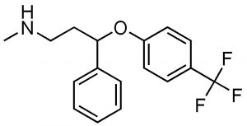
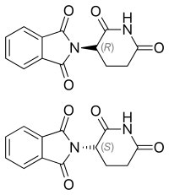
So why does the stereo-asymmetry of a molecule matter? The answer is that organisms (living systems) are—apparently due to an accident of their origin and subsequent evolution—asymmetric at the molecular level. For example, polypeptides and proteins are polymers of amino acids. While organisms can make and use both D- and L-form amino acids, all of the amino acids used in polypeptide/protein synthesis (with the exception of glycine, which is achiral) exist in L- and D- forms. Only L-form amino acids are used in polypeptides and proteins. The use of only L-form amino acids means that each polypeptide/protein has a distinct three-dimensional shape that influence how other molecules bind to it. For example, a particular drug can be designed to inhibit a particular enzyme (protein-based catalyst). If the drug is itself chiral, then it is extremely likely that one or the other of its chiral forms will be an effective inhibitor while the others will not. In fact, it is common for drug companies to first patent the racemic mixture of a drug, and then later the purified enantiomers. For example, Fluoxetine (Prozac)(→) is a racemic mixture of the two enantiomers (can you find the chiral center?). In the human body, the two forms of fluoxetine are metabolized into corresponding forms of norfluoxetine, one of which is significantly more active than the other. Another example of the use of a racemic drug is the terrible story of thalidomide, which was marketed in the 1960’s in Europe and Canada as a drug for morning sickness. The original drug was administered as the racemic mixture but we know that it is the R isomer that is the sedative. The S isomer is teratogenic. That is, it causes birth defects in this case associated with the development of limbs. Many children were born without limbs before Thalidomide was removed from the market. Now we know that even the pure R enantiomer racemizes at physiological pH. In fact, Thalidomide was re-introduced to the market because it is one of the few drugs that can be used to treat leprosy.
Non-chiral species with chiral centers.
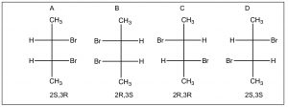
Just because a compound has a chiral (stereogenic) center, doesn’t mean the actual compound is optically active. Remember that the requirement for a chiral substance is that there is no symmetry element. Consider the set of compounds below.
There appear to be four stereoisomers here, but, in fact, there are only three. Isomers A and B are identical due to the a mirror plane through the center of the molecule (bisecting the C2-3 bond), the top half of the molecule is identical to the bottom half. Compounds like this are called meso isomers. The meso isomer is a diastereomer of the pair of enantiomers C and D.

Questions to Answer
- Without looking at the diagram above, construct your own representation and explanation for the various types of isomers that we have encountered. Give an example of each type of isomerism (using two such isomers) and explain how and why they differ from each other and from other types of isomers.
- How is it possible that compounds with chiral carbons are not themselves chiral?
- Do you think it is possible to have a chiral compound that does not have chiral carbons in it? What structural features would you look for? Why?

Questions to Ponder
- Most biomolecules are chiral, how do you think they got that way?
- Most biomolecules are chiral, what are the implications for the synthesis of pharmacologically active compounds?

Recall that this is not the case for sp
or sp hybridized carbon, which also form pi bonds, where the orbital overlap is destroyed by rotation. Therefore, as we will see later, a much higher input of energy is required for compounds with pi bonds to rotate the bonding carbons relative to each other.

Chapter

Chapter 4: Nucleophilic Substitution Part II
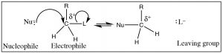
In Chapter 1, we learned about one of the most fundamental reactions in organic chemistry: nucleophilic substitution. Before we move on, it is important to make sure that you have a good understanding of what the terms nucleophile, electrophile, and leaving group mean and that you are able to predict the products for a range of substrate molecules (electrophiles) with different leaving groups and nucleophiles. In this section, we move forward and look at nucleophilic substitution reactions in more detail by examining the evidence that leads us to understand how the mechanisms of nucleophilic substitutions were determined.

Kinetics and Mechanisms:
One of the most powerful sources of evidence for how a particular reaction proceeds comes from the study of reaction rates or reaction kinetics. In such studies, how the rate of a reaction changes is measured as a function of the concentration of each reactant. One of the most common ways of measuring this change is by using a spectroscopic technique. For example, if the compound absorbs in the UV-VIS region of the spectrum, the absorbance is proportional to the concentration. Therefore, if the concentration of the substance changes, it can be measured by changes in the absorbance. The reaction is carried out several times with all but one of the reactants set as constant; then a different concentration of the remaining reactant is added and the rate of the reaction measured. This is repeated for each reactant over several concentrations. The end result of such a study is to produce what is known as the rate equation; for a generic reaction A + B C + D the rate equation takes the form:
Rate = k[A]x[B]y
In this equation, k is the rate constant, and the exponents x and y tell us about how the concentration of each reactant influences the rate. The sum of the exponents (that is, x + y + …) is the order of the reaction. For example, if x = 1, then the rate is directly related to the concentration of A. If both x and y = 1, then the rate is directly proportional to both [A] and [B], and the overall reaction order is = 2. If an exponent = 0 then the rate is not dependent on that reactant concentration, and that reactant can be removed from the rate law equation (since [n]0 =1 no matter what the value of concentration of n is).
The most important idea to remember is that the rate equation only contains the reactants that are involved in the rate-determining step (that is, the slowest step) of the reaction. If the reaction proceeds by a number of steps, then the step with the highest activation energy will be rate-determining, and only those reactants that participate in this step will be present in the rate law. Since the rate law is determined empirically, the rate law provides us with evidence about the mechanism of the reaction.
Evidence for the SN2 Mechanism:
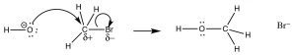
The reaction we discussed earlier in the course is known as an SN2 reaction that is shorthand for Substitution, Nucleophilic, Second order. We proposed a mechanism for this reaction without providing any empirical evidence, but now let us use some of what you have learned to consider more carefully the evidence for this mechanism.
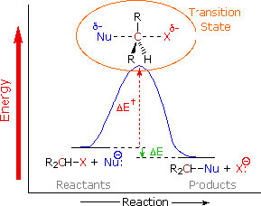
The reaction is second order: the first piece of evidence comes from the kinetic rate law. The rate of reaction depends on both the concentration of the substrate and the nucleophile: rate = k[RX][Nu]. This means that both must be present in the rate-determining step. The simplest explanation that is consistent with this finding is the one we have already proposed: the nucleophile attacks the electrophilic carbon atthesametime as the leaving group leaves. That is, the reaction takes place in one continuous step. A reaction energy diagram in which we plot Energy v reaction progress looks like this (→). In this reaction, there is only one energy barrier, only one maximum in the reaction pathway. The energy of this barrier is known as the activation energy ΔE‡. Looking at the reaction diagram, we also note that the reaction is exothermic (or exergonic if we plot Gibbs energy), since the ΔE of the overall reaction is negative). The species at the peak of the activation energy barrier is known as the transition state, and its structure and associated energy determines the rate of the reaction.
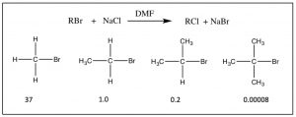
Thestructureofthesubstrateaffectstherate: Perhaps you have noticed in our earlier discussions of nucleophilic substitution that the organic substrate was always either a methyl or primary carbon attached to a good leaving group. The reason was that in the reactions we have considered, both the rate and mechanism of reaction is highly dependent on the structure of the substrate. As the number of methyl groups attached to the primary carbon increases (from 0 for a methyl group itself to three [tertiary]) the reaction rate slows, as shown. The rate of an SN2 reaction for a tertiary substrate is negligible.
So two questions arise: first, why are these reaction rates different? and second, why is this change in reaction rates evidence for the SN2 mechanism? Both can be answered by taking a closer look at the reaction from a molecular perspective. Remember, all of the reactants are dissolved in a solvent; thermal motion leads to their colliding with one another and with solvent molecules. For the nucleophile and the substrate to react with each other, they first have to collide with one another. For a reaction to occur, that collision has to transfer enough energy so that the complex (substrate + nucleophile) can form the transition state—moreover to form the transition-state molecule, the molecules must collide with one another in the correct orientation. Once formed, the transition state can decay to form the products of the reaction.
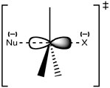
Recall that our proposed structure for the transition state for this reaction has the central carbon connected to five groups: the incoming nucleophile, the leaving group, and the three other substituents that do not change during the reaction (they are not part of the reaction). As the bond forms between the nucleophile and the substrate carbon, and the bond breaks between the carbon and leaving group, the carbon changes its hybridization state. What does that mean? In the substrate molecule, the reacting carbon is attached to surrounding groups (H– or CH3–) with bonds formed from sp3 orbitals. In the transition state, this carbon is still attached to those groups that will remain in the product molecule, but now with bonds formed from sp2 orbitals. Additionally, it is still attached to both the leaving group and the incoming nucleophile using a p orbital to form these partial bonds. You can think of this process as electron density being funneled from the nucleophile through the carbon and out the other side to the leaving group. However, for this to occur the nucleophile can only begin to bond when it approaches from the back of the bond to the leaving group .
At this point, you might well find yourself asking: what does all this have to do with the structure of the substrate? For a reaction to occur, the only productive collisions are those where the nucleophile begins to form a bond with the back part of the sp3 hybrid orbital; but the structure of the substrate influences the probability of such an event. In the tertiary substrates (for example (CH3)3CBr) the approach to the substrate is hindered by the bulky alkyl groups such that the probability of the nucleophile interacting with the reactive center is low. This phenomenon is called steric hindrance and provides an explanation for the order of reaction of SN2 reactions.
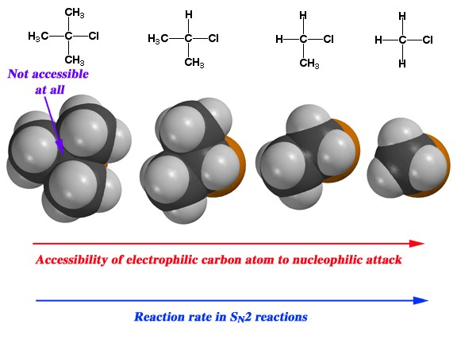
SN2 reactions at a chiral center: Another piece of evidence for the SN2 mechanism is what happens
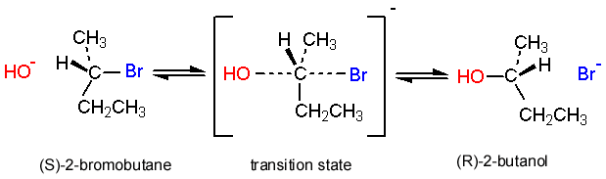
when an SN2 reaction takes place at a chiral center (within a molecule). It turns out that the configuration at that center is changed; the carbon inverts (like an umbrella blowing inside out in the wind) so that an S enantiomer is converted to an R enantiomer. In fact, it is possible to follow the progress of an SN2 reaction involving a chiral center using a polarimeter (the instrument used to measure optical activity); as the reaction proceeds to completion, the optical rotation of the solution changes over time. For each particular substrate, the direction and magnitude of the rotation for the product will be different. This phenomenon is called the Walden inversion and provides another piece of evidence to support the proposed reaction mechanism.
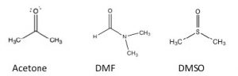
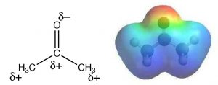
The role of solvent in an SN2 reaction: SN2 reactions are generally carried out in a solvent (why is that?). Empirical studies reveal that such reactions proceed more rapidly when carried out in what is known as a polar aprotic solvent. So what is a polar aprotic solvent? The term means that the solvent is polar but without acidic protons. Examples of polar aprotic solvents are acetone, dimethyl formamide (DMF), and dimethylsulfoxide (DMSO): each is polar, but lacks a potentially acidic proton such as the H that is bonded to the O in ethanol CH3CH2OH or in water H-O-H. Water (and methanol and ethanol) is a polar protic solvent. In a polar aprotic solvent, the negative end of the C=O or S=O dipole is localized to the O, while the positive end is diffuse and delocalized. For example, in acetone, the oxygen has a δ– charge on the oxygen while the positive charge of the dipole is delocalized over both the C and the methyl groups as shown in the electrostatic potential map (→). In practice, polar aprotic solvents can solvate cations well through interactions with the localized negative end of the dipole, but they cannot solvate anions very well. Recall that solvation is an interaction that lowers the energy of the system, making it more stable (less reactive). Therefore, a solvent that leaves the nucleophile (the anion) unsolvated will make it more reactive. In contrast, a polar protic solvent (such as water or ethanol) can solvate the nucleophile, through interactions with the positive end of a dipole that is localized on an acidic H, stabilizing the nucleophile and making it less reactive. In summary, SN2 reactions occur in one step with inversion at a chiral center. Such reactions are generally faster for unhindered substrates and are accelerated when carried out in polar aprotic solvents.

The SN1 Reaction
If you have already taken a laboratory course in chemistry, you have no doubt observed that you do not get a 100% yield for a particular reaction and often more than one product is generated. This is not (generally) a case of faulty experimental technique, but rather reflects the complexity of reaction systems. Given our experience using evidence to support proposed reaction mechanisms, let us take a look at another set of conditions for nucleophilic substitutions. Consider the reaction:
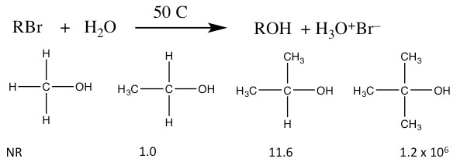
Relative Rates of SN1 Reactions
In this scenario, water is both the nucleophile and the solvent. Water is not a very strong nucleophile and it is a protic solvent. Under these conditions, a nucleophilic substitution takes place, but this reaction differs in several empirically observable ways from the SN2 reactions discussed earlier.
- The rate of reaction depends only on the substrate. The reactivity of the nucleophile is irrelevant. The rate equation for these reactions is: rate = k[RBr]. The reaction is first order, and is therefore named as an SN1 reaction (Substitution, Nucleophilic, First Order).
- The relative rates of reaction for substrates are reversed from the SN2 reaction. That is, reaction rate is higher for the tertiary and lowest for the primary form.
- When a chiral center undergoes an SN1 reaction, the product contains a mixture of both possible enantiomers, rather than the inversion of configuration found with SN2 reactions..
- The reaction is accelerated by polar protic solvents (which slow SN2 reactions).
How can we explain these behaviors? Our assumption is that a different reaction mechanism is involved; compared to the SN2 reactions we have been considering. What might that mechanism be?
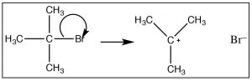
Given that the observed reaction rate is dependent only on the substrate concentration (1) we can assume that only the substrate molecule is involved in the rate-determining step. So how does the reaction begin? We must assume that the reaction involves bond-breaking (since there is nothing else that can happen if there is only one molecule in the rate-determining step. Since bond breaking requires energy, thermal collisions with solvent molecules must drive this bond breaking event. However, we also know that the the solvent molecule does not take part in this step of the reaction (because it is not in the rate law). One possibility is that the bond to the leaving group breaks, resulting in a positively charged carbon (a carbocation) and the leaving group anion . This is the first instance we have seen of a carbocation. The formation of this carbocation requires energy (since the bond is breaking), and we can infer that it has a high activation energy. Carbocations themselves are high-energy species that are very reactive. However, they are different from transition states in that it is possible to generate and detect the a carbocation—it usually has a short lifetime—but we can detect its presence by spectroscopic methods. This is different from a transition state, which is the highest-energy species on the reaction energy profile. Transition states exist for only one molecular vibration and have lifetimes on the order femtoseconds.
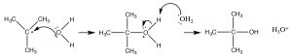
We might expect that such a carbocation would rapidly react with any potential nucleophile present, which in this case is the solvent water molecule.
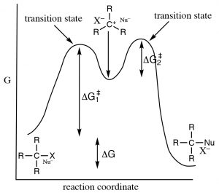
Although water is a poor nucleophile, it will react with the highly reactive carbocation to give the intermediate protonated form. This is followed by a proton transfer to another water (solvent) molecule to form the final product.
Such a mechanism satisfies our experimental observations. It has a slow (rate limiting, high activation, energy requiring) first step, and a faster (lower activation energy) second step. Because of the differences in the activation energies of the two steps, only the first step is involved in determining the overall reaction rate. To figure out which is the rate determining step we can see that ΔG‡ for step 1 is larger than ΔG‡ for step 2.
Whydoesthestructureofthesubstratematter? The formation of intermediate carbocation is the rate-determining step in such a reaction, and therefore it follows that the structure of the carbocation has an impact on the activation energy of the reaction, and therefore its rate. The more stable the carbocation, the lower the energy of the transition state leading to the carbocation. Factors that stabilize the carbocation will also stabilize the transition state and lower the activation energy.
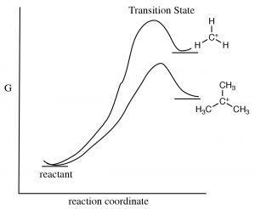
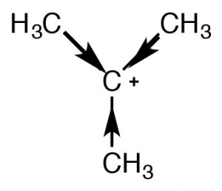
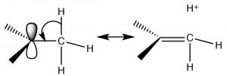
There are two mechanisms that can stabilize carbocations and both predict that, as the number of alkyl groups attached to the C+ increase, so will its stability. One mechanism we have already encountered is induction. The alkyl groups attached to the central carbon, are polarizable and their electron density is attracted towards the positive charge of the central carbon thus delocalizing the positive charge over the alkyl groups. The more alkyl groups attached to the central carbon, the more pronounced this stabilization is. The second mechanism, known as hyperconjugation, also delocalizes the positive charge. In hyperconjugation, the electron density from any adjacent C-H or C-C bond can overlap with the empty p orbital on the sp2 hybridized carbocation, forming a sort of pi bond and, again, delocalizing the positive charge over the rest of the molecule. The more alkyl groups present (attached to the C+), the more pronounced this effect will be.
Together, both induction and hyperconjugation explain why an SN1 reaction proceeds faster with tertiary substrates. The tertiary carbocation is more stable (relative to secondary and primary carbocations) so that the reaction has a lower activation energy.
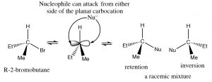
Why do chiral centers racemize? The answer to this question lies in the structure of the carbocation. It is a planar, sp2 hybridized, symmetrical structure. Once formed, it can be attacked from either side by a nucleophile; in simple compounds which side the carbocation will be attacked on involves a random collision event, giving a mixture of enantiomers.
Why are SN1 reactions accelerated by polar protic solvents? Remember a polar protic solvent (such water or ethanol) contains a dipole: a partially positive and partially negative domain.
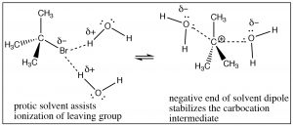
Attack at a chiral center gives a racemic mixture of products.This solvent molecule dipole serves two functions: it can solvate the leaving group, in effect helping to remove it from the carbocation through interactions with the positive end of the solvent dipole and it can solvate the carbocation through interactions with the solvent dipole’s negative domain. In essence, the solvent assists in the ionization of the leaving group, and it lowers the energy of the intermediate carbocation.
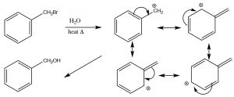
SN1 reactions in resonance-stabilized systems: As we have seen, SN1 reactions tend to occur when a stabilized carbocation intermediate can be formed. In addition to those tertiary cations discussed earlier, which are stabilized by induction and hyperconjugation, there are also occasions when even primary carbocations can be formed if there is a way to stabilize them. For example, any primary carbon that can be conjugated with a pi system can be stabilized by resonance. For example, a benzylic (that is any carbon attached to a benzene ring) carbocation can be stabilized by delocalizing the positive charge into the benzene ring. This lowers the activation energy for the reaction and makes an SN1 reaction possible.
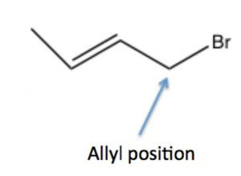
A similar phenomenon can happen in substrates with leaving groups in the allylic position: that is, on the carbon next to a double bond, where the resulting carbocation can be resonance stabilized by delocalization onto the pi system of the double bond. We will discuss this phenomenon in more detail later (in Chapter 7).
SN1 or SN2?
Before we move on, let us review what we know about SN1 and SN2 reactions. While it may seem a little confusing, there are a number of factors that can help us predict what the potential mechanism for a reaction might be, and also to predict the product. As we move forward to more complex reaction systems, it will be important to remember that there is typically more than one pathway a reaction can take, but by understanding how reactions occur we can adjust conditions so that the product we want is the major product. The table below summarizes what we have discussed so far with regards to SN1 and SN2 reactions.
 | N | N
Substrate |  | Methyl>primary>secondary>tertiary
LeavingGroup | Good leaving groups increase rate by lowering the energy of the TS | Good leaving groups increase rate by lowering the energy of the TS Accelerated by strong nucleophiles
Nucleophile | Non-(Bronsted) basic nucleophiles, weak nucleophiles (strong bases promote elimination—see next section)
Solvent | Polar (solvates carbocation) protic (helps pull off the leaving group and solvates it. | Polar aprotic—solvates the cation leaving the nucleophile unsolvated and more reactive.
Stereochemistry | Racemization results from attack at both sides of the planar carbocation | Inversion of configuration if reaction takes place at the chiral center
In practice, tertiary substrates only undergo SN1 and methyl and primary only undergo SN2, it is the secondary substrates where the ambiguity lies, and for that we have to consider the other factors such as solvent and nucleophile strength. However, reactions that generate carbocations may also undergo other reaction pathways besides substitution.

Rearrangements: A consequence of generating unstable carbocations
Reactions that generate carbocations can undergo reaction pathways besides substitution.
Consider this reaction:
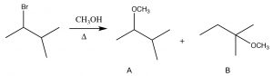
The substrate is a secondary alkyl halide, and since the solvent is methanol, a polar protic solvent, and with a weak nucleophile, we would expect an SN1 reaction to occur, via a carbocation at the secondary carbon. The first product (A) is exactly that, but how did the second product (B) form? To understand this, let us look at the mechanism of the reaction. the first step is the ionization of Br– to leave behind the secondary carbocation (which produces product A). Product B must have been formed by nucleophilic attack of the O in methanol onto a different carbocation. The precursor to B is a tertiary carbocation, which is more stable than the secondary, and it is formed by what is known as a hydride shift in which the hydrogen shifts with its pair of electrons.
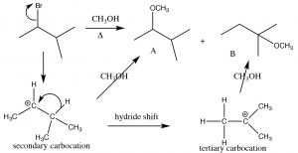
Formation of carbocations is often accompanied by a skeletal rearrangement: Here a 1,2 hydride shift occurs
This rearrangement produces a more stable intermediate that then undergoes reaction; it can also involve the shift of an alkyl group with its electrons from one carbon to the next.
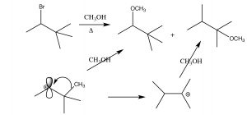

Eliminations
Skeletal rearrangements are a drawback of exposing substrates to conditions in which the leaving group ionizes. Unfortunately, they are not the only complication—there is also the possibility that another type of reaction may occur—an elimination to produce an alkene.
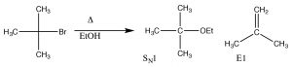
In this case, the reaction proceeds through the same carbocation intermediate, and then a proton is eliminated from a carbon next to the carbocation (a β carbon).
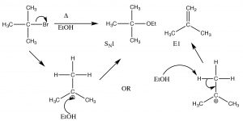
An E1 elimination reaction
This is called an elimination reaction, and it is first-order since the rate-determining step is the formation of the carbocation, and so it is an E1 reaction. In fact, SN1 reactions are often accompanied by E1 reactions (and vice versa). If there is a possibility of forming more than one alkene (because there are different β carbons), usually the most substituted alkene is the major product. For example, alcohols undergo E1 eliminations when treated with concentrated sulfuric acid. In this case, there is no substitution product because the sulfate anion is not a good nucleophile (it is highly stabilized by resonance).
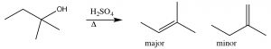
Here, the major product has three alkyl groups on the double bond, while the minor product only has two. In fact, this acid catalyzed dehydration of alcohols is quite a synthetically useful reaction, but if the substrate has the potential for rearrangements (i.e. the resulting carbocation can be stabilized by a hydride or alkyl shift), then there is the potential for the formation of even more products. For example:
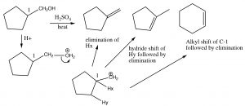
Elimination and Rearrangements
Obviously, these kind of rearrangements and eliminations are not synthetically useful on substrates that are prone to skeletal rearrangements. However, there is an elimination reaction that typically provides us with much more control.
The E2 Reaction.
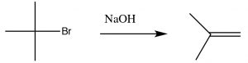
As we will see shortly, the synthesis of alkenes by elimination of H–L (where L is a leaving group) is an important reaction, but we are much more likely to have control over the products if the reaction does not go through a carbocation. That is, if we can simultaneously eliminate both the H+ and the leaving group there is less chance of side reactions. This reaction is an E2 reaction (elimination second order), and is promoted by the presence of a strong base. For example, the reaction of t-butyl bromide with hydroxide (or any strong base), shown above. In this case, there is little substitution product, and instead the base simultaneously removes a proton from the β carbon as shown.
An E2 Elimination
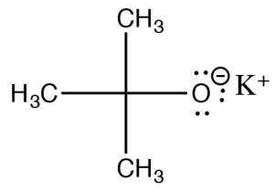
The rate therefore depends on both the substrate and the base: Rate =k[RL][base]—that is, a second order reaction. But wait—didn’t we see that strong bases are good nucleophiles? From the beginning, we have shown that methyl and primary substrates with strong nucleophiles undergo SN2 reactions. How can we bring about an elimination in this case? Well, just as a sterically hindered substrate will not undergo an SN2 reaction, we can use a sterically hindered base to avoid such reactions. If the base is too bulky around its reactive site, then it cannot approach the substrate at the electrophilic center, and will instead pick of a proton from one of the β carbons. One such base is the salt of t-butanol, potassium t-butoxide (tBuOK), which is used to bring about E2 eliminations for primary and secondary substrates.
Just as with E1 reactions, the most substituted double bond is the major product:
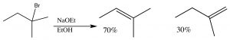
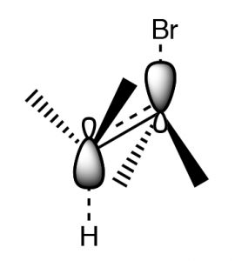
Another factor that must be accounted for in E2 reactions is that for such a reaction to occur, the leaving group and the proton that is eliminated must be in an orientation that allows the rehybridizing orbitals to overlap in the transition state.
This orientation is called antiperiplanar, and this need for a specific arrangement for the reaction to occur is called the stereoelectronic requirement.
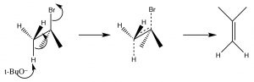
Antiperiplanar (or trans diaxial) stereoelectronic requirement for E2 eliminations
In systems where free rotation is possible, this lining up of the groups is not usually a problem, but if the elimination is to take place in a ring system, then the H and the leaving group must be trans and diaxial, otherwise the stereoelectronic requirement cannot be met.
So, for example, 1-bromo-2-methylcylohexane produces 3-methylcyclohexene, not 1- methylcyclohexene. This is because the hydrogen on the same carbon as the methyl group must be equatorial (if the methyl group is trans). Therefore the axial hydrogen on the other beta carbon is eliminated instead.
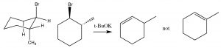
E2 elimination requires a trans diaxial (antiperiplanar) conformation
Nucleophile/base strength | Methyl | Primary | Secondary | Tertiary
–3 | N | N | E2 | E2
Strong/weak e.g. RSH, halide ions | N | N | N | NR
–t | NR | E2 | E2 | E2
23 | NR | NR | N | N
One thing is certain: the interplay between substrate and solvent can be very confusing. It is impossibleto memorize all the possible outcomes from a given set of reaction conditions, and although some generalizations can be made, the best way to manage all of this is to try to work through the reaction by writing a plausible mechanism. That being said, the following table summarizes some of the potential outcomes by type of substrate and strength of the nucleophile/base.

Chapter

Chapter 5: Alkenes and Alkynes
When a carbon is bonded to one or more electronegative atoms, it takes on a partial positive charge and it is electrophilic. Such electrophilic carbons can undergo nucleophilic substitution or elimination reactions, or both, depending upon the structures of the reacting molecules, the strength of the nucleophile, and the type of solvent in which the reaction occurs. Now, we turn to reactions that electron-rich carbon species can undergo.
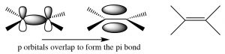
Alkenes and alkynes. Both alkenes and alkynes are “unsaturated,” which means that they contain double or triple carbon-carbon bonds. The term unsaturated comes from the fact that more H atoms can be added to these molecules across the double or triple bonds. A simple alkene contains a pair of carbons linked by a double bond; this double bond consists of a sigma bond and a pi bond. The sigma bond is formed by end-to-end overlap of sp2 hybrid orbitals, and the pi bond by side-to-side overlap of the p orbitals. A pi bond has two lobes of electron density above and below the plane of the molecule. There are a number of consequences to this arrangement: 1) the resulting region of the molecule is planar (the molecule is said to have trigonal planar geometry), 2) the electron density between the two carbons is high because there are four electrons in this region instead of two, and 3) rotation around a double bond is constrained (in contrast to rotation around a single bond). Rotation around a double bond requires breaking the overlap of the pi bond and its subsequent reformation. As with all bond-breaking phenomena, the bond-breaking step requires energy; in fact, significantly more energy than is required to bring about rotation around a single bond where no bond-breaking occurs. As we will see, these three factors have a marked effect on the behavior of alkenes.
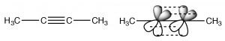
Alkynes are compounds that contain triple bonds. The triple bond consists of one sigma bond formed from end-to-end overlap of sp-hybrid orbitals and two pi bonds formed from side to side overlap. The carbons are sp-hybridized and the molecule is linear in the region of the triple bond; again rotation around a triple bond is constrained—two pi bonds must be broken for it to occur (which requires an input of energy). This bonding arrangement results in a very electron rich C-C region with the sigma bond inside what looks like a cylinder of pi electron density.
Naming Alkenes
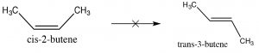
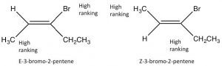
Since alkenes have restricted rotation around the C=C group, they can exist as stereoisomers. For example, in 2-butene there is a methyl and an H bonded to each of the double-bonded carbons (carbons 2 and 3 of the molecule). Because the C=C group is planar, the CH3 groups can be on either the same (“cis”) or opposite (“trans”) sides of the double bond (→); this cis/trans nomenclature is similar to that we used with cyclohexane rings. As the groups attached to each carbon get more complex, such nomenclature quickly becomes confusing. To cope, we turn to another established naming scheme; in this case, the Cahn-Ingold-Prelog convention we previously used with chiral centers. This involves ranking the groups linked to each double-bond carbon. If the high groups are together (same side), the name is prefixed by Z (from the German word for together: zusammen). If they are on opposite sides, they are labeled E (entgegen; away). E and Z isomers are diastereoisomers: they have the same connectivity but neither can be superimposed on its mirror image. In E-3-bromo-2-pentene, the CH3 and CH2CH3 groups are closer to one another than they are in Z-3-bromo-2-pentene; the result is that they have different physical and chemical properties. These differences make it possible to separate E and Z isomers (and cis/trans since they are just a special case of E/Z) from one another.
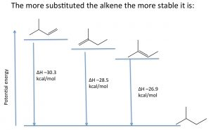
Stability of alkenes: Elimination reactions that produce alkenes tend to favor the most substituted alkene as the major product. The relative stabilities of various alkenes can be determined by reacting the alkene with hydrogen and determining the enthalpy change (ΔH).
For example, shown (→), the three different alkenes produce the same product, and therefore the differences in the energy released must arise from the fact that the initial alkenes have different energies. The more alkyl groups attached to the double bond, the more stable (less reactive) the alkene is, and therefore a lower amount of energy is released. Molecular stability in alkenes is attributed to the same causes as the relative stabilities of carbocations; alkyl groups stabilize the pi bond by hyperconjugation and induction.

Reactions of Alkenes: Electrophilic Addition
The double-bonded carbons of an alkene are electron-rich, that is, the electron density is high in the region of the double bond. Therefore, the “signature” reaction of alkenes involves initial attack on an electrophile. Instead of a substitution, alkenes undergo electrophilic addition, a reaction in which a two-component reactant adds across the double bond. The reaction begins with an electrophilic attack by the double bond onto the reactant which produces a carbocation that then undergoes nucleophilic attack. In the case of unsymmetrical alkenes (where the groups attached to the double-bonded carbons are not exactly the same), the most stable carbocation is produced. This reaction is regioselective, that is, we can predict the orientation of reactant addition across the double bond. If we designate the reagent as E (for electrophile) or N (for nucleophile), the reaction would proceed as outlined below.
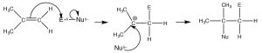
Reagent | Electrophile | Nucleophile | Typical Conditions
HBr | + | – | Low Temp
2 | + | 2 | Aqueous acid/Low Temp
ROH | + | ROH | 3+
2 | + | – | 24
BrOH | – | – | 22
BrOR | + | – | 2
The intermediate carbocation is the tertiary carbocation, (rather than the primary carbocation that would be produced by addition to the =CH2 end of the double bond). This pattern of reaction is referred to as Markovinkov addition, after the person who first discovered that HBr adds in this way to a double bond. We can classify many reagents as combinations of electrophile and nucleophile and, in this way, predict how they will add across the double bond. Examples of such reagents are shown (↑). Rather than memorizing the product of every type of addition across a double bond, it is much more productive to write a mechanism by determining which part is the electrophile, adding it to give the most stable carbocation, followed by the nucleophile.
Additions to alkenes are reversible: Let us now take a closer look at the addition of water across a double bond. Such a reaction can be accomplished by reacting the alkene with dilute sulfuric acid at low temperatures. The first step is addition of a proton to produce the most stable carbocation—which is then attacked by water (the nucleophile). The final product is the alcohol that forms after a proton is transferred to water. In this case, we can consider the proton (or more accurately H3O+) as a catalyst since it is regenerated at the end of the reaction sequence.
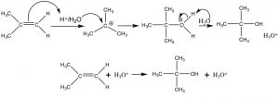
Acid-catalyzed addition of water across a double bond
At this point you might be asking yourself: well didn’t we just talk about the reverse reaction—that is, the elimination of H2O from alcohols to give alkenes? Indeed we did! Many organic reactions are reversible, it is just a matter of manipulating the conditions. The exact reaction conditions will determine which reaction is favored.
As is the case with most addition reactions, the addition of water across an alkene is exothermic, that is, ΔH is negative because stronger (sigma) bonds are formed during the reaction and energy is released into the environment. A typical energy diagram is shown below.
Reaction energy diagram for addition/elimination across a double bond.
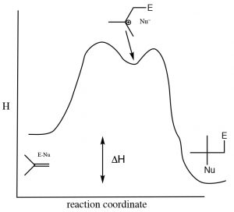
This means that ΔH for the elimination reaction must be positive (i.e. going from right to left on the diagram above). The question then is: why does an elimination reaction ever occur? To answer that, we have to recall that the thermodynamic criterion for a reaction to proceed is not simply a negative enthalpy change, but rather a negative change in the Gibbs change (ΔG). Recall that ΔG = ΔH – TΔS. The change in entropy also influences the thermodynamic favorability of a reaction. In the elimination reaction, two molecules (alkene and water) are produced one alcohol molecule –the entropy change will be (Recall that entropy is associated with the number of possible arrangements of the system. Since two molecules will have more possible arrangements than one, this reaction will always be accompanied by an increase in entropy of the system). To encourage the equilibrium to shift to the right (the addition reaction) we need increase the temperature, which will increase the magnitude of the –TΔS term, making ΔG more negative (assuming that ΔS is positive). In general, additions to double bonds are carried out at lower temperatures, while elimination reactions involve heating the reaction solution. Another way to influence the equilibrium state is to change the relative concentrations of reactants or products. Because water is a reactant, increasing the concentration of water shifts the equilibrium position towards the addition product while lowering the water concentration favors the elimination reaction.
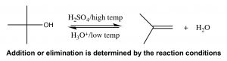
Specific reagents for additions across a double bond that reduce the carbocation problem
The problem with many of these simple addition reactions to a double bond is that they generate carbocations, which as we have seen already can lead to further reactions, resulting in skeletal rearrangements and the production of racemic mixtures (rather than a single stereoisomer). To address this issue, a number of reagents have been developed that minimize this problem. For example, a reagent that involves mercuric acetate (Hg(OAc)2) and sodium borohydride (NaBH4) as an intermediate can be used to add H2O, (or alcohol) across a double bond (↓).
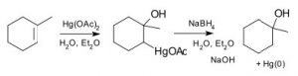
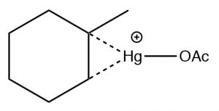
The reaction involves a mercury-stabilized cation (→) that prevents unwanted rearrangements. The product is still a Markovnikov product (see above) but is often formed more cleanly, that is, without unwanted alternatives.
Another set of reactions that can be used to constrain molecular rearrangements and lead to stereospecific products are those that begin with the addition of bromine across the double bond. The simplest of these co-reactions is addition of Br2 itself; since Br is a large polarizable atom, the bromine molecule can become polarized and interact with the double bond as shown (↓) to form a bromonium ion (rather than a carbocation).
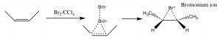
The bromonium ion can now undergo nucleophilic attack at either carbon (since in this example they are the same, that is, they are attached to identical groups), to produce the trans-dibromo addition product. The trans product is formed because the second step is an SN2 reaction with the bromide nucleophile attacking the carbon from the back-side.
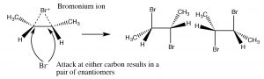
Addition of Br2 is accomplished by using a reaction solvent such as carbon tetrachloride that does not interfere with the reaction. If water or an alcohol is used as the solvent, then attack on the bromonium ion comes from the solvent acting as the nucleophile in the second step.
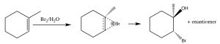
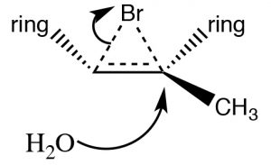
Again, the addition is trans, but now an incoming nucleophile (H2O) will attack the carbon that is most carbocation-like, that is it is the most stabilized, as shown here . The reaction is both regiospecific and stereospecific.

“Anti-Markovnikov” addition across double bonds
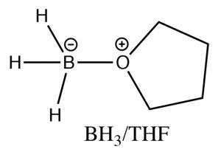
While the heading for this section is called “anti-Markovnikov” addition, this does not mean that the reaction mechanism is actually different. In the two examples we will discuss here, the difference is merely that the first addition to the double bond is not the H, which as we will see makes it appear that we have added a particular reagent the opposite way to the normal addition. For example, if we want to add water across the double bond in to give the anti-Markovnikov product a different set of reagents is used: a Lewis acid-base complex of BH3 and the ether tetrahydrofuran (THF), followed by a solution of hydrogen peroxide in base. This reagent adds across the double bond in the direction that you would expect, that is the electrophile (Lewis acid) boron adds to the least substituted carbon, but at the same time, a hydrogen adds to the most substituted carbon from the same side of the molecule.
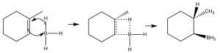
Mechanism of syn addition of BH3 across the double bond
This process happens twice more, and then the boron species is replaced by reaction with hydrogen peroxide and sodium hydroxide.
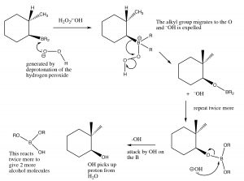
Mechanism of removal of boron moiety from the double bond
The overall reaction appears to have added the elements of water in an anti-Markovinkov direction. This reaction is not only regiospecific, but it is also stereospecific. The H and OH are added on the same (cis) side of the double bond and it is termed a syn addition.
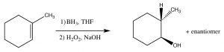
Anti-Markovnikov addition of HBr across a double bond.
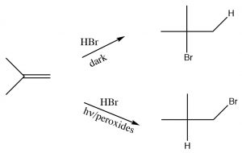
Another reaction which appears to violate what we have learned about the regiochemistry of addition across double bonds is the reaction of an alkene with HBr in the presence of light or peroxides. In contrast to the reaction we discussed previously, under conditions of light and in the presence of peroxides, the HBr adds in the reverse direction. Clearly something different is happening here: the reaction is proceeding by another Br mechanism. The clue is the presence of peroxides, which almost always signify that a reaction is proceeding via a radical mechanism rather than a polar mechanism.
Radicals are species with unpaired electrons, and, as such, are very reactive. The reaction begins with an initiation step in which the peroxide (which contains a weak O–O bond) is broken homolytically to give two oxygen radicals. These react with HBr by abstracting a hydrogen, and leaving a bromine radical. Note that the oxy radical abstracts H and not Br, because Br is a more stable radical than H. Bromine radical is a large polarizable species and which can help stabilize the unpaired electron. A hydrogen radical is actually a hydrogen atom, it is highly unstable and reactive.
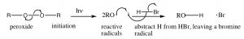
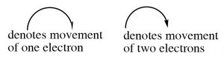
Note: when a mechanism involves single electrons moving (as in a homolytic bond cleavage, or any reaction of a radical species) we use what is called a fishhook arrow—with only one head, rather than the typical arrow that denotes movement of two electrons.
The resulting bromine radical now reacts with the alkene double bond to produce the most stable intermediate, which is (just as in the carbocations) the tertiary. Carbon radicals show the same trends in stability as carbocations for the reason that they are also electron deficient and can be stabilized by the same mechanisms as carbocations (induction and hyperconjugation). The resulting carbon radical now abstracts an H from another molecule of HBr, to produce the anti-Markovnikov addition product, plus another bromine radical that can begin the cycle again. This is called a radical chain reaction—because it produces another reactive species that can continue the chain reaction.
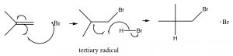
Note: Even though this reaction produces a different addition product than the typical addition of HBr across the double bond, the principles guiding the reaction are the same. The first addition produces the most stable intermediate; the difference is that bromine adds first.

Reduction of Alkenes:
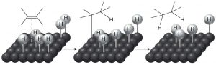
The historical meaning of “reduction” involved reactions with hydrogen (H2), and conversely, oxidation meant reaction with oxygen (O2). This makes sense from the perspective that carbon is slightly more electronegative than hydrogen, so that a C-H bond is polarized as C∂– and H ∂+. Therefore, adding hydrogen to a C=C will increase (slightly) the negative charge on the carbon. (Similarly, a C-O bond is polarized C∂+ and O∂–, so that adding more oxygens to a carbon increases the amount of positive charge on the carbon.) Even today we refer to adding hydrogen across pi bonds as a reduction. However, alkenes do not normally react with hydrogen; typically a catalyst (usually a transition metal) is necessary for the reaction to occur. In general, the catalyst is supplied as a finely divided powder adsorbed onto an inert substance such as charcoal. The, most common catalysts are platinum or palladium on charcoal (Pt/C or Pd/C). Typically, the substance to be reduced is dissolved in a solvent, the catalyst is added, and then hydrogen is bubbled through the mixture. The catalyst adsorbs both H2 and the alkene onto its surface and this interaction weakens both the H2 bond and the pi bond. The hydrogen then migrates to the adsorbed alkene and adds across the double bond. The reaction is stereospecific in that both H’s add from the same side—a syn addition. This can be seen more clearly if we use deuterium instead of hydrogen—both the D’s add from the same side.
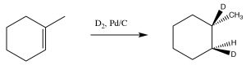

Oxidation of Alkenes
There are a variety of reagents that can result in the oxidation (i.e. the addition of oxygen to both carbons) of an alkene. These reactions are synthetically useful because they enable us to place functional groups on adjacent carbons and these groups can subsequently be modified. The reagents used in these transformation reactions are highly reactive, and most include species in a high oxidation states, such as permanganate (MnO4–) and or Osmium tetroxide (OsO4), or contain unstable oxygen-oxygen bonds (e.g. Ozone O3) or a peroxy-acid (see below). The common factor in these reagents is that they are able to add oxygen in various ways to the C=C bond. Many of resulting reactions are quite complex, and we will not delve into their mechanistic details except where necessary: for example, to explain why a particular stereochemistry is produced.
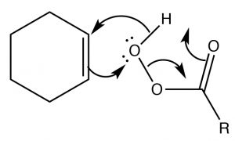
Epoxidation: Epoxides (also known as oxiranes) (→) are three-membered ring ethers, and can be formed by the reaction of an alkene with a per-acid, that is, a carboxylic acid with an extra oxygen (←). The reaction occurs via a concerted (coordinated) movement of electrons. The result is that both of the carbons in the original double bond end up linked to the same O atom.

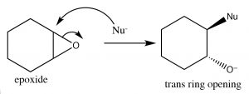
Recall that earlier we looked at relative stabilities of rings, and found that their stability depends on the ring size and the torsional (eclipsing) strain. A three membered carbon ring is highly strained because the bond angles are distorted away from the 109º angle that sp3 hybridization calls for; moreover, all of the bonds are eclipsed. The result is that epoxides are susceptible to nucleophilic attack at a ring carbon (→). An SN2 reaction that proceeds via attack from the back side of the ring, leading to the production of the trans product. Such ring opening reactions can be accomplished by a range of nucleophiles, including water. The reaction with water results in a trans diol. In general, under SN2 conditions the ring opening is also stereospecific—that is the nucleophile will attack the least hindered carbon (↓).
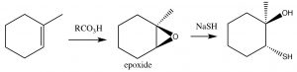
Epoxides tend to be reactive and for this reason can be useful as synthetic intermediates. Within biological systems, their reactivity can lead to chemical modification of DNA, leading to mutations (for that reason, many are known as genoxic or toxic to the genome). As a defense against such epoxides, organisms encode enzymes known as epoxide hydrolyzes.
Cis-diols: Alkenes can be oxidized to produce cis-diols using a different type of reagent that adds atoms across the double bond via a cyclic intermediate. For example permanganate (MnO4–) and osmium tetroxide (OsO4), both of which contain transition metals in high-oxidation states, can accomplish this transformation (→). It is worth noting that by controlling the reaction conditions, we can choose to produce either cis or trans diols. As we move into more complex organic chemistry we will see that the ability to choose and predict outcomes is a major component of organic chemistry.
Ozonlysis: Another type of alkene double-bond oxidation involves a reaction with ozone (O3), the highly reactive allotrope of oxygen. The mechanism is quite complex as shown below (no need to memorize it!).
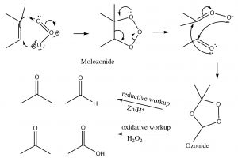
Typically, ozone cleaves the double bond and the reaction is treated with a mild reducing agent such as tin (Sn), leading to the production of the corresponding aldehydes or ketones (↓).
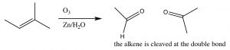
As we will see later, the ozonolysis reaction can be useful in identifying the position of a double bond within a molecule, as well as in the synthesis of aldehydes and ketones.

Reactions of Alkynes
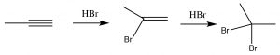
As you might predict, alkynes often behave in a similar way to alkenes. The triple-bonded carbons are an electron-rich region of the molecule and we would expect them to undergo electrophilic addition, in a similar manner to alkenes. So, for example, we see Markovikov addition across the triple bond with HBr (→), the only difference being that if excess HBr is present, two—rather than one—bromine atom will be added; one to each of the originally triple-bonded carbons. Other reagents behave in a similar manner. For example Br2 will also add across the triple bond to give first the dibromo, and then the tetrabromo compound.
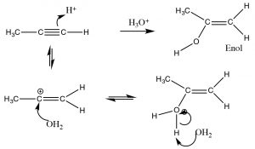
In contrast, when water is added across the triple bond we find a somewhat different outcome. While the initial steps are the same: the electrophile (H+) adds to the least-substituted carbon, and the nucleophile (H2O) adds to the carbocation that is produced. This produces a new functionality called an enol (A combination of alkene and alcohol). The enol now undergoes what is known as a tautomerism: the proton from the alcohol moiety is removed (by water as a base), and another proton is picked up on the alkene CH2 carbon (→). As we have seen many times before this type protonation/deprotonation reaction occurs readily on either oxygen or nitrogen, but this is the first time we have seen it on a carbon; keto-enol tautomerism is an important part of the reactions of carbonyl groups.
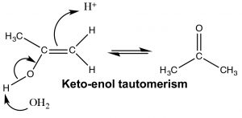
The keto and enol forms appear to be different compounds and we might be tempted to classify them as structural isomers—but they are not. The keto- and enol- forms always exist in an equilibrium with one another, and even though we usually write the structure with the carbonyl group (the keto form), there is always a small amount of the enol form present. The transition between keto- and enol- forms of the nucleotide bases initially confused Watson and Crick in their modeling of DNA structure.
Reduction of alkynes: Addition of hydrogen (H2) to alkynes can be accomplished in several ways. It is possible to completely reduce the alkyne to the corresponding fully-saturated alkane through the addition of two H2 molecules. In fact, when using catalysts such as Pd (palladium) or Pt (platinum) the reaction cannot be stopped at the intermediate alkene stage. There are, however, specialized catalysts that allow for partial hydrogenation to the alkene. One of these is known as Lindlar’s catalyst, which is less efficient (poisoned) catalyst. As one might expect (by analogy with alkene reduction), the cis hydrogenated product is formed (↓).
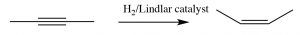
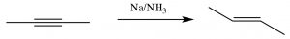
It is also possible to reduce an alkyne to the trans product, but to do this we have to use a different method; a method that involves the stepwise addition of the components of the reduction. The conditions for this reduction require a source of protons and a separate source of electrons. For example, a solution of sodium metal (a source of electrons) in liquid ammonia (a source of protons) at low temperature (since ammonia boils at -33ºC), can be used to reduce an alkyne, but since the reaction proceeds via a stepwise (not concerted) addition, the product formed is the trans alkene: the most stable product (→).
Acidity of Terminal Alkynes: One alkyne-specific reaction involves the acidity of protons attached to sp hybridized carbons. The pKa of such protons is around 25, which is much lower than that of alkanes (> 55) or alkenes (~ 45). In fact, “terminal” alkyne protons can be removed by strong bases such as NH2– (the amide ion), since the pKa of NH3 (ammonia) is 33 (↓).
The acidity of terminal alkyne protons can be explained by the idea that the negative charge (the lone pair on the resulting anion) is located in an sp hybrid orbital. The more “s” character in the hybrid orbital, the closer to the nucleus. Since the sp orbital is more “s” than either sp2 or sp3 orbitals, then the electron of the carbon anion is held closer to the nucleus and is therefore more stable than if the carbon were sp2 or sp3 hybridized. The effect is similar to the effective nuclear charge explanation for the trends in electronegativity across the periodic table (i.e. why fluorine is more electronegative than oxygen). The alkyne anion is very useful because it is now a carbon nucleophile, and will attack electrophilic carbon species in an SN2 reaction. This is the first example we have seen of carbon carbon bond formation (although we will see many more).

Chapter

Chapter 6: Alcohols and an introduction to thiols, amines, ethers & sulfides
In this chapter, we are going to take a closer look at the families of compounds that have carbon linked through a single covalent bond to an O, N, or S. These are known as alcohols (R-OH), amines (R-NH2, RR’-NH, RR’R”-N), thiols (R-SH), ethers (R-OR’), and sulfides (R-SR’). We group these compounds together based on the predictable similarities and differences in their chemical and physical properties, specifically the fact that each of these functional groups has a relatively electronegative element (O, N or S) attached by a single bond to carbon and each has available lone electron pairs that can be donated to H+ or other electrophiles. The result is that alcohols, thiols, and amines (primary and secondary) all have relatively acidic hydrogens, which influences their chemical reactivities, and all show nucleophilic properties.
Table 6.1 Examples of Functional groups, their names and approximate pKa‘s
Functional Group | Example | Name | a
Alcohol
Alcohol
Thiol |  |  | ~10
Primary amine |  |  | ~33
Secondary amine |  | N-methylethanamine | ~33
Tertiary amine |  | N-ethyl-N-methylpropanamine | N/A
Ether |  |  | N/A
Sulfide |  |  | N/A
We will concentrate our discussion on oxygenated compounds, but we will note reactivities across the various groups to illustrate their similarities (and differences).

(Brønsted) Acidity of alcohols, thiols, and amines
Recall that there are several factors that can influence Brønsted acidity. These include: the strength of the bond between the R (C) and the O, S, or N (denoted by “Y” below) and H; the polarity of the bond; and the stability of the resulting anion (“Y–“).
R–Y–H + B– BH + R–Y–
Simple alcohols have acidities that are about the same as water, with a pKa of around 15-16 (remember the pKa of water is 14). In comparison, amines are much less acidic, with pKa‘s around 33-36. We understand this difference based on the fact that O is more electronegative than N, therefore the O–H bond is more polarized than the N–H bond—making the partial positive charge on the H larger in O–H than in N–H bonds. In polar solvents, this means that the H bonded to an O is better solvated and the proton is easier to remove than an H bonded to an N. Similarly, the resulting negative charge on the anion is more stable on O than on N because the effective nuclear charge on O is greater (which is the cause of its greater electronegativity, compared with N). In contrast, thiols are more acidic than alcohols because the S–H bond is weaker—the size of S and H orbitals results in smaller overlap and therefore weaker bonds (just like HBr is more acidic than HCl) and the resulting anion is more stable because the larger size of S results in the negative charge being distributed over a larger volume.
To deprotonate a simple alcohol, with a pKa of around 15, requires a base that forms a bond with H that is than the bond that would be formed with the resultant alkoxide (RO–)—otherwise the acid-base reaction would reverse. For this reason, we cannot use a base like sodium hydroxide, because its conjugate acid H2O has a pKa of around 14. Therefore, although some alcohol deprotonation would occur in water, the equilibrium position would be somewhere in the middle, so that both –OH and RO– would be present in the reaction mixture. To completely deprotonate an alcohol with a pKa of around 15, we would need to use a stronger base, such as sodium hydride (NaH), or sodium amide (NaNH2).
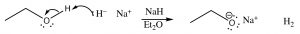
Note that the reaction must take place in an aprotic solvent; in this case diethyl ether is used (otherwise the NaH would react with the solvent as well as the alcohol). Another common method to deprotonate alcohols is through a redox reaction, using a group one metal—usually sodium.
Some alcohols are much more acidic; for example –OH groups attached to an aromatic ring (which are called phenols) typically have pKa‘s around 10. This difference in pKa must lie with the nature of the conjugate base (the anion), since the same O–H bond breaks during the proton transfer. In this case, the conjugate base is stabilized by delocalizing the electrons to the aromatic ring by resonance. Recall that the more delocalized a charge (in this case the electrons), the more stable the resultant ion is.
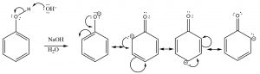
Phenols are more acidic than typical alcohols because the conjugate base is stabilized by resonance
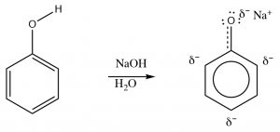
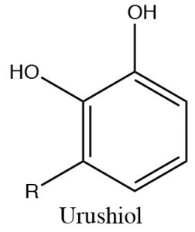
Phenols can be deprotonated by NaOH because the phenolate anion is more stable than hydroxide. Therefore, phenols are soluble in aqueous solutions of sodium hydroxide. This also provides a way of separating phenols from other (non-acidic) organic substances, since the phenol can be regenerated simply by adding acid. One practical way that this phenomenon can be used is to remove the highly allergenic substances secreted by poison ivy (or oak or sumac) plants. The major allergen belongs to a family of di-phenols called urushiol. The R can by any of a number of long chained hydrocarbons. Washing the affected part with a basic solution (soap for example) will help solubilize the urushiol and remove it from the skin.
Alcohol acidity can also be increased by inductive electron withdrawal (due to the presence of electronegative atoms linked through sigma bonds) just as we discussed earlier in the case of carboxylic acids: for example CF3OH is more acidic than CH3OH.
We might also predict the effects relative to acidities of amines and thiols in terms of resonance and inductive stabilization, but, in fact, most of their chemistry is not associated with acidity and we will not dwell on this idea here.

Nucleophilicity of ROH, RSH, and RNH2
Earlier (Chapters 1 and 4), we discussed (at great length) that all three functional groups (–OH, –NH, and –SH) are nucleophilic: that is, they will react at the carbon center that is electron-deficient. For functional groups that contain nucleophilic centers from the same row of the periodic table, the trends in nucleophilicity parallel Bronsted basicity: amines are more nucleophilic (and basic) than alcohols. However, in functional groups that contain nucleophilic centers from the same group of the periodic table (nucleophilicity increases down the group, while basicity decreases), thiols are more nucleophilic than alcohols. Both amines and thiols are very nucleophilic. All three groups participate in nucleophilic substitutions as discussed in Chapters 1 and 4.
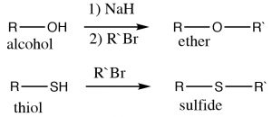
Examples of these kinds of nucleophilic substitutions are the reactions of alcohols, thiols, and amines with alkyl halides to give the corresponding ethers, sulfides, and (secondary, tertiary or quaternary) amines. Alcohols are not as nucleophilic as thiols and amines, and therefore typically the corresponding alkoxide must be used (because it is more reactive), for the synthesis of ethers.
In the case of amines, the nitrogen can react several times with the electrophile (alkyl halide), and in practice it is difficult to stop the reaction at any intermediate step (in the laboratory).
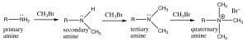
Amines typically react with electrophiles to give poly-alkylated amines

O, S, and N as leaving groups:
Recall that a good leaving group should be able to accept (in a stable form) the pair of electrons from the bond that breaks. Typically, good leaving groups are weak bases. For this reason, hydroxide (–OH) and amide (–NH2) are unlikely to be produced during a nucleophilic substitution reaction. However, as noted earlier, alcohols can be converted into good leaving groups by protonation, which results in H2O as the leaving group.
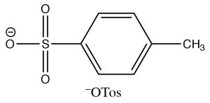
Alcohols can also be modified (or derivatized) to produce better leaving groups. This is particularly useful when we need to carry out a reaction that is sensitive to acidic conditions when the method we have used earlier (protonation of the OH) cannot be used. The most common derivative used to make the OH group into a good leaving group is the Tosyl group (para-toluenesulphonate). It can be formed by reacting an alcohol with p-toluenesulfonylchloride (TosCl) in the presence of a base (such as pyridine) that acts to remove the HCl that is produced).
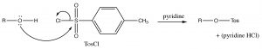
We can consider the derivatization reaction as mechanistically similar to other nucleophilic substitutions we have considered, except that it takes place at an S instead of a C.
The resulting OTos group is a very good leaving group, making the molecule reactive to nucleophilic substitution reactions. In effect, we have changed the leaving group from –OH, which is a relatively strong base, to –OTos which is a very weak base—it is the organic equivalent of sulfate, the conjugate base of sulfuric acid. The negative charge on –OTos becomes delocalized to the other oxygens bound to the S, thereby stabilizing the base.
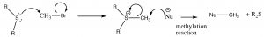
In a similar manner, sulfides can be transformed into leaving groups, most commonly through the methylation of the sulfide, which produces a powerful reagent that can be used to methylate other species.
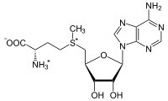
In biological systems, a common methylating agent, S–adenosylmethioninine (SAM ), uses this mechanism.

Oxidation of Alcohols
Before we discuss oxidation of alcohols, it should be clear what we mean by the “oxidation” and “reduction” of carbon compounds. Recall that in earlier discussions we used the term reduction to mean the addition of hydrogen and oxidation to mean the addition of oxygen, rather than calculating changes in oxidation numbers (decrease for reduction, increase for oxidation). The reason is because oxidation numbers in organic compounds can be hard to calculate and apply. In this section, we consider how alcohols can be oxidized to give aldehydes, ketones, or carboxylic acids. In general, we consider a carbon compound to be oxidized when the number of bonds between the C and electronegative atoms (often, but not always, O) is increased.
For example, a primary alcohol can be oxidized (which we will denote by O for the time being) to an aldehyde; depending upon the reagent used, the reaction can proceed through a second step to produce the corresponding carboxylic acid. At each step, the oxidation level of the carbon is increasing.
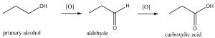
Starting with a secondary alcohol, the product of an oxidation reaction is the corresponding ketone, but tertiary alcohols do not give useful products and may simply lead to degradation (C–C bond breaking). Generally, it is not possible to oxidize a secondary carbon beyond the ketone level without breaking carbon-carbon bonds, and similarly, tertiary alcohols cannot be oxidized under normal circumstances.
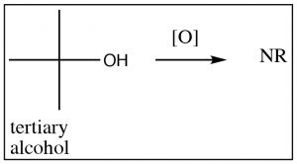
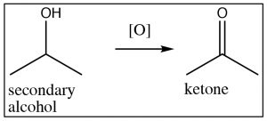
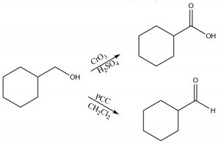
Typical oxidizing reagents include transition metals in high-oxidation states (that is able to accept [bond to] O atom). For example, chromium (VI) in the form of chromium trioxide (CrO3) or sodium dichromate (Na2Cr2O7), when in concentrated H2SO4, are both powerful oxidizing agents and both will oxidize a primary alcohol through both steps, that is, all the way to the carboxylic acid form. Pyridinium chlorochromate (PCC ) is a milder oxidizing agent that will oxidize primary alcohols, only through the first step, to produce an aldehyde.
The general mechanism of oxidation is shown below, note electrons leave the alcohol and end up on the Cr, reducing its oxidation state from 6 to 4, and the alcohol carbon ends up oxidized.
Primary alcohols can be selectively oxidized to aldehydes with PCC
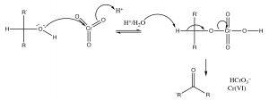
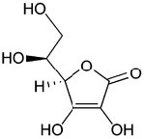
One problematic aspect of such oxidizing reagents is that they contain highly toxic and carcinogenic Cr (VI) in one form or another. Such materials oxidize a range of biomolecules such as vitamin C (ascorbic acid) and some thiols (such as the amino acid cysteine). Reduced chromium also reacts with nucleic acids and can lead to mutations, which can lead to cell death and/or cancer. To avoid using such toxic chemicals, there has been increasing in what has come to be known as green chemistry. One of the tenets of green chemistry is to minimize the use of toxic reagents (such as chromium compounds).

Oxidation of Thiols
In alcohols, oxidation generally occurs at the carbon bonded to oxygen. In contrast, with thiols the oxidation site is often at the sulfur. For example, many oxidizing agents (even molecular oxygen in air) oxidize thiols to disulfides. The reverse reaction is also readily accomplished using a reducing agent such as Zn/HCl. The disulfide bond is relatively weak, that is, requires less energy to break (about half the strength of a typical C-C or C-H bond).
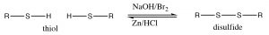
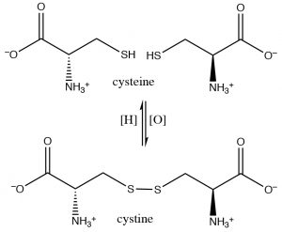
In fact, the amino acids cysteine and diamino acid cystine are readily interconverted in biological systems (usually through the NADH/NAD oxidation/reduction system; see below). These disulfide crosslinks between cysteine moieties in polypeptides and proteins often serve to stabilize the 3D structure of proteins.
Sulfides (R-S-R) are also susceptible to oxidation, which can lead to the formation of a sulfoxide, which can be further oxidized to form a sulfone.
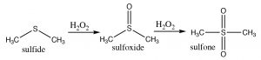

Preparation of alcohols
We have already seen several methods by which alcohols can be produced, mostly in Chapter 5. For example, the addition of water across a double bond, either through acid catalysis (Markovnikov addition) or by hydroboration/oxidation (Anti-Markovnikov addition), produces alcohols. We have also seen, under certain conditions, that alcohols can be produced by nucleophilic substitution. Both SN1 and SN2 reactions can produce alcohols, and now would be a good time to review all of these reactions (covered in Chapters 1, 3, 4 and 5).
A reaction that we have not yet encountered is the reduction of carbonyl compounds. For example, a ketone such as acetone can be reduced through a reaction with sodium borohydride (NaBH4) or lithium aluminum hydride (LiAlH4); both of these molecules can deliver hydride (H–) to the partially positive carbon of the carbonyl.
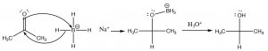
Sodium borohydride (NaBH4) is generally the reagent of choice as it is less reactive and the reaction can be carried in an open flask, whereas LiAlH4 typically must be used with solvents that do not contain water and under a dry atmosphere. The intermediate R–O–BH3 complex is destroyed by adding aqueous acid to give the final alcohol product.
Reactions where hydride is delivered to a carbonyl are similar to a reaction found in biological systems. NADH (Nicotinamide Adenine Dinucleotide Hydride) is an unstable intermediate generated through a number of metabolic processes (such as fermentation), while not as reactive as NaBH4, and (like, essentially, all biological reactions) requires a catalyst (an enzyme) to bring about the reduction of carbonyls; but the mechanism is similar. The reaction (like all reactions) is also reversible, so that the oxidized version of NADH, NAD+, can accept a hydride from an alcohol to produce a ketone. In the mechanism (with only the nicotinamide part of NADH shown) the “R” group attached to the N in the ring is actually a complex molecule consisting of an adenine moiety (a base found in nucleic acids and nucleotides), two sugar units (ribose), and two phosphate linkages. For now, let us focus on the similarities between the reduction reactions discussed above and those that take place in biological systems.
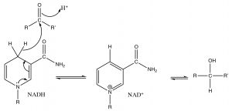
Reduction of a carbonyl by NADH by delivery of H– to the carbonyl carbon
The conversion of pyruvic acid to lactic acid during glycolysis is just such an example. By looking at simpler systems, we can understand (and model) the types of reactions that occur in organisms.
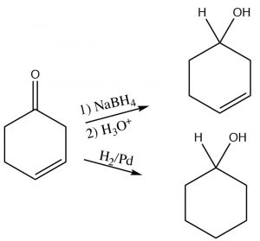
Alcohols can also be produced by direct reduction with H2(g) using a transition metal catalyst, in a way similar to the reduction of C=C, except that the hydrogens add across the C=O.
The choice of reducing agent depends on presence of other functional groups within the molecule. For example, if we wanted to reduce a carbonyl group in a molecule that also had a carbon-carbon double bond, we would not use H2/Pd as the reagent/catalyst, since it would also reduce the double bond as shown here (→).
Preparation of alcohols with Grignard reagents: Just as we can add hydride ion by a nucleophilic attack at a carbonyl, we can also add an alkyl group, which formally contains a carbanion (a negatively charged carbon). The most common way to do this is via a Grignard reagent, produced by reacting an alkyl halide with magnesium metal in a dry atmosphere with a non-protic solvent such as diethyl ether (Et2O). The resulting Grignard reagent, RMgBr, is now polarized with a large partial negative charge on the carbon.
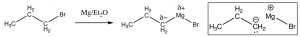
For our purposes, we can treat the Grignard as if it were a carbanion, which will react with a carbonyl group in much the same way as a hydride ion.
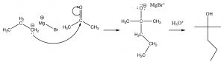
Reaction of a Grignard reagent with a ketone to give an alcohol
This reaction is applicable to a wide range of compounds that contain carbonyl groups including aldehydes and ketones, and (as we will see later) to esters and acid chlorides, but not carboxylic acids (why do you think that is?).

NaH is synthesized by the reaction of sodium with hydrogen—a redox reaction. It is an ionic compound consisting of Na
and H
(hydride) ions; hydride cannot be produced by deprotonating H
.

The pK
of NH
(the conjugate acid of NH
) is 33

To use the oxidation number method, we must remember that H is less electronegative than C; so in CH
the ON of carbon is –4 and each H is +1. (This is confusing since we usually consider C–H bonds as non-polar). In CO
, each O is –2 and the C is +4. Therefore, in CO
the carbon is in a higher oxidation state than in CH

NaBH
and LiAlH
both contain a group III element (B, Al) here found in the form of the Lewis acid-base complex BH
or AlH
They are sources of Hydride ion, as shown above. LiAlH
is more reactive than NaBH
.

Chapter

Chapter 7: Nucleophilic attack at the carbonyl carbon:
There is a set of organic compounds that incorporates the carbonyl group (C=O) which includes aldehyde ketones, carboxylic acids, and carboxylic acid derivatives such as: esters, amides, acid anhydrides, and acid chlorides (as shown in Table 7.1).
Table 7.1: Functional groups that contain a carbonyl group
Functional Group | Example | Name
Aldehyde
Ketone
Carboxylic Acid |  | 2
Ester |  | 2
Amide |  | 2
Acid chloride |  | 2
Acid anhydride |  | 2

These functional groups have a number of similarities and some notable differences in their properties, which can be predicted on the basis of our understanding of structure and function relationships. These carbonyl compounds can be classified into two broad groups: 1) ketones and aldehydes and 2) carboxylic acids and derivatives (amide, chloride, ester, and anhydride). These two, broad groups differ in the oxidation level of the carbonyl carbon: aldehydes and ketones have two bonds to the electronegative oxygen; acids and derivatives have three bonds to electronegative atoms (O, N or Cl); and, of course, alcohols only have one bond. Interconverting between alcohols, ketones, and carboxylic acids involves some kind of redox reaction. We have already discussed the alcohol to ketone (or aldehyde) transformation and, later, we will discuss further oxidation to the acid level.
As we discussed in Chapter 6, the carbonyl carbon is highly polarized; the large + on the carbon makes it susceptible to nucleophilic attack. There are a large number of reactions that begin by the attack of a nucleophile on a carbonyl group. To make understanding these reactions more manageable (intelligible), we will consider these reactions in a sequence of increasing complexity, beginning with reactions of aldehydes and ketones. We will then cycle back around and visit similar reactions involving acids and their derivatives.

Aldehydes and Ketones
Is there a difference in reactivity between aldehydes and ketones? Not really; both types of compounds undergo nucleophilic attack, although, in general, aldehydes react faster than ketones for two reasons:
- Aldehydes are less hindered at the carbonyl carbon than ketones (since there is always at least one H attached whereas ketones always have two bulkier alkyl groups).
- Alkyl groups are electron-donating so the partial positive charge on the carbon is partially offset by induction from the alkyl groups.
In practice, however, there is generally little difference between the two and so unless we point out a difference you can assume that they undergo similar reactions.
The similarities between aldehydes and ketones are supported by an examination of their spectra. For example, both aldehydes and ketones display a strong carbonyl absorption around 1700 cm–1. As we will see shortly, not all carbonyls absorb in this area—their C=O stretching frequencies are dependent on their electronic environment. In C-13 NMR, both aldehydes and ketones show a low field peak for the C=O around 200 ppm indicating that the electronic environment of the carbonyls are similar. The major difference in the spectra is the aldehyde proton resonance in the HNMR that appears downfield. This peak often appears as a singlet, even though it may be adjacent to a C-H group, because the coupling constant is often small and, depending on the sensitivity of the instrument used, splitting may not be detectable.

Nucleophilic attack by hydride or carbanions
As we discussed in Chapter 6, aldehydes and ketones react with reagents that are able to deliver hydride (for example from sodium borohydride) or a carbanion (in the form of a Grignard reagent) to the carbonyl group.
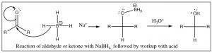
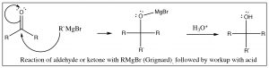
In addition to Grignard reagents, carbanions can also be generated by treating alkyl halides with lithium under dry conditions. These alkyl lithium reagents (RLi) behave in a very similar way to Grignard reagents, although they are somewhat more reactive.
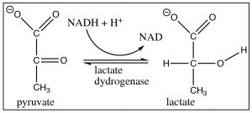
These two reactions: addition of hydride (reduction) or a carbanion (resulting in carbon-carbon bond formation) to a carbonyl are analogous. They also have something else in common in that, under normal laboratory conditions, they are not reversible because reversing the reaction would require that the hydride ion or carbanion be expelled from the central carbon. These species are very unstable, very strong bases. The reagents that produced them (NaBH4, RMgX, RLi) are specialized reagents that do not contain “naked” hydride ions or carbanions. If we wanted to reverse them, we would have to use completely different reaction conditions that avoided the expulsion of the high-energy hydride or carbanion. For example, to accomplish the reverse of the reduction reaction, we would have to use an oxidizing agent (such as Cr(VI)) under completely different conditions. The reduction of a ketone group is central to the reactions of glycolysis, in which pyruvate (the conjugate base of pyruvic acid) is reduced to lactate (the conjugate base of lactic acid) by NADH (see Chapter 6). This reaction can be also reversed under different conditions (in this case, the presence of the enzyme lactate dehydrogenase). Glycolysis will be discussed in more detail in Chapter 9.
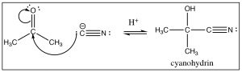
Reactionwithothercarbanions: There are a number of other ways to generate carbanions: for example, terminal alkynes are quite acidic (pKa 22) and can be deprotonated by sodium amide (Chapter 5). The resulting carbanion adds to the carbonyl just as we might expect. Similarly, cyanide ion (CN–) is another source of a negatively charged carbon. It is a good nucleophile, and just as one might expect, it adds to carbonyl groups, and after reaction with a dilute acid, the resulting cyanohydrin is formed. There are two items to note here:
- Sodium cyanide NaCN (the usual form of cyanide ion) is highly toxic, so don’t try this at home.
- The oxidation state of the carbon in the cyano group is the same as a carboxylic acid. As we will see later, this reaction will come in very useful. All of these reactions are the result of a nucleophilic addition to the carbonyl group, during the course of which the carbonyl carbon rehybridizes from sp2 to sp3.

Reactions of Aldehydes and Ketones with Oxygen Nucleophiles
In contrast to the addition of hydrogen or carbon nucleophiles, the addition of oxygen and nitrogen nucleophiles is reversible under the conditions in which the reaction occurs. This is because (as we will see) the addition of an oxygen or nitrogen nucleophile results in a tetrahedral intermediate that can regenerate the carbonyl by expelling a leaving group. In contrast to the cases with carbon or hydrogen nucleophiles, oxygen and nitrogen nucleophiles can be good leaving groups. Typically, the reaction is catalyzed either by acid or base as discussed below. For example: in aqueous solution, most aldehydes and ketones will react with water to produce a hydrate.
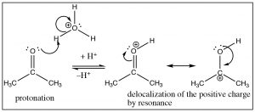
In acid, the first step is protonation of the carbonyl oxygen, the resultant positive charge is partially delocalized onto the carbon , which makes the carbonyl more susceptible to nucleophilic attack even by a relatively poor nucleophile such as water.
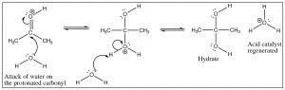
This reaction is completely reversible in aqueous solution, and if any aldehyde or ketone is dissolved in water there is always some equilibrium concentration of the hydrate. In fact, formaldehyde (H2C=O) exists almost exclusively as the hydrate in aqueous solution, whereas most other aldehydes and ketones exist mainly in the carbonyl form. However, it is important to keep in mind that both forms are typically present, and therefore further reactions can proceed from either the hydrate or the carbonyl form.
Base catalysis differs in that the first step is attack by the hydroxide (rather than water) on the carbonyl. Since hydroxide is more reactive than water, the carbonyl does not need to be activated by protonation. What the two mechanisms have in common is the rapid protonation/deprotonation reactions that take place in the intermediate steps. We have already seen this many times and with the reactions of aldehydes and ketones, it becomes more important to appreciate just how ubiquitous protonation and deprotonation are. By controlling the pH or the amounts of reactants or products we will see that it is possible to direct such reactions so that the product we desire is produced.
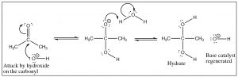
The hydrate is an example of a structure that will play a major part in our discussion of all carbonyl compounds—which we will refer to as the “tetrahedral intermediate.” In this tetrahedral form, the carbon is in the same oxidation state as the ketone (two bonds to oxygen) but in a different hybridization state, sp3 for the hydrate and sp2 for the carbonyl. In most cases, the C=O bond (in the sp2 hybridized form) is stronger (745 kJ/mol in a typical ketone) than two single C–O bonds (2 x 358 kJ/mol) (in the sp3 hybridized form), which explains why (when there is a low-energy stable leaving group) the tetrahedral intermediate that is formed by attack on the sp2 carbon usually collapses back down to a C=O, expelling a leaving group at the same time. As we move forward, we will see the move from tetrahedral to C=O many times, the difference in many of the reactions is which group will leave during this process.
If we change the solvent to an alcohol, we see that the same type of reaction occurs. The alcohol oxygen attacks the carbonyl carbon, but we find that the reaction proceeds further. The first product, formed by addition of one alcohol to the carbonyl is called a hemiacetal but then the reaction continues. Each step is reversible (with low activation energy), each protonation and deprotonation is reversible. All of the oxygens in the molecule can be protonated and deprotonated. When the OH group of the hemiacetal is protonated, it is turned into a good leaving group (H2O) and the carbon undergoes another attack by an alcohol molecule. The end result is an acetal and water.
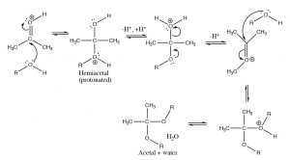
Since these reactions are reversible, you may be asking how we can control the reaction. In this case we can use Le Châtelier’s principle: we can either add a lot of starting material or we can remove one of the products as it is formed. In this case, acetal formation is usually done using the alcohol as solvent, and the water that is formed is removed, so that the position of equilibrium is shifted over to produce the acetal. However, as we will see shortly, sometimes we want to regenerate the carbonyl compound, and this can be done by adding water (and acid catalyst) so that the equilibrium shifts back.
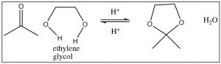
If we use a diol such as ethylene glycol (OHCH2CH2OH), the resulting cyclic acetal is formed. This is frequently used to protect carbonyl groups in more complex molecules, for example, if we wanted to do a reaction in another part of the molecule. Again, the carbonyl group is easily regenerated. The mechanism of hydrolysis is simply the reverse of the acetal formation, beginning with protonation, attack by water, and so on as shown below.
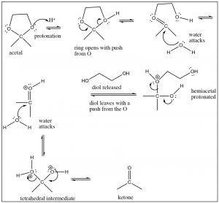
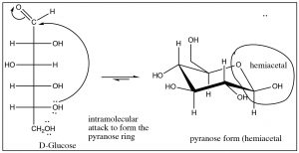
While this mechanism may look (a bit) complicated, in fact, each step is simple and we have seen similar things many times. The issue with these kinds of reactions is that all the oxygens are being protonated and deprotonated all the time. Note that the ways that tetrahedral intermediates behave depends on which oxygen is protonated, and which nucleophile (water or alcohol) attacks the protonated acetal or ketone.
One common example of hemiacetal formation is the intramolecular cyclization of D-glucose to form a six-membered ring which contains a hemiacetal group (among many others). This case is actually a rare example of the tetrahedral form (hemiacetal) being more stable than the carbonyl form.

Reactions with Nitrogen Nucleophiles
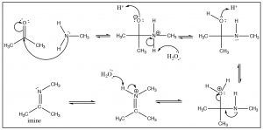
There is a similarity between the reactions of oxygen nucleophiles and nitrogen nucleophiles. For example, let us look at the reaction of a primary amine with a ketone. The mechanism begins in the same way with the nucleophile(N) attacking the carbonyl to form a tetrahedral intermediate, which can undergo various reversible protonation/deprotonation reactions until an intermediate is formed that can collapse down to a new product with a C=N function—which is called an imine. It is the nitrogen analog of the ketone and behaves in much the same way.
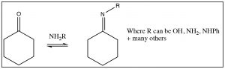
There are many other nitrogenous nucleophiles that can react with aldehydes and ketones, for example hydroxylamine (NH2OH), or hydrazine (NH2NH2) or a whole range of substituted hydrazines, all react with aldehydes and ketones to produce the corresponding imine.
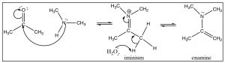
Generally, we do not see the nitrogen analog of an acetal, the intermediate is unstable and reacts to form the imine. However, in the case of a secondary amine, the reaction proceeds in exactly the same way until the imine stage—with the one difference that the nitrogen is now in the quaternary state (an iminium ion). Instead of addition of another amine, a proton is removed to produce a new functionality, the enamine.
A note on how these reactions proceed: While these mechanisms may seem complex with many steps, those individual steps are very similar. Students often ask how they can know which way the reaction goes, and the way we write out mechanisms does tend to give the idea that each step is marching purposefully along like clockwork—from one intermediate to another as if the molecules had an “end goal” in sight. Nothing could be further from the truth: each step in the reaction, each protonation and deprotonation, and each nucleophilic attack and loss of a leaving group is occurring all at the same time in a stochastic and chaotic fashion. However, we can control the reaction as discussed earlier by using Le Chatelier’s principle: adding reactants or removing products can shift the position of equilibrium to produce the product that we are after.

Carboxylic Acids and Derivatives
Now that we have a fairly solid understanding of the reactions of aldehydes and ketones, we are going to move up one oxidation state to look at the behavior of carboxylic acids and their derivatives (Table 7.1), a group of compounds that includes the acids, esters, amides, acid chlorides, and acid anhydrides. Just as we did with aldehydes and ketones, we will highlight and discuss the reasons for both the similarities and differences observed. The most obvious difference between this group of compounds is that the carboxylic acids are acidic; the other derivatives lack an acidic hydrogen bonded to an O and, therefore, do not participate in simple acid-base reactions. Since we have discussed the reasons for the acidity of carboxylic acids earlier, we will not go over that here at great length, but be sure to check Chapter 1 if you need a refresher. However, we do want to remind you that many organic compounds are acidic (or basic) and can exist as their conjugate base (or acid) in aqueous solutions, and that the relative amounts of conjugate acid or bases change as pH changes. The degree to which a molecule exists in an acidic or basic form (in water) is particularly important for biological systems that (in humans) are buffered at around 7.3–7.4. Recall that we can relate the pH of a buffered solution to the pKa of any acid that is participating in the solution using the Henderson-Hasselbalch equation:
pH = pKa + log ,
where HA and A– are the concentrations of the acid and its conjugate base, respectively. We can rewrite this equation (by taking the anti-log of the terms) so that:
= 10(pH-pKa)
which allows us to estimate the relative amounts of acid and base.
For example, a typical carboxylic acid has a pKa of around 4. At physiological pH (~7), the ratio of the conjugate base to conjugate acid is ~10(7-4) = 103, that is, there is about 1000 times more of the conjugate base than the conjugate acid for most common carboxylic acids in biological systems.
There are many naturally occurring (that is, biologically relevant) carboxylic acids and most of them exist as the conjugate base at physiological pH. One consequence is that these species are soluble in water because of the favorable ion-dipole interactions that can be formed. Biological molecules that do not contain such polar (ionized) groups (-COO– or –NH3+) are typically insoluble in water: indeed, the presence of this type of polar (ionic) side chain explains the water solubility of many large biological molecules.

Infra-red spectra as evidence of carboxylic acid derivative structure
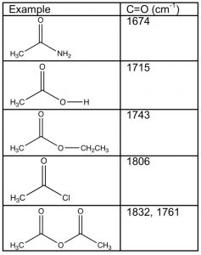
Carboxylic acids and their derivatives have a number of features in common, the most obvious being that the carbonyl carbon has three bonds to electronegative elements—the carbonyl carbon is, therefore, in a higher oxidation state than aldehydes and ketones. However, the nature of the electronegative atom bonded to the carbonyl does impact the properties of the molecule as a whole. For example, if we examine the carbonyl absorptions of these derivatives, we find quite a wide range of frequencies. Recall that most aldehydes and ketones absorb around 1710-30 cm–1, similar to the value displayed by carboxylic acids. Derivatives of carboxylic acids, however, range from around 1670 cm–1 for amides to 1810-30 cm–1 for acid chlorides and anhydrides. How can we explain the difference and use it to predict (and explain) differences in the properties of these derivatives?
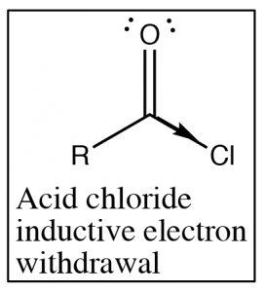
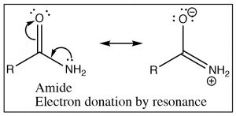
Recall that the IR absorption frequency of carbonyls depends on the energy required to stretch the bond (which is determined by the bond energy). Since the amide absorption frequency is much lower than the absorption frequency of the acid chloride we can conclude that the carbonyl group in the amide requires less energy to stretch than the acid chloride (the bond is weaker). If we look at the structures of these two functional groups we see that both involve an electronegative element bonded to the carbonyl carbon, leading to electron withdrawal by induction through the sigma bond to the carbon. The difference between the two (amide and acid chloride) arises because the amide nitrogen can also donate its electron pair to the carbonyl oxygen. The result is that in amides there is significant overlap between the lone pair of the amide nitrogen and the carbonyl pi bond system. The C-O bond now has less double bond character and therefore it takes less energy to stretch. In contrast chlorine (or any halogen) is not basic and so does not participate in this kind of resonance through the pi system. In acid chlorides, the chlorine is removing electron density from the carbon by induction through the pi system; there is more C=O double bond character than in an amide and it takes more energy to stretch the carbonyl bond (leading to a higher IR absorption).
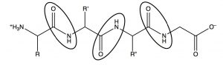
Electron donation from the nitrogen means that the lone pair on the amide nitrogen is not as available for donation to acids. This means that amides are not basic, or rather, nowhere near as basic as amines in which the lone pair is freely available for donation to an acid. This has important ramifications in biological systems. In polypeptides, which are amino acids linked by amide functional groups (circled below), amines are protonated at physiological pH (they exist as RNH3+). It is an interesting thought experiment to predict how proteins and peptides would behave if amide nitrogens were more basic. While there are relatively few naturally occurring acidic or basic side chains in polypeptides (from amino acids such as glutamic acid or lysine), every peptide is linked by innumerable amide bonds between the individual amino acids. If all these amide nitrogens were protonated, the peptides and proteins would take up very different structures (since they would have a large positive charge which would, in the absence of counter ions, repel other parts of the molecule).

Relative reactivities of carboxylic acids and derivatives
The evidence from IR spectroscopy can help us predict the relative reactivities of carbonyls. For example: IR spectroscopy evidence tells us that the amide functional group is stabilized and the nitrogen lone pair is conjugated to the carbonyl group, whereas the partially positive charge at the acid chloride carbonyl carbon is increased (because of induction) compared to the amide. Therefore, a plausible prediction is that the acid chloride is more reactive than the amide and, as we shall see shortly, this is true. In general, the order of reactivity parallels the absorption frequency of the carbonyl group, acid chlorides are more reactive than anhydrides, esters and carboxylic acids are fairly similar in their reactivity (except with bases), and amides are the least reactive. In general, aldehydes and ketones are more reactive than all carboxylic acid derivatives except acid chlorides.

Reactions at the carbonyl group of acid derivatives with irreversible nucleophiles
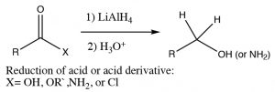
Just as we saw with aldehydes and ketones, we can reduce a carbonyl group by the addition of a hydride ion. Typically, Lithium Aluminum Hydride (rather than sodium borohydride) is used in such a reaction because acid derivatives (amides, esters, anhydrides, chlorides) are usually not reactive enough to react with sodium borohydride. With LiAlH4, the acid or acid derivative is reduced all the way down to the primary alcohol or amine. With acids or esters, the reaction does not stop at the aldehyde step since aldehydes are generally more reactive and the reducing reagent will preferentially reduce any aldehyde as it is formed.
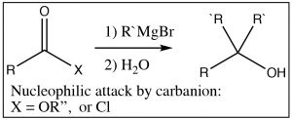
The situation is a different when acid derivatives are reacted with highly reactive carbanions such as Grignard reagents or alkyl lithium reagents. In this case, any derivative that has acidic protons (the carboxylic acid itself or most amides) will simply deprotonate and the reaction will go no further. With esters or acid chlorides, however, two equivalents of the carbanion add to the carbonyl. The reaction goes through the intermediate step of forming a ketone, but just like the LiAlH4 reduction, since ketones are more reactive than acid derivatives, the ketone will undergo nucleophilic attack as they are formed, resulting in the alcohol.

Nucleophilic addition and elimination reactions of acids and derivatives
Just as with aldehydes and ketones, the reaction of acids and derivatives with oxygen and nitrogen nucleophiles is somewhat more complex: at each step, there is the potential for reversal. The formation and decomposition of the tetrahedral intermediate again plays a central role in the outcome of the reaction, and it is possible to use the knowledge of structure and properties to predict how the reaction will proceed. Furthermore, with a knowledge of how concentrations of reactants and products affect equilibrium positions, we can control the outcome of reactions using Le Châtelier’s Principle.
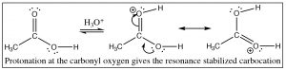
First, we will consider the reaction of a carboxylic acid with an alcohol leading to the formation of an ester. The reaction is typically performed with an acid catalyst and given that information, you should be able to write the mechanism. The first step is protonation; while there are two potentially basic oxygens, protonation tends to occur preferentially on the carbonyl oxygen (not the OH) because the resulting cation can be resonance-stabilized. As with aldehydes and ketones, protonation activates the carbonyl and the next step is attack by the nucleophile—in this case an alcohol. In the reaction scheme below, ethanol reacts with acetic acid to give ethyl acetate.
The crucial part of this mechanism is the series of tetrahedral intermediates that are interconverted by protonating and deprotonating the three different oxygens. Since all these groups are similar (OH or OR) the probability of each of these groups leaving is more or less the same once they are protonated. Just as with aldehydes and ketones, the system will become more stable (with stronger bonds) if the carbonyl group reforms by the elimination of one of the groups attached to the carbon. Again, we can shift the equilibrium for this reaction by manipulating the reaction conditions. Typically, esterifications are carried out using the alcohol as solvent (so it is in large excess), and the water produced is removed as it is formed.
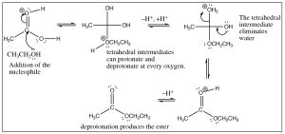
As you might expect, this reaction is entirely reversible, and the reverse reaction is typically carried out in aqueous solution with either acid or base catalysis. In fact, this reaction is the basis of saponification (soap making); in which long-chained fatty acid esters of glycerol (triglycerides) are hydrolyzed in an aqueous solution with a base catalyst.
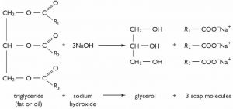
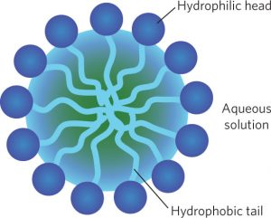
The triglyceride (fat or oil) is insoluble in water, while the sodium salt of the long-chain fatty acid (soap) is soluble. The soap molecules aggregate to form spherical micelles in which the polar head groups lie on the outside and the non-polar tails are inside.

Interconversion of acids and derivatives: predicting outcomes.
As we have just seen, esters can be made from carboxylic acids and vice versa: we can control the outcome of the reaction by using Le Châtelier’s principle. This is because the tetrahedral intermediate contains only oxygen leaving groups and the reactants and products are of similar stability. However, if we react a derivative such as an acid chloride with an oxygen nucleophile, we see that the resulting reaction tends not to be reversible. It is possible to go from the acid chloride to the carboxylic acid (with H2O nucleophile), to the ester (with an alcohol nucleophile), or to the amide (with an amine nucleophile). The reverse reaction is not feasible because 1) the tetrahedral intermediate, for either the forward or the reverse reaction, now has different leaving groups as shown below and 2) the acid chloride is highly reactive (it is destabilized by inductive withdrawal) and the reaction is unlikely to reverse under typical reaction conditions.
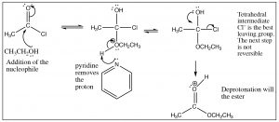
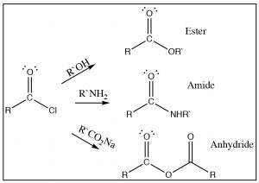
The tetrahedral intermediate reacts to produce the carbonyl by expelling chloride, which is the best leaving group. It is, therefore, difficult to get this reaction to reverse. In fact, the acid chloride can be used to produce all the other acid derivatives, and carboxylic acids. Reaction of acid chlorides with amines will produce amides and, with a carboxylate anion, will produce acid anhydrides as shown. In each case chloride is the best leaving group when the tetrahedral intermediate collapses, and the more stable product is formed.
You may now be asking yourself if acid chlorides are such good reactants, how can we make them in the first place? We cannot use chloride ion to do a nucleophilic addition/elimination on any other acid derivative, so how can we get around that problem? The answer is to introduce an even better leaving group into the molecule. One example is the reaction of carboxylic acids with thionyl chloride (SOCl2). The sulfur in thionyl chloride is highly susceptible to nucleophilic attack—much more so than the carbonyl—because of all the electronegative groups attached to it. The first step is attack by the carboxylic acid oxygen on the SOCl2, as shown below.
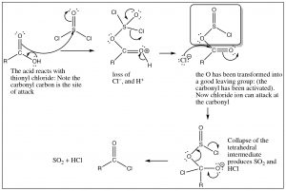
The intermediate that is formed has an excellent leaving group (in the shadowed box). In effect, we have activated the carbonyl and made it more reactive. Attack of chloride ion can now proceed and the reaction will move forward because we have a better leaving group than chloride. The tetrahedral intermediate now collapses and, at the same time, the leaving group decomposes to give SO2 and hydrogen chloride, both of which are gases that are expelled from the reaction mixture which drives the reaction towards products (Le Chatelier’s principle).
In this reaction, we have seen a very important and powerful idea: we have been able to drive a reaction forward to produce a thermodynamically unfavorable product by producing a highly reactive intermediate. We encountered simpler examples earlier: for example, protonating an alcohol or preparing a tosyl derivative to transform OH into a good leaving group. In this case, the reaction is messy and toxic (it’s no fun at all to do this reaction in a laboratory), but biological systems use this strategy to bring about thermodynamically unfavorable reactions. As we will discuss later in the course, substrate reactants can be activated by this same strategy of making an OH into a good leaving group that then leads to the formation of a product that could not be produced under normal circumstances. For example, the formation of sucrose from glucose and fructose proceeds using such a (enzyme-catalyzed) strategy. In this case, activation involves the activation of an OH group by coupling with ATP.

Preparations of carboxylic acids.
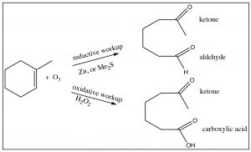
All the derivatives of carboxylic acids can be produced from the acid form, although it may occur via the acid chloride. We have also seen several reactions in which carboxylic acids can be produced by alternative mechanisms: for example, via the oxidation of primary alcohols or aldehydes. It turns out that we can also produce acids by ozonolysis (reaction with ozone O3) if one or both of the alkene carbons are bonded to a hydrogen. When we looked at such reactions previously, they were accompanied by a reductive workup (either Zn, or dimethyl sulfide) and arrested at the aldehyde level. If instead we use an oxidative workup with hydrogen peroxide, the oxidation goes all the way through to the carboxylic acid.
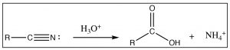
Another reaction that is often used to produce carboxylic acids is the hydrolysis of nitriles (RCN). The nitrile carbon is at the same oxidation state as a carboxylic acid, and when treated with aqueous acid (or base), it undergoes a hydrolysis reaction in just the same way as we have seen on numerous occasions (try it—you will see!).
Finally, a different approach to producing carboxylic acids occurs when we react a Grignard reagent (or alkyl lithium) with carbon dioxide. You may recall from general chemistry that CO2 is a linear molecule and has no overall molecular dipole. However, each C=O bond in the molecule is polarized, leading to a partial positive charge on the central carbon that makes it susceptible to nucleophilic attack. Therefore, when reacted with a Grignard reagent, the end result is the formation of a new C-C bond with the CO2 becoming a carboxyl group.
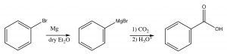

The Wittig Reaction
This reaction allows us to synthesize alkenes by adding the two carbons of the alkene double bond together. This is a very powerful synthetic technique that allows us to construct larger molecules from smaller ones. It is much more efficient to add two molecules together, than to try and synthesize a large molecule one carbon-carbon bond at a time.
The Wittig reaction starts by preparation of a reagent that involves addition of an alkyl halide to a phosphine (the phosphorus analog of an amine), such as triphenylphosphine (Ph3P). This reaction is directly analogous to the alkylation of amines that we have seen previously to produce the phosphonium salt as shown. However, the reaction can go further in the presence of a base to produce the stabilized carbanion by deprotonation of the carbon next to the phosphorus as shown.
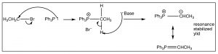
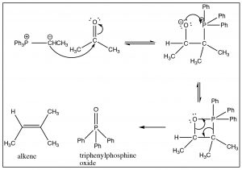
The Wittig reagent can then react with an aldehyde or ketone as shown. The first step, as we might imagine, involves nucleophilic attack at the carbonyl, but since the carbanion is also attached to the phosphorus, another avenue of reaction is now available. The tetrahedral intermediate undergoes further reaction in which the oxygen bonds to the phosphorus and then, via a cyclic rearrangement of electrons, the four-membered ring rearranges to form the alkene and triphenylphosphine oxide. In fact, it is the formation of the very strong P=O double bond that makes this reaction essentially irreversible, and drives the reaction towards products.
The Wittig reaction can be used to prepare many different alkenes. In general, if there is a possibility of E/Z isomerism, the most stable alkene will be produced (for example a trans isomer rather than a cis isomer). But, just as we have seen many times, it is possible to manipulate the reactants and reaction conditions to produce the desired product—a subject for a more advanced treatment of organic chemistry.

Synthesis
Up to now, we have focused mostly on the reactivity of organic molecules, particularly from the standpoint of being able to predict reactivity from the structure of a particular compound. We have also discussed how spectroscopic techniques allow us to determine molecular structure. However, we have not really discussed another of the major areas of organic chemistry, that is: the design and synthesis of molecules, particularly those that may be expected to have biological activity (drugs of various sorts). Now that we have a fairly large repertoire of reactions to choose from, let us take a closer look at the kinds of decision-making that goes into designing molecular structures.
Typically, molecular synthesis involves a target structure, which may be an actual molecule, or it could be a substance that has particular properties: for example, the active site of an enzyme or a regulatory domain of a protein. To achieve specificity, the molecule to be synthesized must fit into the surface of the protein and influence its structure or catalytic activity. The better the fit, the more specific (higher affinity, fewer non-target interactions) interactions the drug will make. We will begin by thinking about how to go about the synthesis of a given molecule. Molecular synthesis is both an art and a science: it requires that you have at your fingertips a good collection of reactions you have organized in such a way as to make them accessible to you, but it also requires creativity and imagination. There is always more than one way to design a synthesis and, in reality, there are many setbacks and path changes since reactions may not go as planned, so alternative routes have to be considered. In this section, we will look at strategies that you might employ to design a synthesis of a target molecule.
Retrosynthetic analysis
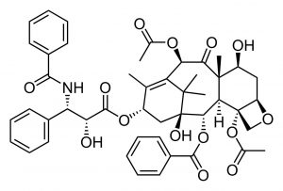
Retrosynthetic analysis is exactly what it sounds like: you begin with the target and move backwards one step at a time to identify what reactants and reagents could have produced the products. This is often the situation when you are dealing with a natural product that was originally isolated based on its biological activity. A classic example is the molecule Paclitaxel, which was isolated from the Pacific yew tree, Taxus bervifolia, based on its anti-cancer properties.
The process of molecular synthesis can be broken down into a number of steps, but as we will see, depending on the nature of the task, we do not always approach synthesis in a linear manner.
Step 1: Identify the number of carbons in the target molecule and determine whether you will need (at some point in the synthesis) to make new carbon-carbon bonds.
Step 2: Identify what functional groups are present in the molecule. Functional groups are where the reactivity of any molecule lies and they give you a place to begin because you now know ways to produce that functional group.
Step 3: Identify which bonds are going to be made during the reaction in which the product is produced.
Step 4: This will allow you to work backwards to identify what the precursor is and (using your knowledge of functional group transformations) decide what reaction will product the product.
Step 5: Repeat until you reach a recognizable target material.
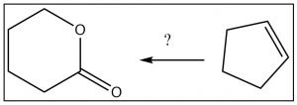
Let us approach the process with a (significantly simpler) target. Let us design a synthesis of the lactone (cyclic ester) from cyclopentene. We begin by noting that both the starting material and the product have five carbons, which means we do not need to consider any carbon-carbon bond formation reactions. However, the route from cyclopentene to the lactone is not obvious, so let us go back one step at a time as outlined below.
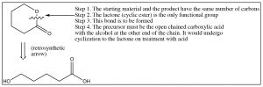
So, we have the immediate precursor to the lactone, but how do we get that from cyclopentene? While you could continue moving backwards through the steps, the knowledge that you don’t have to construct the carbon skeleton makes a difference in the way that you might approach the problem. For example, if you look at the starting material, it is clear that there is no five-membered ring in the product and no alkene. Not only that, but at each end of the carbon chain is at least one oxygen. Is there a reaction that will allow us to open up that ring and, at the same time, introduce oxygens at each carbon? Yes! Recall that alkenes can be cleaved by ozonolysis (under oxidizing conditions), to give the dicarboxylic acid. If one of those carboxylate groups can be reduced to the alcohol, something that might well be be difficult to do in practice, the ring would cyclize spontaneously to give the lactone as shown below.
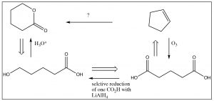
Note that, in this synthesis, we mixed up both retro and forward synthetic analysis to produce an overall synthetic pathway. This is where some of the art and imagination come into play. When you are trying to design a synthesis, it is a good idea to start from the product and work backwards—but at some point you may have to also work forward. Every synthesis is different and, as we noted before, there are often many synthetic routes that can be designed for any single target molecule.

The pK
of protonated amines (RNH
) is about 10. Using the Henderson Hasselbalch equation, we see that the ratio of [RNH
]/[RNH
] is about 0.001—that is, there is 1000 times more protonated than unprotonated amine.

Both HCl and SO
are highly toxic, requiring special precautions—another one not to try at home.

Chapter

Chapter 8: Conjugated compounds and aromaticity
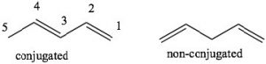
Conjugation: Conjugation is the term we use to describe an arrangement of alternating single and double bonds. To explain how conjugated systems behave differently from non-conjugated systems we will compare 1,3-pentadiene (which is conjugated) and 1,4 pentadiene (which is not conjugated). To recognize the differences between the two, let us look at the orbitals that are involved in the π system bonding. Recall that π bonds can be considered as the side-to-side overlap of p orbitals, so that the electron density lies above and below the plane of the rest of the molecule. Consider the orbitals in 1,3-pentadiene: there is overlap of p orbitals that result in a continuous
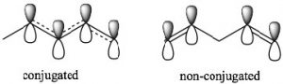
π orbital system over carbons 1-4. The consequence of this is that there is some partial double-bond character between carbons 2 and 3. In 1,4-pentadiene there is no possibility of overlap between the two separate π bonds. Note that in the non-conjugated system, there is an sp3 hybridized carbon between the two sets of sp2 hybridized carbon-carbon double bonds which prevents any overlap of (p) orbitals on carbons 2 and 4.
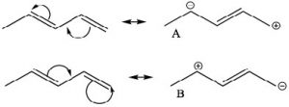
One way to indicate and predict where this partial double bond character can occur is to use resonance structures. We can write resonance structures for the conjugated system which have double bond character between C-2 and C-3. Note that since resonance contributors A and B are equivalent, there is no actual charge separation in this molecule. It is not possible (without breaking a sigma bond) to write resonance structures like this for 1,4-pentadiene (try and convince yourself that this is true ).
MolecularOrbitalTheory: Another model that can be used to describe the bonding is to consider the π system in terms of molecular orbital theory. Molecular orbital theory considers the bonding orbitals as extending over the whole molecule. The number of molecular orbitals is equal to the sum of all the atomic orbitals. In practice, this approach is far too complex for even the smallest of organic molecules, which is why we usually use the simpler valence bond model in which we consider bonds as being located between two atoms. In the case of conjugated systems, it is often helpful to use the valence bond approach for the sigma (single bonds) framework and then consider the conjugated π system using molecular orbital theory. In this case, if we have a conjugated system of two π bonds, then four p atomic orbitals are involved in forming the four molecular orbitals (MOs). Recall that when molecular orbitals are formed from atomic orbitals (AOs), if the (quantum mechanical) wave functions add in phase, the resulting energy of the MO is lower—that is, the interaction is stabilizing and the MOs are bonding MOs. If the AOs add out of phase, the interaction is destabilizing and the result is antibonding MOs. Note that, in the diagram (↓), only the lowest energy MO has electron density between carbons 2 and 3. All the other MOs have a node (no electron density) at this position. Overall, we see that there is more π electron density between C-1 and C-2, and between C-3 and C-4.
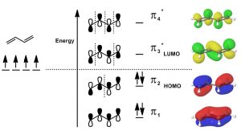
Since there are only 4 π electrons, only the two bonding MOs are occupied while the two antibonding MOs are unoccupied. As we will see, if we consider reactions using MO theory, the Highest Occupied MO (HOMO) and the Lowest Unoccupied MO (LUMO) are the orbitals that participate in new bonding interactions. In general, we use the simplest model that allows us to predict and explain the outcome of reactions, which is usually valence bond theory, but we will call on MO theory when necessary—and discussions of conjugated systems sometimes require MO theory to explain phenomena.
Stability of Conjugated Systems: As we have seen before, one way to identify the thermodynamic stability of alkenes is to reduce them to the corresponding alkane by adding H2 (hydrogens) across the double bond and determine the enthalpy change. In the case of 1,3- and 1,4-pentadiene, we can compare their heats of hydrogenation to produce the corresponding pentane; we find that the conjugated diene is about 25 kJ/mol more stable. This is a general finding: the more conjugated a system, the more stable it is and the less reactive it is.
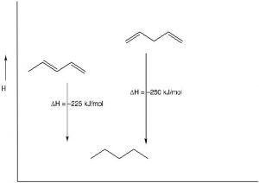

UV-VIS Spectroscopy and Conjugated Systems: Review
As you probably remember, the more atomic orbitals that combine to produce molecular orbitals, the smaller the energy gap between the MOs becomes. For example, an electron in an isolated pi bond absorbs energy in the far UV (~170 nm), a rather high energy. As we increase the number of conjugated double bonds, the energy gap between the orbitals (in fact the gap between the HOMO and LUMO) gets smaller and smaller, so that lower energy photons can bring about this transition. Eventually, the wavelength of light needed to promote an electron from highest occupied to the lowest unoccupied MO (HOMO→LUMO) moves into the visible region, and the substance becomes colored. Note that its color does not represent the the light that is absorbed, but rather the light that is transmitted or reflected. These conjugated regions of molecules are called chromophores. The longer the conjugated section of the molecule, the longer the wavelength that is absorbed. The compounds responsible for highly colored fruits and vegetables—such as lycopene and B-carotene, as well as your ability to see visible light (retinals) contain large chromophore regions.
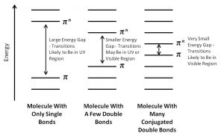
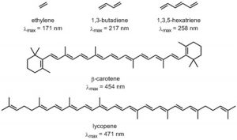
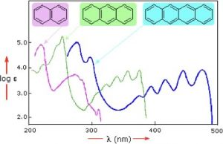
Samples of UV-VIS absorption spectra are shown here (→). Note that, in contrast with most other spectroscopic techniques (which usually produce sharp lines), the peaks in these spectra are more broad; the longer the conjugated section of the chromophore is, the longer the wavelength (and lower energy) that it absorbs. This means that each of these compounds has a different color. Moreover, the fact that the peaks in these spectra are not sharp means that UV-VIS spectroscopy is typically not used for identification of compounds. However, the amount of light absorbed is proportional to the concentration of the substance, so UV-VIS spectroscopy can be used to determine the concentration of samples. The visible spectrum runs from about 300nm to 750nm.
Reactions of Conjugated Systems: Kinetic and Thermodynamic Control of Reactions: Now let us consider the reaction of 1,3-butadiene with a reagent such as HCl. Just as we saw with isolated alkenes, the first step in the reaction is the addition of the electrophile H+ to produce the most stable carbocation. In this reaction, the proton adds to C-1; the resulting carbocation is resonance-stabilized with positive charge at both C-2 and C-4. The question, then, is: where does the nucleophile add?
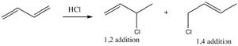
In fact, the position of equilibrium depends upon the conditions under which the reaction occurs. First, let us consider the two potential sites of attack. Attack at C-2 would mean that the reagent has added across the C-1/C-2 pi bond—this is called 1,2 addition. Attack at C-4 is called 1,4-addition and the two products are clearly different.
The partial positive charge at C-2 is located on a secondary carbon, whereas that on the C-4 is on a primary carbon. This means that the intermediate carbocation has more partial positive charge on C-2 than on C-4 and the transition state for the reaction to give the 1,2-addition product will have a lower activation energy than the transition state for the 1,4 product because it is more stabilized (by induction and hyper-conjugation). Therefore, the attack of the nucleophile (chloride) would occur faster at C-2; that is, 1,2 addition is the kinetically favored product.
However, if we consider the 1,4-addition product, the alkene product itself is more substituted (there are two alkyl groups on the double bond) and, therefore, it is more stable than the product of 1,2 addition. Even though the 1,4-addition product is formed more slowly through a less-stabilized transition state, the product itself is more stable; it is the thermodynamically favored product.
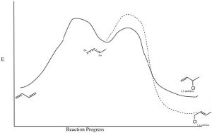
In fact, by controlling the reaction conditions, it is possible to produce either the kinetic or the thermodynamic product. If the reaction is run at relatively low temperature, there will not be enough energy to overcome the activation energy barrier associated with the 1,4-addition product reaction and the kinetic (1,2) product will be produced. However, at higher temperatures, there is enough energy; the 1,4 activation energy barrier will be reached more often, so that even if the kinetic product is formed, the fact that the reaction is reversible will, over time, lead to the most stable product accumulating at equilibrium. It is important to note that the most stable product is not always formed—it depends upon reaction conditions.
Conjugated carbonyl compounds: Carbonyl compounds can also be conjugated with carbon-carbon double bonds. These compounds are often referred to as α,β unsaturated carbonyls (the carbon next to the carbonyl carbon is termed the alpha carbon). By drawing resonance forms for this system, we see that there is a partial positive charge on the carbonyl carbon and on the β carbon. This means that α,β unsaturated carbonyl compounds are susceptible to nucleophilic attack at both the C=O and at the β carbon. Which is analogous to the 1,2- and 1,4-additions to conjugated dienes.
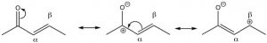
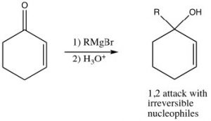
Just as the 1,3-conjugated diene case, attack at the carbonyl carbon is the kinetically preferred product since there is more positive charge there and the reaction is faster. Reagents that attack carbonyls irreversibly, such as grignards, alkyl lithiums, or reducing agents such as LiAlH4 will, therefore, tend to produce the product of attack at the carbonyl. This is the 1,2-addition product.
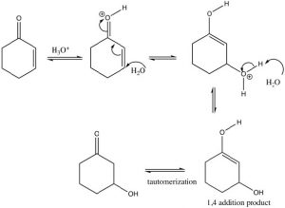
If we use a reversible nucleophile (ROH, H2O, RNH2), then the most thermodynamically stable product will predominate, that is, the product of 1,4 addition. However, this product undergoes a tautomerism that regenerates the carbonyl (which is the source of the stability—recall C=O bonds are very strong).
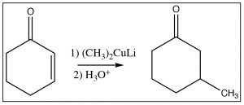
Another reagent that can produce a product resulting from attack at the beta carbon is a reagent that we have not seen yet, an organocuprate, otherwise known as the Gilman reagent, which consists of a complex of alkyl groups, copper, and lithium and has the generic formula R2CuLi. The general reaction is shown here. The organocuprate has the two alkyl groups bonded to the copper species (formally Cu2+), but the carbon-copper bond is more covalent than ionic (the charge on the carbon is lower than on the equivalent Grignard or alkyl lithium reagent) and this makes attack at the beta carbon more likely.
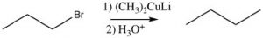
Gilman reagents are also very useful because they can accomplish nucleophilic attack on alkyl halides, which does not occur with Grignard or alkyl lithium reagents.

Aromaticity
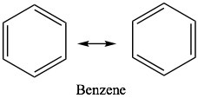
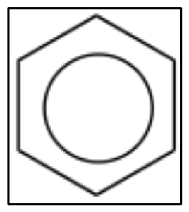
After considering some of the properties of conjugated systems, we now move on to what might be the ultimate in conjugated systems, as exemplified by benzene C6H6. While many of the properties of benzene and its derivatives are similar in some ways to those of open-chained conjugated systems, there are important differences. Benzene has the property known as aromaticity and we say that benzene is aromatic. In everyday language, the term aromatic implies that something smells; usually in a good way. While benzene does have a fairly strong smell, in chemistry, aromatic has come to mean a particular set properties that emerge from the molecular structure of some molecules. Benzene is the simplest and most common example of an aromatic compound. The structure of benzene was something of a puzzle for quite a long time; it eventually came to be written in the form of what are now called Kekulé structures in which double and single bonds appear to alternate around the ring. We can write two equivalent resonance structures which contribute equally to the overall structure of the molecule. While these models can serve us well when trying to figure out what the electrons are doing during reactions, neither is not adequate to represent the actual structure of benzene. Sometimes, you will see benzene written with a circle in the middle (ß) to indicate that, in reality, there are no single or double bonds present; rather, there is the same electron density (1.5 bonds) between all the carbons.
Benzene has some rather remarkable properties which led chemists to classify it as a member of a completely different type of functionality. For example, benzene is much more stable than one might imagine—even for a conjugated system. The heat of hydrogenation of benzene is -208 kJ/mole, while the ΔH of hydrogenation of the isolated double bond in cyclohexene is 130 kJ/mol. We can see the effects of conjugation in 1,3-cyclo-hexadiene, which is 232 kJ/mol (not 260 as might be expected if it were conjugated). Similarly, if benzene were not conjugated, we would expect a heat of hydrogenation to be 3×130 = 390 kJ/mol. Therefore, the difference between the expected and the actual hydrogenation energy must be due to the stabilization conferred by resonance.
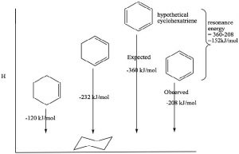
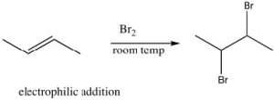
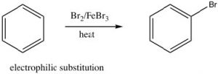
This stability is called the resonance energy and, in aromatic compounds like benzene, it has a significant effect on the properties of the substance and types of reactions that a molecule participates in. For example, benzene does not react with electrophiles in the same way as isolated alkenes or even open-chained conjugated alkenes. Recall that the most common reactivity of simple alkenes is the electrophilic addition of E-Nu, where E is an electrophile and Nu is the nucleophile, across the double bond. In contrast, benzene undergoes electrophilicsubstitution; typically the reaction conditions require a catalyst and extensive heating. We will discuss the mechanism of this reaction shortly, but for now the important thing to note is that it is difficult to disrupt the aromatic ring of electrons and, when that does happen, the aromatic ring regenerates.

What is aromaticity and how do we recognize aromatic systems?
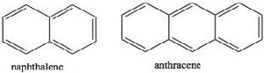
To recap, benzene is uniquely stable and it is relatively difficult to get it to react, despite the high electron density in the ring. It is significantly more stable than cyclohexadiene which is conjugated, but only contains two bonds. There is clearly something special about a conjugated ring system above and beyond simple conjugation properties.
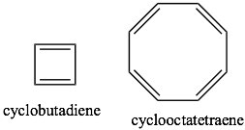
If we examine other systems, we can begin to find the parameters that govern the property of aromaticity. We can begin by looking at some other cyclic, conjugated systems. Many fused six-membered rings (for example: naphthalene and anthracene) are aromatic. However, cyclobutadiene and cyclooctatetraene are not aromatic and have quite different properties.
By investigating many cyclic conjugated systems, it has been possible to identify the factors that lead to aromaticity.
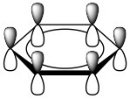
These are known as Huckel’s Rule: Aromatic compounds are planar, cyclic, conjugated, and have 4n+2 π electrons in the π electron cloud. Benzene is the archetypal aromatic compound: it is planar (all carbons sp2 hybridized), cyclic (obviously) conjugated (apparent alternating single and double bonds), and it has 6 π electrons (n=1). If we look at the bonding within benzene, we see that overlapping p orbitals form a ring of pi electron density above and below the sigma C-C framework. More generally, aromatic compounds must be planar, cyclic, and conjugated so that the p orbitals overlap to form this continuous ring of electron density. So why do aromatic compounds have 4n+2 π electrons? The answer involves molecular orbital theory.
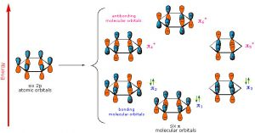
As previously noted, a consideration of the number and type of atomic orbitals that contribute to the bonding system enables MO theory to predict the molecular orbitals that span the whole molecule. In benzene, we have six p atomic orbitals and, therefore, expect that they combine to give six molecular orbitals as shown here. Note that there are three bonding and three antibonding MOs and, since there are only six electrons in the system, we get a total of three bonds.
This type of analysis can be done for any cyclic conjugated system. While it is too complex here to go into the mathematical underpinnings, there is a relatively simple way to determine the relative energies of the MOs. The approach requires that you inscribe the cyclic system into a circle, with one corner of the ring at the bottom. The places where the corners meet the ring are represent the relative energies of the MOs, as shown below. This arrangement is the origin of the 4n+2 rule as we will see.
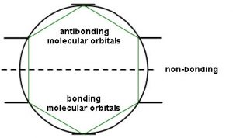
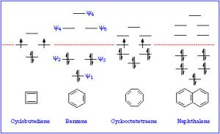
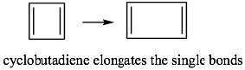
So, for example, if we consider cyclobutadiene (which has 4n π electrons), we see that there are 4 MOs and 4 electrons. However, two of those electrons are in non-stabilized orbitals AND are uncoupled because the orbitals are of the same energy. Remember Hund’s rule: electrons occupy orbitals singly until they have to start doubling up.
This means that if cyclobutadiene were aromatic, it would be highly unstable because it would contain two unpaired electrons—it would exist as a diradical. The presence of unpaired electrons generally makes compounds very reactive. In fact, cyclobutadiene is not aromatic and instead exists as two isolated double bonds by lengthening the single bonds. Even so, it is still unstable and does not exist above -78º C.
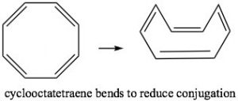
Cyclooctatetraene also has 4n π electrons (where n=2), and again we see the problem is that there are a pair of degenerate (same energy) MOs, where the last two π electrons are located. Again, this is highly destabilizing and, to avoid this electron configuration, cyclooctatetraene actually bends so the double bonds are not conjugated with each other. The origin of the n+2 rule, then, has to do with the arrangement of MOs. Any cyclic conjugated compound with 4n π electrons will not be able to take up a stable conjugated arrangement because it will involve the highly unstable diradical.

Aromatic Ions
The stability conveyed by aromaticity can be a powerful driving force. For example, cyclopentadiene is quite acidic with a pKa of 15 (compared to > 50 for alkanes). It is the sp3 hybridized carbon that is deprotonated and it rehybridizes to sp2 so that conjugation around the ring is possible. The product cyclopentadienyl anion is aromatic since it now has 6 π electrons; two from the lone pair resulting from the deprotonation and four from the original pi system. It is the drive towards aromaticity that makes cyclopentadiene so much more acidic than a normal alkene.
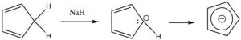
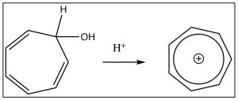
Similarly, cycloheptatriene can be induced to become a positively charged aromatic ion by treating the corresponding alcohol with acid which will allow the OH to leave as H2O, leaving behind a positively charged delocalized aromatic ion (the tropylium cation), which has six electrons delocalized over seven carbon atoms. In fact, there are quite a few ways to generate such aromatic anions, and they are all more stable than might be predicted if you didn’t know about aromaticity.

Heterocyclic aromatic compounds
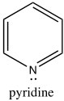
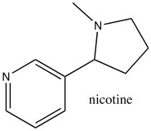
While the aromatic ions are interesting curiosities, there is a class of aromatic compounds that are of practical importance from a biological perspective: the heterocyclic aromatic compounds. These compounds typically have one or more carbons replaced by N, O, or S. For example, pyridine can be considered as the nitrogen analog of benzene. The nitrogen is sp2 hybridized and contributes an electron to the aromatic system. Pyridine is an important component of many biological molecules; for example, nicotine, a component of the NAD and NADH oxidation/reduction system discussed earlier. The lone pair on the pyridine nitrogen sits in an sp2 hybrid orbital at right angles to the pi system (like the C-H bonds) and, therefore, pyridine is basic because the lone pair is accessible. In fact, pyridine is often used as a base to react with any by-product acid such as HCl that might be produced in a reaction.
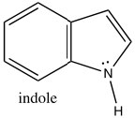
Indole is another heterocyclic aromatic system, but, in contrast to pyridine, indole uses the nitrogen lone pair to contribute the aromatic pi system. Indole has 10 π electrons (n=2), of which two are from the nitrogen lone pair.
Consequently, indole is not basic. The ring system of indole also appears in many biologically important molecules, including the neurotransmitter serotonin, amino acid tryptophan, and hallucinogen lysergic acid diethylamide (LSD).
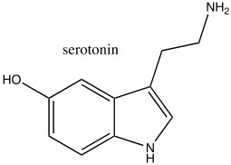
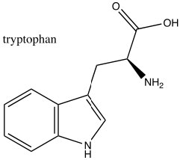
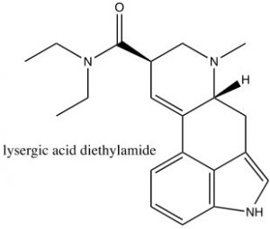
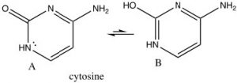
There are many biologically important nitrogenous aromatic heterocycles, for example the bases in DNA and RNA all contain heterocyclic aromatic rings. For example, cytosine, which is usually written in the keto form (structure A) – which may not at first sight seem to be aromatic. However, all the atoms in the ring are planar sp2 hybridized and there are six electrons in the ring. The result is that cytosine can exist in its tautomeric enol form (B), but the keto form is actually more stable (because of the C=O). Both enol and keto forms are aromatic.

Spectroscopy of aromatic compounds:
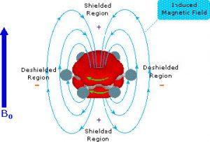
As you might expect, both the C-13 and the 1H NMR spectrum of benzene show only one peak (H-NMR 7.3 ppm and C-NMR 128 ppm) meaning that there is only one type of carbon and one type of hydrogen present in the molecule. However, these single peaks appear at lower field strengths relative to those found in alkenes or even conjugated alkenes (which normally appear between 5 and 6 ppm in the H-NMR). This low field absorption is caused by a phenomenon that occurs when the cyclic electron cloud in the ring is placed into an external magnetic field. The ring of electron density begins to cycle, producing a ring current and an induced magnetic field; the resulting intrinsic field reinforces the external field. The result is that the external field does not need to be very high to bring the carbon or hydrogen nuclei to resonance. In effect, the aromatic carbons and hydrogens are deshielded and appear at low field.
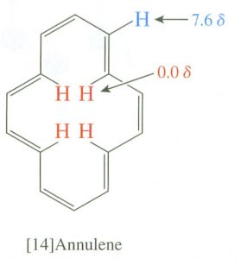
Interestingly, the induced field opposes the external field in the center of the ring, and, in fact, there are cyclic aromatic polyenes where (because of structural constraints) some of the hydrogens do point to the center of the ring. There is a marked difference between the inner and outer hydrogen resonances in these compounds because the hydrogens are in different areas of the induced magnetic field. This effect is called diamagnetic anisotropy.
The IR spectra of aromatic compounds typically show a C-H stretch above 3,000 cm-1, and a C-C bend around 1600 cm-1, but these signals are often mixed in with others and, in general, IR is not very useful for identifying aromatic compounds. On the other hand, UV-VIS spectroscopy is often used to identify the aromatic chromophore. Benzene itself has a broad absorption around 254 nm and, as we will see, this absorption changes depending on the electron withdrawing and donating properties of groups on the ring itself.

Reactions of Aromatic Compounds: Introduction of one group onto the ring
As we have seen, aromatic compounds are considerably more stable than one might predict. Consequently, it takes more energy to make aromatic compounds undergo reactions since, in order to react the aromatic overlap of orbitals in the ring, it must be destroyed at some point during the reaction. Since the aromatic ring is so electron-rich we might predict that it would undergo electrophilic attack but, rather than undergoing electrophilic addition like alkenes and conjugated alkenes do, aromatic compounds typically undergo electrophilic substitution. For example, benzene will react with bromine in the presence of a catalyst such as iron (III) bromide (FeBr3) to give bromobenzene.
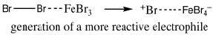
Let us now take a closer look at the steps involved in this reaction to see how this substitution (Br for H) is accomplished. Since benzene is so stable, a more reactive electrophile is needed to react with the ring. This is accomplished by adding a Lewis acid catalyst FeBr3, which forms a complex with the bromine to produce Br+ (stabilized by the FeBr4–). The Br+ electrophile now reacts with the electron-rich benzene ring to produce a resonance-stabilized intermediate called a sigma complex.
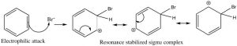
Now, instead of a nucleophile attacking, the aromatic ring is regenerated by loss of a proton.
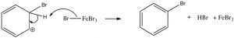
The resulting bromobenzene is much more stable than the corresponding addition product.
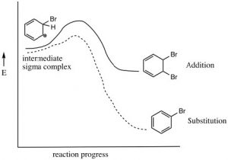
This electrophilic substitution reaction is the primary mechanism by which most aromatic compounds react. A very reactive electrophile must be generated; it then adds to one of the ring carbons followed by loss of a proton from the same carbon.
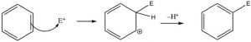
There are a number of substituents that can be introduced onto the ring in this way, including nitro, alkyl, acyl, and sulfonyl groups. Each proceeds via a similar mechanism (via a reactive electrophile that is generated in the reaction) either by using a catalyst or by using very reactive reagents.
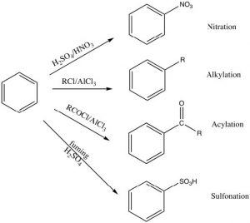
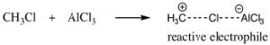
Alkylation and acylation can be accomplished by treatment of an alkyl halide or acyl halide with a Lewis acid catalyst such as aluminum trichloride (AlCl3). In this case, the reactive electrophile is generated when the alkyl (or acyl) halide interacts with the catalyst to produce an intermediate that is carbocation-like. It is this very reactive species that reacts with the benzene ring to produce the substituted benzene. This reaction is called a Friedel-Crafts alkylation (or acylation). The acylation reaction is usually preferred because it is difficult to stop an alkylation reaction at just one substitution since the product is more reactive than the starting material (see below).
Nitration is accomplished by treating benzene with a mixture of concentrated nitric and sulfuric acids. This mixture generates a nitronium ion (NO2+), which is the reactive electrophile.
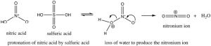
Sulfonation is accomplished by using fuming sulfuric acid, which actually contains sulfur trioxide (SO3) dissolved in the sulfuric acid. It is the actually the SO3 that is the electrophile in this case.
Some groups cannot be introduced directly onto the ring: for example, groups that we might normally consider as nucleophiles (such as NH2 or OH) have to be introduced indirectly. For example, aniline (aminobenzene) can be produced from nitrobenzene by reduction.
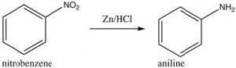
As we will see later, other nucleophilic groups have to be introduced by a different approach.

Multiple Substituents: Directing Effects.
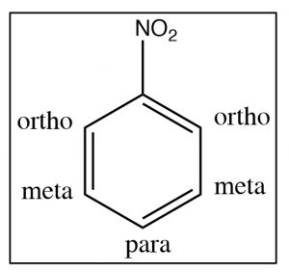
In this section, we will consider how substituents on the ring affect further reactions. It turns out that we can classify substituents into three groups. To understand and identify what these classifications are, let us take a look at some evidence beginning with nitrobenzene. There are two ways to identify positions on a substituted benzene ring: one way is simply to number the ring starting at the substituent; the other (which can only be used for disubstituted benzenes) is the ortho, meta, and para nomenclature as shown .
As we have seen, nitrobenzene can be produced by treating benzene with a mixture of nitric and sulfuric acids. If this reaction is carried out at room temperature, nitrobenzene is produced. If the reaction mixture is heated, eventually another product is produced. While there are three possible products (1,2- or 1,3- or 1,4-dinitrobenzene) only 1,3-dinitrobenzene (or meta-nitrobenzene) is formed. In addition, it is formed much more slowly and it is quite easy to isolate only the mono-nitro product.
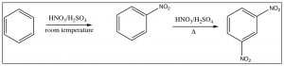
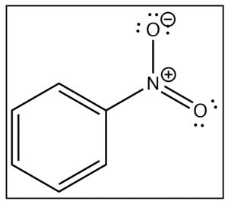
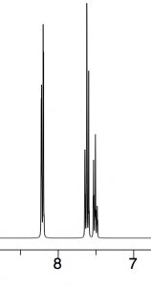
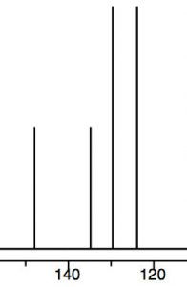
To understand why only one further product is formed and why the rate of the second substitution is slower (so that it requires more energy to surmount the activation energy barrier), let’s take a look at nitrobenzene itself. Notice that the positively charged nitrogen is adjacent to the ring. We might expect that this would remove some electron density from the ring and indeed it does. We can see this effect both in the C-13 and 1H NMR spectra, where the peaks are shifted to the lower field. Recall that benzene H signals all appear at 7.3 while in nitrobenzene we see that not only are there different signals, but that they are all at a lower field than benzene. There are chemically distinguishable hydrogens in nitrobenzene (2 ortho, 2 meta and 1 para).
The lowest field 2H doublet at 8.2 ppm corresponds to the ortho Hs, the 2H signal at 7.6 ppm is the two meta Hs, and the signal at 7.5 is the para H. In the C-13 NMR spectrum, all the carbons in benzene appear at 128 ppm. In nitrobenzene, C-1, the carbon bonded to the nitro group is, as we might expect, shifted downfield to 148 ppm because of its proximity to the positively charged nitrogen.
The evidence shows us that nitrobenzene is less electron-rich than benzene—in fact, it reacts with electrophiles 10,000 times more slowly than benzene—but why does it only produce one product on dinitration? The answer to this lies in the structure of the intermediate sigma complex. If you draw out the resonance forms for reaction at the ortho, meta, and para positions, what becomes clear is that the meta position is the only one that does not (cannot) place the negative charge on the original nitro-substituted carbon. Both ortho and para substitution are highly disfavored because these intermediates are of such high energy (because of the adjacent positive charges), and, therefore, only the meta product is formed.
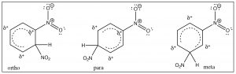
Nitro groups belong to the class of substituents that are deactivating meta directors. Other substitutents that belong in this group are sulfonic acids (SO3H) and any group with a carbonyl next to the ring (aldehydes, ketones, carboxylic acids, and derivatives). All of these groups are destabilized by having a positive charge on the adjacent carbon.
It makes sense then that there is another group of substituents that are activating ortho, para directors. For example, all alkyl groups fall into this classification because they are electron donating by induction. Toluene (methyl benzene) is the simplest example, and indeed when we nitrate toluene, we see a mixture of ortho and para products because now these are the intermediate sigma complexes that can be directly stabilized by induction from the methyl group.
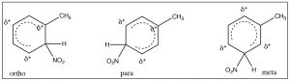
In this case, the ortho and para substitution products are stabilized and produced preferentially. The ratios of products are approximately 2:1 ortho to para (because there are two possible ortho positions). Indeed toluene can be nitrated further until all the ortho and para positions are substituted to give 2,4,6-trinitrotoluene, otherwise known as TNT.
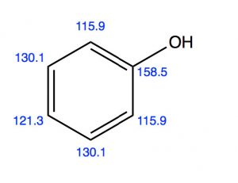
Another group of ortho, para directors are substituents that are attached to the ring by an O or N (that is, phenol) alkoxybenzenes or aniline and its derivatives. While it might seem, at first glance, that these electronegative atoms would be electron-withdrawing by induction, we know that they can also donate electrons through resonance with the ring. We can see both modes in operation if we look at the evidence from the C-13 NMR. C-1 appears at a much lower field (158 ppm) than benzene (128ppm), presumably because it is directly attached to the electron-withdrawing O. But the ortho and para carbons appear at a slightly higher field than benzene because these positions are enriched in electron density by resonance.
In fact, phenol is more reactive than benzene and it is difficult to stop the reaction at the mono-nitration step. Again, we observe a mixture of ortho and para products, because the transition state on the way to the intermediate sigma complex can be stabilized by resonance.
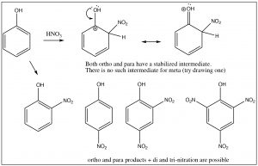
Generally, any benzene derivatives with a lone pair that is available for stabilizing the intermediate will be an ortho, para director including aniline (and any N-alkylated analogs) and anisole (methoxybenzene). This also includes compounds that have a lone pair that must be shared between the ring and a carbonyl group: for example, phenyl esters or amides.
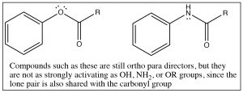
There is one more classification for directing groups: the halogens are anomalous in that they are deactivating ortho, para directors. Halogens are electronegative and withdraw electrons from the ring by induction, thus reducing the reactivity. However, halogens also have lone pairs that can be used to stabilize positive charge by resonance. The resonance effect is not as large as it is for N- or O-substituted rings, but it can still operate. Therefore halo-substituted benzene rings tend to react more slowly than benzene, but they do produce ortho and para products.
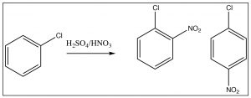
Multiple substituents: While it is relatively easy to predict the position of substitution on a monosubstituted ring (one you know how to do), predicting the outcome when there are two or more often becomes problematic. Sometimes, both substituents will “point” to the same positions. For example, in p-nitrophenol, both the OH and NO2 direct the substituent to the same position, but in m-nitrophenol, they direct to different positions as shown.
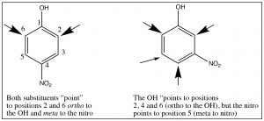
It is, therefore, sometimes possible to predict the position of the third substituent, but, often, it is not. Regardless of this problem, most aromatic substitution reactions have the potential for producing multiple products, either because both ortho and para products are formed or because the product may be more reactive than the reactant. For example, any electrophilic aromatic substitution that adds an activating group to the ring may be difficult to stop at one substitution. Friedel Crafts alkylation is difficult to stop at only one alkylation. In fact, rather than alkylate the ring, it is often preferable to acylate the ring, followed by a reduction of the acyl group. There are a number of reducing reagents that can take the aldehyde or ketone right down to an alkyl group: for example, as shown here, the Clemmensen reduction involves a zinc-mercury amalgam in HCl.
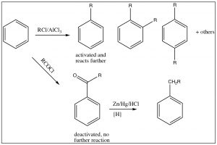

Nucleophilic Substitutions on Aromatic Systems: Expanding the range of potential substitution products.
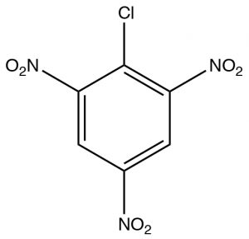
All of the reactions on the aromatic ring so far have proceeded by one mechanism: electrophilic aromatic substitution. Up to now, we have not solved the problem of introducing substituents that usually react as nucleophiles onto an aromatic ring. There are a number of ways to accomplish this and we will consider three of these mechanisms.
The first, Nucleophilic Aromatic Substitution (SNAr), is somewhat analogous to an SN2 reaction. It will occur if two conditions are met: the first is there must be a leaving group present on the ring, typically a halide; the second is that that the electron density of the ring must be reduced. This is typically accomplished by having electron-withdrawing groups such as nitro groups on the ring. We can observe the effect of adding electron-withdrawing groups by looking at the NMR spectra of 2-chloro-1,3,5-trinitrobenzene. The only peak in the H-NMR spectrum is a 2H singlet at 9.1 ppm. This is considerably downfield of the 7.3 ppm of benzene because the of the effect of the electron withdrawing nitro groups. This effect explains why the ring is susceptible to nucleophilic attack.
The reaction proceeds by an initial attack by a nucleophile such as OH, OR, followed by loss of the leaving group which takes the pair of electrons with it.
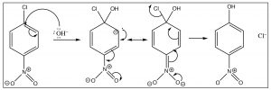
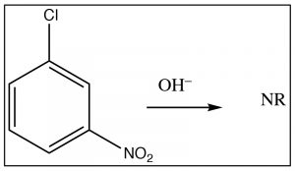
The intermediate anion can be directly stabilized by the nitro group, but only if that group is in the ortho or para position. If the nitro group is meta to the leaving group the reaction will not occur, because such stabilization is not possible (try to draw resonance forms for it).
A second mechanism involves elimination of HX from the ring, followed by a rapid addition of HY; it can be considered analogous to elimination and addition reactions of alkenes and alkynes. The first step is the elimination of HX from benzene, which produces a highly reactive, strained species which is called a benzyne. This intermediate undergoes very rapid reaction to add H+ and Y– across the double bond.
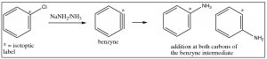

Evidence for this mechanism, rather than SNAr, comes from isotope labeling studies. If the original site is isotopically labeled (e.g. with C-13), the final product has only 50% of the nucleophile at the labeled site and 50% at the adjacent carbon. If this were a straight nucleophilic substitution, all of the substitution would take place at the labeled carbon.
Diazonium ions:
Another approach that allows access to multiple products involves the reaction of aniline (PhNH2) with the nitronium ion (produced in the reaction mixture) to what is known as a diazonium ion.
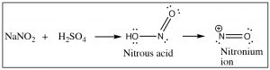
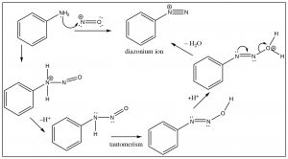
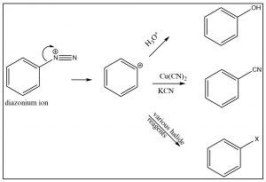
The diazonium ion is highly unstable: it must be prepared at temperatures around 0°C; if the solution is warmed above this temperature, it will decompose by losing a molecule of nitrogen (N2) to produce a carbocation. It is this decomposition that can be captured by a range of nucleophiles. In some ways this reaction is akin to an SN1 reaction in which a carbocation is produced, which then undergoes rapid nucleophilic attack.
The intermediate carbocation can be captured in the presence of a nucleophile: for example water, alcohol, halide, or cyanide ions. Note that all these reactions typically require a raised temperature or the presence of a metal ion catalyst. This is to enhance the rate of decomposition of the diazonium ion, so that the resulting carbocation can be captured by the nucleophile. It is important to note that this carbocation is NOT resonance-stabilized (you cannot draw resonance forms to stabilize—try it).
Diazo coupling reactions: Besides being a way to introduce some nucleophiles into aromatic rings, diazonium salts also undergo what is known as a coupling reaction. The diazonium ion itself is susceptible to nucleophilic attack if it is not decomposed too rapidly—usually by another aromatic system. This reaction has been used to produce a wide range of dyes and indicators.
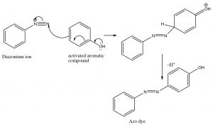
These azo compounds have a long-conjugated chromophore that typically results in absorption of visible light, making the compounds highly colored (as a result of the light that is reflected and not absorbed). Manipulation of groups on either benzene ring can extend the conjugation even further. About 50% of dyes belong to this family of compounds.

Reactions of Substituted Benzenes: Reaction at the Benzylic Position.
The position next to the benzene ring is special because reactive species such as carbanions, carbocations, or radicals at that site can be conjugated (and therefore stabilized) with the benzene pi system. For example, we have already seen that phenol (C6H5OH, pKa ~10) is much more acidic than a typical alcohol (pKa ~16) because the negative charge can be stabilized in the aromatic ring. Similarly, benzyl halides ( e.e. C6H5CH2Br) undergo nucleophilic substitution under SN1 conditions, even though these compounds appear to be primary halides, a carbocation next to the ring can be stabilized.
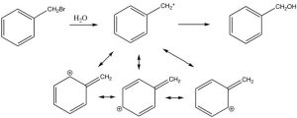
The position next to the ring is called the benzylic position, and is particularly reactive because of the ability to stabilize any intermediate in the aromatic ring. For example, it is possible to selectively introduce a bromine at the benzylic position via a reaction in which radicals are generated. We have spent little time on the reactions of organic compounds with radicals, because, generally, these reactions are very difficult to control. For example, an alkane will react with halogens in the presence of light or peroxides (which initiate the reaction by forming a radical), but the reaction is not synthetically useful and typically the halogen can end up in all the possible positions.
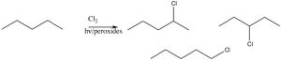
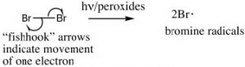
However, we can selectively introduce a bromine atom at a benzylic position, because the intermediate benzylic radical is most stable, and will have a lower activation energy to formation. The reaction begins by producing a bromine radical from Br2 by breaking the bond with light to give two Br radicals. The Br radical abstracts (removes) an H from the benzylic position to give the resonance-stabilized benzylic radical which then abstracts a Br from bromine (Br2).
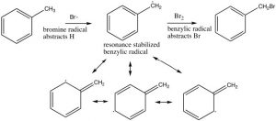
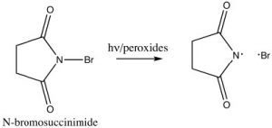
In practice, we use a source of bromine radicals that is easier to handle than elemental bromine, N-bromosuccinimide (NBS), which has a weak N-Br bond that will break homolytically (i.e. to give two radicals) in the presence of light or peroxides. NBS will react with alkyl benzenes to introduce a bromine specifically at the benzylic position.
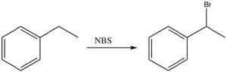
Another unique reaction of benzylic positions is that they can be oxidized by reagents such as KMnO4 to give the corresponding carboxylic acid; any other carbons in the side chain are removed in the process.
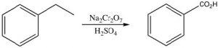

Pericyclic reactions:
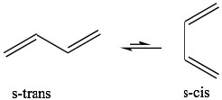
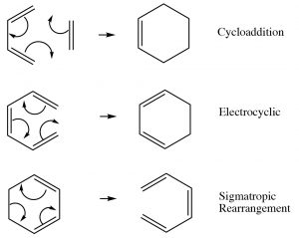
Up to this point, we have focused on two types of reactions that can be broadly classified as Lewis acid-base (electrophile-nucleophile) reactions and, to a lesser extent, on oxidation-reduction reactions. Both of these reaction types are typically initiated by differences in electron density—that is, interactions between molecules or parts of molecules that are electrostatically interacting with each other. They may occur via ionic or radical intermediates. However, there is a different type of reaction that is not initiated in this way; instead the reaction occurs via a cyclic movement of electrons, breaking and forming bonds in a concerted fashion (at the same time). These reactions are called pericyclic reactions and can occur with a variety of substrates. The three major types of these reactions are shown. What is interesting about them is that they involve the cyclic rearrangement of six electrons.
Diels-Alder Reactions:
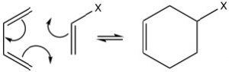
The best-known of these reactions is a cycloaddition reaction known as the Diels-Alder reaction. It typically occurs between a conjugated diene and another alkene known as the dienophile. This reaction is very useful in synthesis because it forms two new C-C bonds at the same time. It is also stereospecific and regiospecific. The simplest diene that can participate in a Diels-Alder is butadiene. Typically, butadiene tends to exist in the more stable s-trans conformation—however, there is an equilibrium concentration of the s-cis conformation through which the reaction can occur. In fact, cyclopentadiene, in which the diene is permanently fused in the s-trans conformation, reacts rapidly with itself (it can be both diene and dienophile) in a reversible reaction.
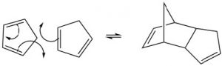
The “dienophile” can be a simple alkene, but the presence of an electron-withdrawing group (such as a carbonyl group) on the double bond improves yields. We can envision the reaction as taking place in a concerted fashion. Again, the reaction is reversible, and the reverse reaction is known as a retro Diels-Alder. We can use our knowledge of thermodynamics to predict the most appropriate conditions for the reaction. Recall that the extent of any reaction can be predicted from the Gibbs free-energy change ΔG = ΔH –TΔS. Since the reaction produces two new C-C single bonds and one new C-C pi bond while breaking two C-C pi bonds, we can assume that the enthalpy change for this reaction is negative (bond formation releases energy and bond-breaking uses energy). Therefore, the ΔH term is always favorable. We can also predict the sign of the entropy change for the system; since we are producing one molecule from two, we would expect ΔS to be negative also. The entropy term is unfavorable. From this analysis, we can see that the temperature at which the reaction is carried out is crucial. High temperatures would favor the reverse reaction. Therefore Diels-Alder reactions are typically run at fairly moderate temperatures that are between room temperature and 150°C).
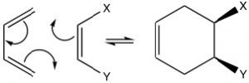
The possibilities for Diels-Alder reactions are quite extensive and since this is a concerted reaction, any stereochemistry in the starting materials is conserved in the products. For example, if the dienophile has cis or trans stereochemistry, this is conserved in the product. The cis dienophile gives the cis product (and vice versa for the trans).
Some examples of Diels-Alder reactions are given here.
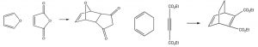
While we can draw mechanistic arrows for pericyclic reactions such as Diels-Alder, they are best understood by using molecular orbital theory. In this treatment, we can consider the reaction as taking place between the highest occupied molecular orbital (HOMO) of the diene and the lowest unoccupied molecular orbital (LUMO) of the dienophile.
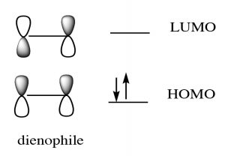
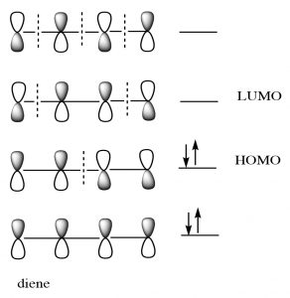
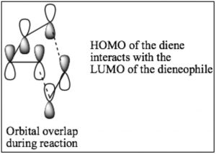
For our purposes, this treatment is too complex, but if you go on to further studies of pericyclic reactions, MO theory will be the approach that will allow you to predict the outcome of many different reactions.
If a fused ring is formed during the reaction, there are two possibilities for the orientation of the substituents on the diene as shown below: exo and endo.
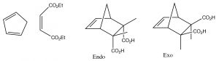
Because of the possibility of a stabilizing interaction in the endo position, (the pi system of the carboxylic acid can interact with the pi system of the diene), the endo product is usually produced.
As noted earlier, there are other types of pericyclic reactions. All of the common reactions that occur simply by heating up the starting materials involve the cyclic movement of six electrons. The transition states for these reactions all involve molecular orbitals that extend throughout the system; these orbitals have considerably lower energy than one might expect. In some ways, this is analogous to the 6 pi electrons of aromatic systems, which are also stabilized in lower energy molecular orbitals.
Interestingly, these reactions do not occur in the same way if they are initiated by electromagnetic radiation (that is, if we shine light on them rather than heat them up). In this case the electrons that participate in the reaction are actually in higher energy orbitals (the electron absorbs a photon and is promoted to a higher energy level). Absorbing light leads to a completely different set of reactions and outcomes, something that is explored in subsequent organic chemistry courses. There is, however, one particularly interesting (and biologically relevant) photochemically induced reaction, namely the reaction of adjacent thymine bases within a DNA molecule. Upon the absorption of a UV photon, such adjacent thymines can undergo an electrocyclic reaction that results in dimer formation.
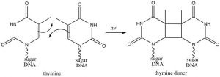
The presence of a thymine dimer results in conformational changes in the DNA that, unrepaired, can lead to mutations. Thymine dimers are recognized and repaired via two distinct cellular-repair mechanisms. Unrepaired damage can lead to skin cancer (a range of carcinomas and melanomas).
This is one reason to limit skin exposure to the sun.

Chapter

Chapter 9: A return to the carbonyl
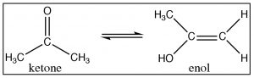
As we have seen carbonyl compounds undergo both acid and base catalyzed reactions involving nucleophilic attack at the carbonyl carbon (or at the beta carbon of conjugated carbonyls). This reaction, in its many guises, can produce an impressive range of products from the formation of an ester from an acid to the production of alcohols from carbonyls. While these reactions may seem superficially different, if you understand the underlying mechanism involved, it is possible to make plausible predictions for the outcome for literally thousands of reactions. By this time, you should have come to understand such processes. Now, it is time to reconsider carbonyl groups in light of the fact that there is a completely different set of reactions that involve the reactivity of the alpha carbon of the carbonyl groups. Carbonyl compounds typically exist in two tautomeric forms: the keto and enol forms. The keto form is usually the major tautomer and there is always some enol present as well.
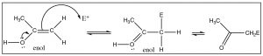
The structure of the enol form can provide clues about its different reactivity, which is distinct from that of the keto form. The enol form consists of an alcohol directly attached to a C that is involved in a double bond. As we know, alkenes are electron-rich and tend to undergo electrophilic attack; the presence of an attached –OH group makes such an electrophilic attack even more likely. Just like an –OH group on an aromatic ring, the OH can donate electrons through resonance with the –C=C– and make the enol more reactive. Carbonyl groups can react, through the small percentage of the enol form present, to undergo electrophilic attack at the alpha carbon.
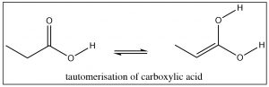
We have already seen that aldehydes and ketones exist as keto-enol tautomers, but, in fact, carboxylic acids, esters, and other acid derivatives also have the potential to exist in the corresponding enol form.
Another implication of the alcohol-nature of an enol is that we expect it to be acidic—and indeed it is. The conjugate base of the enol is called the enolate ion and it is resonance-stabilized so that the negative charge is delocalized on both the oxygen and on the alpha carbon.
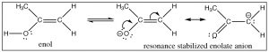
The pKa of acetone is 19—somewhat higher than a typical alcohol (pKa ~15). In the enolate form, the majority of the charge sits on the more electronegative oxygen, but a significant proportion of the negative charge is associated with the alpha carbon: the enolate ion is a stabilized carbanion. The enolate anion is often written in its carbanion form because this is the form that produces most of the interesting chemistry. Treatment of a carbonyl compound with a base, such as an alkoxide, results in the reversible formation of a small amount of the enolate ion (although the equilibrium lies on the side of the unprotonated form). Similarly, many carbonyl compounds can be deprotonated to give the corresponding enolate anion. For example, esters can be treated with a base to give the corresponding enolate anion.
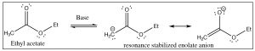
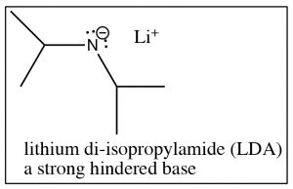
Ethyl acetate has a pKa of around 25 (less acidic than acetone: pKa 19), but still well within reach of many of the strong bases. For example, sodium amide (NaNH2), the conjugate base of ammonia (pKa 33), is strong enough to deprotonate the ester. In fact, we typically use what is known as a hindered base, such as lithium di-isopropylamide (LDA), which is similar to sodium amide but the nitrogen has two bulky isopropyl groups attached to it.
Since LDA is such a strong base, treatment of most carbonyl compounds with LDA produces essentially 100% of the corresponding enolate anion. However, there are exceptions. Any carbonyl compound that has a more acidic proton than the H associated with the alpha carbon will not undergo this reaction. For example, treatment of carboxylic acids with LDA will merely result in the loss of the acidic proton from the carboxylic acid OH group.
Most carbonyl compounds have pKa‘s between 19 and 25. Compounds that have carbonyl groups that are beta to each other (that is, separated by an intervening carbon), have significantly lower pKa‘s (around 9), because the resulting anion can be stabilized on both carbonyl oxygens.
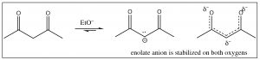
They can be easily deprotonated by bases such as sodium ethoxide or sodium hydroxide.

Reactions of enols and enolates
The keto and enol forms of carbonyl compounds can undergo completely different reactions. The carbonyl (keto) form undergoes nucleophilic attack at the carbonyl carbon and the enol/enolate form undergoes electrophilic attack, usually at the alpha carbon (although the O is also reactive). For example, aldehydes and ketones can be halogenated at the alpha carbon just by treatment with a solution of the halogen, either with acid or base catalysis. The first step is enolization, which produces the very electron-rich alkene that attacks the bromine (just like the first step of addition to a normal alkene). This intermediate then loses a proton to give to the halogenated compound and HBr.
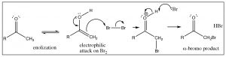
The reaction can also be done in a base via the enolate, but in this case the reaction is difficult to stop after one halogen has added and, typically, all alpha positions will end up brominated. Such a reaction is analogous to the first step of addition of halogens to an alkene, but the second step involves the regeneration of the carbonyl. Just as reversible nucleophilic addition to the carbonyl typically produces the sp2 hybridized product, these enol/enolate forms also end up as substitutions rather than additions.
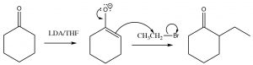
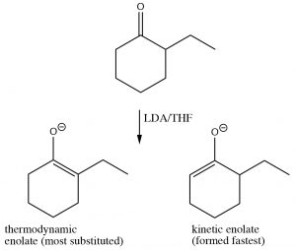
A reaction of an alpha carbon that has no analogy in alkene chemistry involves their acting as a nucleophile in an SN2 reaction. The reaction occurs via the enolate anion, which then attacks any appropriate alkyl halide via an SN2 reaction.
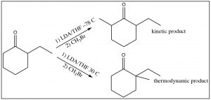
If the ketone undergoing such a reaction has the possibility of forming two different enolates, and therefore producing two different alpha alkylation products, the enolate that has the most substituted double bond is the most stable and is thermodynamically favored. Typically, the enolate formed from the least-hindered carbon is formed fastest (it has the lowest activation energy). It is therefore possible to control the product of such a reaction by carefully controlling the reaction conditions. At very low temperatures, the kinetic product is formed, while at higher temperatures thermodynamic product is formed.

The Aldol reaction
As we have previously discussed, the carbonyl group has a kind of split personality. The carbonyl group is susceptible to nucleophilic attack at the carbonyl carbon and carbonyl compounds can be nucleophiles at the alpha carbon. Therefore, we should not be too surprised to learn that carbonyl compounds can (and do) react with themselves. For example, when acetaldehyde, the simplest carbonyl compound that is capable of forming an enol, is treated with a reversible base such as NaOH, it will form a small amount of the enolate anion, which can then react with the carbonyl of another molecule as shown. This reaction is known as the aldol reaction. As the enolate is used up in the reaction, more is formed and more aldol reaction occurs. The product is a beta-hydroxy aldehyde.
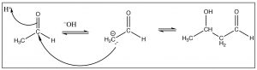
Typically, aldehydes undergo this reaction readily and the aldol product is formed in good yield. The reaction is reversible, however, and ketones often do not give good yields of the aldol product. The reverse reaction is called a “retro aldol” and occurs via deprotonation of the alcohol and loss of the enolate anion as shown.
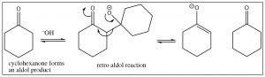
In fact, the aldol reaction rarely ends at the simple addition of one carbonyl and its corresponding enolate. Usually, the reaction is heated and, under these conditions, the alcohol that is formed undergoes an elimination to form the alpha, beta unsaturated carbonyl. When this happens, the reaction is called an aldol condensation (the term “condensation” is usually used for reactions in which water is lost).
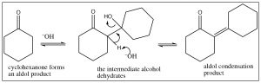
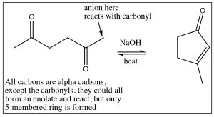
Aldol condensation is often used to synthesize rings via an intramolecular aldol condensation. In these cases, although there may be the potential to form different ring sizes, typically only the most stable rings are produced: that is, five- or six-membered rings.

The Claisen Condensation
As we have noted, all carbonyl compounds are capable of forming enols and enolate anions, and just as aldehydes and ketones undergo condensation reactions with each other, so then to esters. The ester version of the aldol is called a Claisen condensation, but the essential details are very similar in terms of the initial mechanistic sequence.
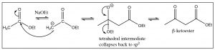
The enolate anion of the ester attacks the carbonyl of another molecule and the resulting tetrahedral intermediate collapses back to the carbonyl by regenerating the ethoxide anion that was used to initiate enolate formation. The difference between the Claisen and the aldol reactions is that the Claisen product is a β-ketoester, which can be a useful species in its own right. Claisen condensations can also form rings via intramolecular condensations (which are known as Dieckmann cyclizations).
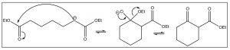
Both Aldol and Claisen condensations can be carried out between two different carbonyl compounds: however, if both are capable of forming enolates, there is the possibility of forming four different products. Consider two carbonyl compounds A and B, if enol A reacts with carbonyl B, we get product AB, but if enol B reacts with carbonyl A we get product BA (which would have a different structure). A can also condense with another A to form product AA, and similarly we could get BB. Therefore, it is important to control the reaction conditions carefully: for example, by using an irreversible base such as LDA to form the enolate first. This precludes the possibility of the enolate reacting with itself. Then, the other component can be added slowly to the reaction mixture and the condensation can be carried out.
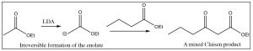

β-Ketoacids Decarboxylate
All of these Claisen condensation reactions produce a difunctional compound in which a carbonyl group is located on the beta position of an ester. There is a useful reaction that can be carried out if the ester is hydrolyzed to the corresponding acid. If the resulting β-keto acid is heated, it decarboxylates (loses CO2) in a pericyclic reaction that involves the cyclic rearrangement of six electrons as shown below.
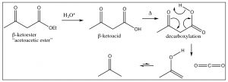
The β-ketoester here is known as acetoacetic ester. The CH2 group between the two carbonyls is easily deprotonated, and the resulting anion can do a nucleophilic attack on any susceptible substrate: for example, an alkyl halide. A subsequent hydrolysis and decarboxylation results in a compound that has three more carbons in it than the original alkyl halide, as shown below.
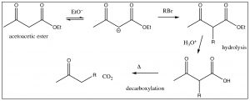
The “acetoacetic ester” synthesis is a powerful way of adding a 3-carbon unit. A similar reaction involves malonic ester (below), which can be used to add a 2-carbon unit.
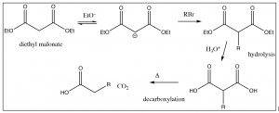
In the decarboxylation step, only one of the carboxylic acids decarboxylates and the alkyl group is extended by two carbon atoms. Interestingly, fatty acids (long chain carboxylic acids) are synthesized by a mechanism that is analogous to this malonic ester synthesis.

Biosynthesis of Fatty Acids:
As we move forward, we will discuss some biosynthetic pathways. It is not our intention that you reproduce these pathways, complete with enzymes and co-factors, but that you understand the underlying organic chemistry behind them. As you will see, most biochemical reactions are quite simple: it is their surroundings (the other parts of the molecules, enzymes, and co-factors) that make it possible for these reactions to occur (generally around room temperature) in a crowded aqueous environment; these pathways appear complex.
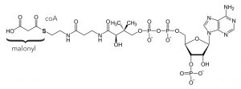
Fatty acids are built two carbons at a time by the following mechanism: the two-carbon unit is provided by a malonyl unit that is formed from malonyl-CoA, (a thioester) which is attached to a carrier protein for recognition purposes. It is formed from acetyl CoA (co-enzyme A)—which is a product of the breakdown of glucose (glycolysis) by reaction with bicarbonate. The result of adding two carbon units is that most biological fatty acids have an even number of carbons. They are synthesized by a sequence of reactions that is highly analogous to the malonic ester synthesis. The syntheses of fatty acids is one of the mechanisms that the body uses to “store” energy and to generate various membranes. Fatty acids often occur as esters of glycerol and are therefore called triglycerides.
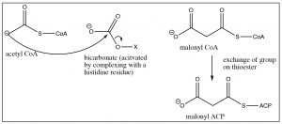
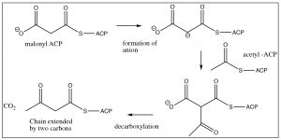
Acetyl CoA is transferred to the acyl carrier protein (ACP) and is then attacked by the malonyl anion with loss of the S-ACP group (this is analogous to the SN2 reaction on an alkyl halide). Decarboxylation produces a new beta-keto thioester, extended by two carbons.
The next step is reduction of the carbonyl (using NADPH—which is analogous to NADH—and delivers hydride ion), elimination, and reduction to the fully saturated chain. The system then cycles around to add two more carbons from malonyl ACP.
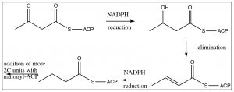
All of these reactions are very similar to those we have learned throughout the course. They seem more complex because of the biological “bits” that control the direction of reaction and activation of the functional groups, but once you understand organic chemistry, biochemistry makes much more sense!

Michael Reactions.
Recall that aldol condensations result in α,β-unsaturated carbonyl compounds, a functionality that we have already discussed at some length.
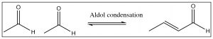
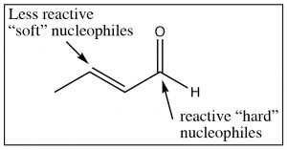
These conjugated carbonyl groups can undergo nucleophilic attack at either the carbonyl carbon or at the β carbon, depending on the nature of the nucleophile. For example: highly reactive (or “hard”) nucleophiles like Grignards or alkyl lithiums tend to react at the carbonyl carbon, while less reactive (soft) nucleophiles like dialkyl cuprates or reversible nucleophiles like amines or alcohols tend react at the β carbon.
Anions formed from β-diketones are relatively unreactive (they are stabilized) and, therefore, we might predict that they will attack the conjugated carbonyl at the β position – and we would be correct! This reaction is called the Michael reaction.
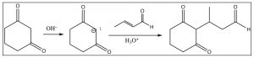
In fact, we can condense the same β-diketone with a different conjugated ketone (not formed from an aldol condensation) to produce an intermediate that can then undergo an intramolecular aldol condensation as shown below. This two-step procedure is called the Robinson Annulation.
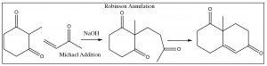
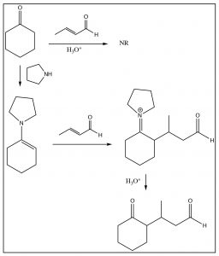
Unfortunately, this reaction only works well with beta-diketones; a simple ketone does not attack the conjugated system. However, there is a relatively simple solution to this, which is to modify the ketone to form an enamine, which will then react as shown below. This variation is known as the Stork enamine synthesis.

Glycolysis
Glycolysis is the name we give to the group of reactions that result in the splitting of a C-6 glucose molecule into two C-3 units, which is accompanied by the overall production of ATP, the molecule that can be used to provide energy to drive unfavorable chemical reactions such as building up biopolymers like peptides, nucleic acid polymers (DNA and RNA), and production of fats. This process is usually depicted schematically, particularly in biology texts, but every step of the process is a relatively simple organic reaction that can be understood in terms of the principles that we have learned over the past year. The overall schematic for glycolysis is given below, but our intent here is not that you memorize each step so that it can be regurgitated; it’s to allow you to understand how and why these reactions occur the way that they do (or at least the way they do in biological systems).
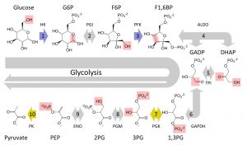
We will be treating these reactions from an organic chemistry perspective, but it is important to note that in the body all of these reactions are mediated by enzymes and co-factors that lower the activation energy for each reaction. The first part of the glycolysis pathway involves the conversion of the sugar glucose, to a different sugar, fructose. Therefore we will begin by looking briefly at the structure and properties of sugars.
Glucose:
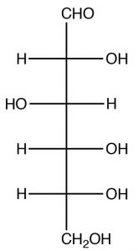
While glucose looks complex, we have already investigated the functional groups present and all the reactions that are important here. Glucose belongs to the family of compounds called sugars part of a larger group, known as carbohydrates, denoted by the suffix -ose. Since it has six carbons, glucose is known as hexose (similarly, a five-carbon sugar would be known as a pentose). Glucose can exist in several forms; both open and closed chain. We consider the open-chained form first. The easiest way to represent sugars is by using a Fischer projection (in fact these representations were invented for just this purpose). Remember that in a Fischer projection, the horizontal bonds are pointing out of the plane and are all eclipsed. The naturally occurring form of glucose is D-Glucose .
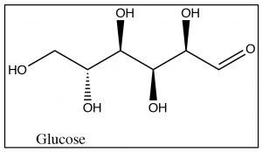
Note that there are four chiral centers in glucose, and therefore there are 16 (24) possible stereoisomers, many of which do occur naturally. The D designation has to do with the stereochemistry at position 5 and does not refer to the direction of the rotation of plane-polarized light. (While it is possible to designate R or S for each chiral center, it is not possible to designate R or S for the molecule as a whole). Note that glucose also has an aldehyde group (at position 1) and, therefore, also belongs to the class of sugars called aldoses.
In its open chain form, glucose has an aldehyde group and five hydroxyl groups and, as you might expect, there is great potential here for reactions, both inter- and intra-molecular. In a solution, glucose commonly exists in the hemiacetal form, in which the OH group on C-5 has attacked the carbonyl group to form a six-membered ring which is referred to as the pyranose form (pyran is a six-membered heterocyclic ring with an oxygen atom in it). The pyranose form is usually drawn in the chair form as shown below.
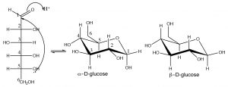
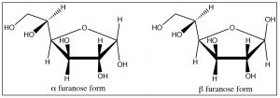
Hemiacetal formation produces two possible configurations, but rather than calling them R and S, we label them alpha and beta. In alpha form, the OH on carbon 1 is on the opposite side of the ring from the CH2OH (C-6 of the original chain), the beta form has the OH group on the same side as the CH2OH. These two forms are stereoisomers because they have the opposite configuration at C-1, but unlike typical stereoisomers, they can be interconverted by ring-opening of the hemiacetal and reclosure of the ring. They are called anomeric forms and C-1 is referred to as the anomeric carbon. Such carbons can be identified by the fact that they have two oxygens attached to them. In an aqueous equilibrium solution of glucose, less than 1% is present in the open chain form, but since there is always an equilibrium concentration present, the alpha and beta forms can and will interconvert via this open-chain form. As might be expected, the beta form is more stable (because the OH is equatorial) and at equilibrium there is about 64% beta. For sugars such as glucose, there is also the possibility that a five-membered ring can form by the reaction of the alcohol at C-4 with the carbonyl. Again, two forms (alpha and beta) are possible, which can be interconverted via ring-opening. This five-membered ring form is called the furanose form (furan is a five-membered ring with one oxygen).
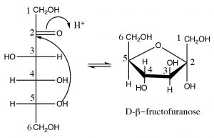
Fructose: Fructose is another six-carbon sugar. It differs from glucose in that it that has a ketone rather than an aldehyde at C-2; for this reason, it is called a ketose (rather than an aldose). Fructose usually exists in a five-membered hemiacetal ring formed by reaction of the OH at C-5 with the ketone carbonyl at C-2. The resulting five-membered ring is called the furanose form (furan is a five-membered ring with one oxygen) and typically furanose rings are depicted using yet another structural representation: the Haworth projection, shown here. In this structure, the ring is drawn as a plane (although it isn’t, of course), and the substituents are either above or below the plane of the ring. In the same way as glucose, fructose can exist in either the alpha or beta forms.

Glycolysis: From glucose to fructose.
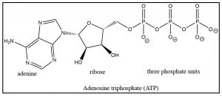
The first steps of the biological cycle known as glycolysis involve the conversion of glucose to fructose. As we will see, this sets up the reverse aldol reaction that results in the splitting of glucose into two 3-carbon fragments—but we will get to that shortly. The first step in glycolysis is the phosphorylation of the OH group at C-6. This reaction is analogous to the formation of a carboxylate ester, the only difference being that the attack occurs at a phosphorus rather than a carbon. The source of phosphate is adenosine triphosphate (ATP) and, in this case, it is the terminal phosphate that is transferred to the glucose and the leaving group is ADP (adenosine diphosphate). The reaction is mediated by an enzyme (a kinase): this reaction is highly thermodynamically favorable (ΔG is negative).
The consequences of glucose phosphorylation reaction are twofold: First, it serves to keep the concentration of glucose in the cell low, so that glucose can continuously diffuse into the cell (through membrane channel proteins). Glucose-6-phosphate is highly charged (the oxygens on the phosphate group are almost entirely ionized at physiological pH) and cannot diffuse back out of the cell (through the channel). The second consequence is that the hydroxyl group on C-6 has been activated. The phosphate is an excellent leaving group.
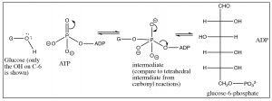
The next step is the transformation of glucose into fructose. In organic chemistry terms, this is a simple tautomerization as fructose is a structural isomer of glucose. The enzyme that regulates this conversion is known as an isomerase.
The glucose aldehyde undergoes enolization as shown, followed by another tautomerization to produce the fructose ketone. All of these reactions are entirely analogous to the keto-enol interconversions that we have seen in simpler systems.
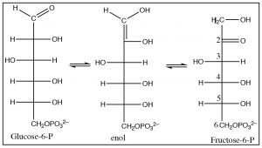
The next step is another phosphorylation reaction at C-1 to produce fructose-1,6-diphosphate; it involves the same reaction mechanism that produced phosphorylation at C-6 using ATP as the source of phosphate. You might be asking, how is it that these reactions occur in this particular sequence and why don’t the other oxygens undergo phosphorylation? The answer to this lies in the fact that these reactions are mediated by enzymes that guide the substrates into the correct (pre-established, evolutionarily) orientations. Reactions in solution depend entirely on random collisions with enough energy to surmount the activation energy barrier and in the correct orientation. In biological systems, the substrate first collides with, and its orientation is constrained through interactions with, the enzyme; limiting subsequent aspects (steps) of the reaction. While there is potential for other hydroxyls to be phosphorylated (and it would certainly be difficult to control the site of attack if the molecules were free in solution, the reactant-enzyme complex favors certain ones dramatically over others. Remember the enzyme itself is result of evolutionary mechanisms. Given the ubiquity of this process, it was likely established early, and present in the last common ancestor of life.
The reverse aldol: The system is now set up for the cleavage of the six-carbon sugar into two three-carbon species via a reverse aldol reaction as shown.
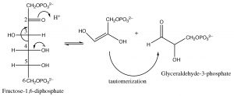
The result is the production of two molecules of glyceraldehyde-3-phosphate from one molecule of glucose. Up to this stage, glycolysis has involved the use of two ATP molecules associated with the two phosphorylation reactions.

In the next stage of glycolysis, another phosphate is added to each glyceraldehyde-3-phosphate molecule; this phosphate is not derived from ATP, but from inorganic phosphate. The mechanism involves an addition of a phosphate unit to the aldehyde carbonyl, followed by oxidation as the tetrahedral intermediate collapses, with loss of the hydride ion that adds to NAD+, to form NADH.
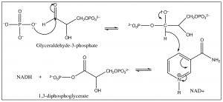
The resultant species now contains two phosphate groups, but they are different chemically: the phosphate attached to the newly oxidized carbon is much more reactive than the other. Attack by a nucleophile at the phosphorus preferentially expels a carboxylate anion from the intermediate, rather than an alkoxide. In the next step of the reaction, the highly reactive phosphate is transferred to ADP through an attack by the O– on the terminal phosphate of ADP onto the P of the 1,3-diphosophoglycerate, with subsequent loss of 3-phosphoglycerate (because the carboxylate is a good leaving group).
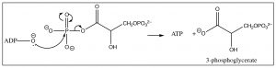
This reaction produces two ATP molecules (and 2 reduced NADH molecules) from one original glucose (because there are now two three-carbon units), so, at this stage, the net production of ATP = 0. The transfer of the other phosphate unit from C-3 to another ADP does not occur because the leaving group (an alkoxide) is not thermodynamically favorable. Instead, the phosphate group is transferred from C-3 to C-2 by an intermolecular nucleophilic attack that forms a five-membered ring intermediate and subsequent elimination of water.
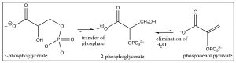
The product of this elimination reaction is called phosphoenol pyruvate (PEP). In essence, it is an enol that has been trapped by esterification with the phosphate. The enol is an excellent leaving group (since it is really a carbonyl group) and, therefore, PEP will also undergo attack by ADP to produce ATP and pyruvate, resulting in a in a net +2 ATP molecules for the overall glucose to pyruvate reaction (plus the two NADH molecules).
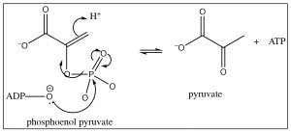
Once again, our intent here is not to have you memorize this long sequence of reactions, but rather to recognize that even in systems that appear highly complex, when each reaction is viewed at the molecular level, it is recognizable as the same reactions that we have been studying. In fact, the mechanisms of a large majority of reactions in biological systems can be understood in relatively simple terms. Many of the reactions are the same: attack at carbonyl (or phosphate) groups, aldol and retro aldol condensations, and keto-enol tautomerizations.

Recall that we have used hindered bases before. In that case, it was to prevent nucleophilic attack when we wanted to bring about an E2 elimination reaction and tertiary butoxide (KOC(CH
)
, as our hindered base.

